
.
News Release
Allison Transmission, Inc.
Communications
Indianapolis, Indiana, U.S.A.

Allison continues to expand global network of trusted distributor and dealer partners
Distributors and direct dealers join the extensive Allison network, growing Allison’s support for valued customers around the world
INDIANAPOLIS, INDIANA, U.S.A. – Allison Transmission, Inc., the world’s leading supplier of commercial duty fully automatic transmissions and hybrid propulsion systems, added a total of 11 new distributors and direct dealers to its global channel network of trusted partners in the past year. Additionally, Allison’s distributor partners further expanded their capability through additional approved service dealers to increase their customer support reach within their given territories. “OEMs and truck owners and operators around the world increasingly recognise the superiority of Allison’s engineering, service and product reliability. Our 2009 network expansion reflects the growing demand for automatic transmissions worldwide and proves Allison’s full commitment to customer service,” says Thomas D. Eifert, executive director of Allison customer support.
“The criteria for becoming an Allison channel partner are rigorous, and many who seek to become an authorised Allison distributor simply do not meet our high standards,” continues Dennis J. Breedlove, director of Allison global channel development. “Each of the companies that have been appointed as Allison distributors and dealers over the past year is the best-of-the-best. Solid financials, the ability to carry required parts and component inventories and a willingness to involve employees and technicians in Allison training programs are all mandatory. Above all, a commitment to customer satisfaction is paramount,” Breedlove adds.
Allison’s new network partners include CICA Co. Limited – Allison’s first direct dealer in Vietnam; Yantai Jereh Group serving China; and Dae Kwang covering the Seoul metropolitan area in Korea. In Australia, Heavy Automatics and Transdiesel Australia Pty Limited have been appointed; in India, Vignesh Equipments and Construction Pvt. Ltd., assumes responsibility for the Andhra Pradesh state, while Trident Services Pvt. Ltd covers the territory of South Maharashtra, and Trans Repower Engineering Services India Pvt Ltd serves the state of Karnataka.
Auto-Mecánica, part of the Transdiesel SL group, serves new and existing customers in North East Spain; Mecanique Hydraulique Services focusing on French customers in Dijon and Lyon; Randon Nordeste is appointed to cover the state of Bahia in Brazil; and Rodacar is added in Uraguay.
Together these partners bring the number of Allison worldwide distributors and direct dealers to 147, nearly an eight percent growth over 2008 in an already extensive network.
Asia Pacific – first entry into Vietnam; Chinese, Indian, Korean and Australian networks grow
Allison entered Vietnam this year offering sales and service support to the local market via CICA Co. Limited, a company already supplying the construction, mining industries, transportation and communications industries. As the provider of genuine service parts for heavy duty equipment such as Renault Trucks, Atlas Copco blasthole drills and Ingersoll-Rand compressors, CICA is strategically located to serve all Vietnamese territory from its Hanoi office and three regional branches. “Through their work for other leading global equipment manufacturers, we were able to see the importance CICA places on offering the latest technical training to its staff,” says G H Tan, Allison’s commercial director of Singapore operations.
In China, Yantai Jereh Group became the country’s second distributor. Boasting a heritage in the manufacture and repair of specialised oilfield equipment, the company has expertise in the maintenance of mining and special industrial equipment, providing engineering services for oil exploration as well as selling mechanical and electrical products, heavy trucks, tractors and trailers. “Jereh was selected because of its excellent engineering and manufacturing processes and a strong and healthy corporate culture that convinced us of its potential to serve and further development the market in this region,” says Steven Chew, commercial director of China. “The fact the company is API Q1 and ISO9000-certified is of value to Allison and our customers.”
In response to a rapid increase in sales of the Allison Torqmatic® Series transmissions supplied into buses in the Seoul metropolitan area, Allison has appointed Dae Kwang as a new authorised service dealer. “Allison Korea has been successfully increasing presence in low floor buses and expanding into regular city buses,” says Ashwin Gopalaswamy, commercial director of Japan and Korea. “The Allison Torqmatic® Series population is now in the thousands. Dae Kwang has operated a service parts business for the city bus market for 20 years and brings valuable knowledge of and strong relationships with bus fleets. Dae Kwang is also Hyundai’s official service parts dealer for its commercial vehicles.
In Australia, new Allison distributor, Heavy Automatics is one of the largest and best known repairers of Allison transmissions throughout Australia, having grown from a small owner/operated workshop in Adelaide to span Australia with branches in Adelaide, Perth, Brisbane, Sydney and Melbourne. Heavy Automatics has over 50 employees on staff. Company directors Ron Neville and Claude Dalese said, “Our aim is to penetrate new markets and further enhance the Allison product to existing customers. We are very excited by the prospect of working with the full backing of the Allison factory.” Transdiesel Australia Pty Limited based in Victoria has been appointed as an Allison direct dealer. In this capacity, Transdiesel will enhance direct coverage for the Allison population in the off-highway and the growing on-highway truck applications in addition to supporting Allison’s hybrid programme in the area.
In India, high demand for Allison automatic transmissions, particularly in off-highway dump trucks and buses, has prompted Allison to seek a direct presence there. Allison has therefore appointed three direct dealers in India, Trident Services Pvt. Ltd, assuming responsibility for the South Maharashtra territory with primary office in Pune, Trans Repower Engineering Services India Pvt Ltd covering the state of Karnataka with main offices in Bangalore, and Hyderabad-based Vignesh Equipments and Construction Pvt. Ltd. has been selected to support customers in the state of Andhra Pradesh. “Allison Transmission maintains a strong presence in the Indian off-highway segment and the upgrading of the road transport infrastructure and government stimulus packages means the demand for automatic transmissions are growing in the on-highway segment as well,” says Ram Amarnath, managing director of Allison Transmission India Pvt. Ltd. “We felt the need to bring onboard customer support partners who have excellent knowledge of our products and the market to ensure that our customers experience Allison’s unrivalled quality, reliability, durability and superior after sale support.”
Latin America – customer focus continues
The aim to achieve widespread continental coverage in Latin America has progressed well in 2009.
The Brazilian state of Bahia gained a new direct dealer – Nordeste Comercial de Implementos Rodoviários Ltda., known as Randon Nordeste – to provide Allison’s customers with specialist sales and after sales support, parts distribution, training and maintenance on the Eastern border of the country. “As distributors for an OEM that uses Allison transmissions in many of its trucks, this bond was natural,” says Fernando Susin, general manager machine unity from Randon Nordeste. “With this partnership we link our sales and after sales services with a very traditional brand and an extremely reliable product.”
Additionally, a new distributor, Rodacar, has been appointed in Uruguay.
Strong further expansion is planned in this region, and as Evaldo Oliviera, Allison’s director of Latin American sales and customer support, comments, “We continue to drive to be the benchmark in customer support in our industry and are committed to our firm customer focus.”
Europe – new Dealers in Spain; changes to strengthen Allison’s presence in France
In Spain, Allison appointed Auto-Mecánica – part of the Transdiesel SL group – as an authorised service dealer for the North East of the country. In the Galicia region, the growing demand for fully automatic transmissions in a wide variety of vehicles, including urban solid waste collection vehicles, fire trucks, crane-carriers, heavy-duty work and construction vehicles, as well as distribution and delivery trucks, prompted Allison to assume a more direct presence. According to Trond Johansen, sales manager of Allison Transmission in Spain, experience is a key factor in the choice of local partner: “The accumulated experience of Auto-Mecánica in providing service and technical assistance for many types of transmissions and their history as dealers in spare parts for industrial vehicles, has given them a solid knowledge of the product, the market and the needs of customers in this area.”
Another Transdiesel Dealer, Autosur de Levante of Valencia, has recently opened a new facility in Mallorca to serve Allison users on the Balearic Islands.
Rhone-Alpes-based dealer MHS (Mecanique Hydraulique Services) joined the Allison network in France to serve customers from locations in Dijon and Lyon. Also in France, TUCOM has been added in Agen.
North America
In Allison’s original home market of North America, Allison maintains a comprehensive and established network of 30 distributors and direct dealers as well as over 1100 dealers. In over 60 years of serving transmission customers needs, Allison seeks to optimise and continuously improve its ability to provide coverage and outstanding customer experience across the breadth of the Allison product offerings. In partnership with its channel network, Allison continually works to improve the delivery of the outstanding service support our customers expect.
Eifert and Breedlove both agree, “2009 was an exciting year as Allison further expanded its customer support reach around the globe. We are looking forward to an equally active 2010.”

About Allison Transmission, Inc.
Allison Transmission, Inc. (Allison) is the premier global provider of commercial duty automatic transmissions and hybrid propulsion systems. Allison products are specified by over 250 of the world’s leading vehicle manufacturers and are used in many market sectors including bus, refuse, fire, construction, distribution, military and specialty applications. Founded in 1915, the Allison business is headquartered in Indianapolis, Indiana, U.S.A. and employs 2,900 people. Regional headquarters with dedicated support staff are located in China, The Netherlands, Brazil, India and Japan. With a global presence in 80 countries, Allison has over 1500 distributor and dealer locations. More information about Allison is available at www.allisontransmission.com.
###

Press enquiries

Claire Dumbreck, Market Engineering
North Bar House, North Bar
Banbury
Oxfordshire OX16 0TH
Tel: +44 (0) 1295 277050
claire.dumbreck@m-eng.com

Allison Transmission Europe B.V.
Marketing Communications
Baanhoek 188
3361GN Sliedrecht - The Netherlands

Contact: Miranda Jansen
Tel: +31 (0)78-422 174
Miranda.Jansen@allisontransmission.com

Photographs

Available from Claire Dumbreck by email (see above)

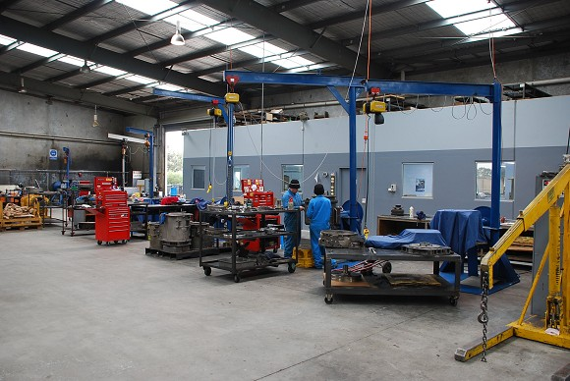  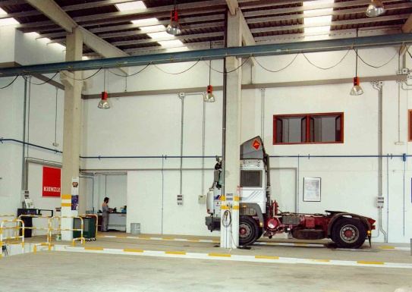  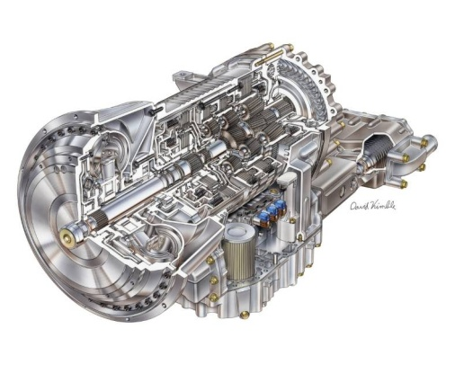  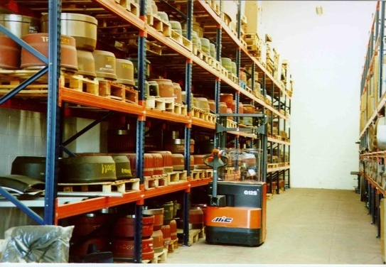 | Transdiesel Australia Pty Limited, based in Victoria, Australia, is geared up to serve Allison customers and enhance direct coverage for the off-highway and the growing on-highway truck markets in addition to supporting Allison’s hybrid programme in the area.  Allison has announced Auto-Mecánica as its authorised service dealer in the Northeast of Spain, in a move to strengthen the company’s position and improve the service offered to customers in Galicia.  Dae Kwang has operated a service parts business for the city bus market for 20 years and is perfectly positioned to help support increasing sales of the Allison Torqmatic Series transmissions on Seoul city buses.  Authorised Allison service dealers have large selections of products in stock, as well as extensive experience and a proven capacity to provide a timely and professional response for any type of vehicle equipped with an Allison transmission.

