17 January 2013

PRESS RELEASE

Winner of Formex Formidable 2012

Formex Formidable 2012

Object: FANNY Vase
Company: Klong
Designer: 3do/Ami Katz

The Jury’s motivation:
A sculptural object that captures our prevailing love of flowers and fascination with brass. With glimmering inspiration from Art Nouveau and the Wiener Werkstätte (Vienna Workshop), Fanny combines strictness and playfulness, innovation and forward-lookingness. A future classic, a stylized bouquet that does not require any flowers.

Jury:
Stefan Nilsson, trend expert from Trendgruppen, Dan Gordan, Editor of Sköna Hem, Kerstin Wickman, Professor of the History of Design and Crafts, designer Monica Förster, Monica Förster Design Studio, and Kajsa Falck-Torlegård, Formex.

Formex Formidable People’s Choice:

Object: Canes
Company: Nobaloney Aps Designer
Designer: Rie Nörregaard - OMHU

Motivation:
The canes – an optimal combination of function and design – received most votes from the general public via the Formex website.

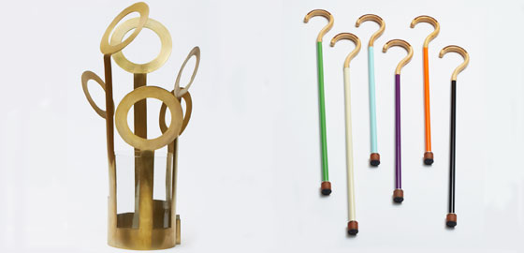

To find out more, please visit www.formex.se or contact Ida Mlowe, Press Officer, ida.mlowe@stockholmsmassan.se or +46 8 749 44 13

