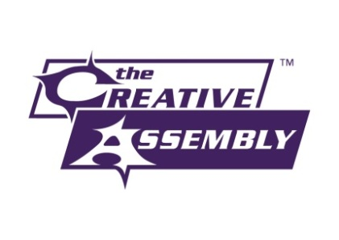 | 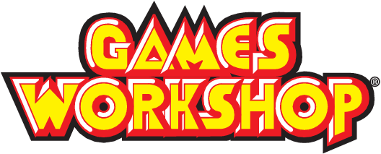 | 

PRESS RELEASE

SEGA and Creative Assembly Announce Partnership with Games Workshop to Create Warhammer Games
STOCKHOLM, SWEDEN – December 6, 2012 – SEGA® of America, Inc. and SEGA® Europe Ltd. today announced that Creative Assembly™, award-winning creator of the Total War™ series, and SEGA® Group have entered into a multi-title licensing deal with Games Workshop® to create videogames based in the Warhammer® universe of fantasy battles.
A new high-calibre development team has been set up at Creative Assembly’s UK studio to work alongside the existing Total War, Alien™ IP and Mobile teams on the first Warhammer title in the deal, scheduled to launch from beyond 2013.
“With this year being our 25th anniversary”, said Tim Heaton, Studio Director at Creative Assembly, “it seems fitting for us to embark on such a dream project with such a well-established partner. The incredibly rich and detailed Warhammer world is something we grew up with, and has left an indelible imprint on us as both designers and gamers.”
“We’ll be doing the Warhammer universe justice in a way that has never been attempted before. We’re bringing those 25 years of experience and expertise in extremely high-scoring games to bear, delivering a Warhammer experience that videogamers will absolutely love.”
“We have enormous respect for SEGA and Creative Assembly and have felt for a long time that the combination of the enormously rich setting of the Warhammer world, and their stunning development talent is a match with huge potential,” said Jon Gillard, Games Workshop's Head of Licensing. “Now that we’ve managed to bring these two giants of gaming together it is safe to say that some truly amazing products are going to be unleashed as a result. We are excited at the possibilities, and are enthusiastically working with the team at Creative Assembly already.”
This first Warhammer game joins the eagerly-awaited Total War™: Rome II and the untitled Alien IP as one of five projects currently in production at Creative Assembly, now one of the largest developers in Europe.
For future updates and career opportunities please visit www.creative-assembly.com.

About Creative Assembly
Founded in 1987 and based in Horsham, West Sussex, Creative Assembly is one of the UK’s most successful and established game studios. Creator of the multi award-winning Total War strategy series, the studio has received numerous press, industry and consumer accolades, including BAFTA and the Develop Industry Excellence awards. With nearly 250 highly talented developers and counting, the studio is expanding to embark on thrilling new triple-A console, PC and mobile projects.

About Games Workshop®:
Games Workshop® Group PLC (LSE:GAW.L) is based in Nottingham, UK. Games Workshop designs, manufactures, retails, and distributes its range of Warhammer® and Warhammer® 40,000® games, miniature soldiers, novels and model kits through more than 400 of its own Hobby centres, the Internet and independent retail channels in more than 50 countries worldwide. Further details on the company can be obtained at www.games-workshop.com
Warhammer © Games Workshop Limited 2012. Games Workshop, the Games Workshop logo, GW, Warhammer, the Warhammer logo, the foregoing marks’ respective logos and all associated marks, logos, names, places, characters, creatures, races and race insignia, illustrations and images from the the Warhammer world and Warhammer game setting are either ®, TM and/or © Games Workshop Ltd 2000-2012, variably registered in the UK and other countries around the world. All Rights Reserved to their respective owners.

About SEGA® Europe Ltd.:
SEGA® Europe Ltd. is the European Distribution arm of Tokyo, Japan-based SEGA® Corporation, and a worldwide leader in interactive entertainment both inside and outside the home. The company develops and distributes interactive entertainment software products for a variety of hardware platforms including PC, wireless devices, and those manufactured by Nintendo, Microsoft and Sony Computer Entertainment Europe. SEGA Europe’s web site is located at www.sega.com

About SEGA® of America, Inc.:
SEGA® of America, Inc. is the American arm of Tokyo, Japan-based SEGA® Corporation, a worldwide leader in interactive entertainment both inside and outside the home. The company develops, publishes and distributes interactive entertainment software products for a variety of hardware platforms including PC, wireless devices, and those manufactured by Nintendo, Microsoft and Sony Computer Entertainment Inc. SEGA of America’s Web site is located at www.sega.com

