Annex A – Biographies of student artists

BA(Hons) Music
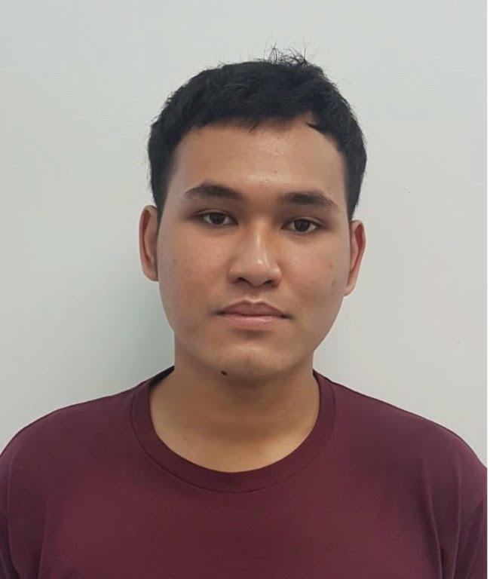
Name of Artist: Mohammad Fairuz Bin Ramlan
Bio: Fairuz is an Electronic Musician from Singapore who is fascinated by sounds that are produced in nature, and when different mediums interact with each other by means such as vibrations, plucking etc. As every object has a natural frequency that it best vibrates at, Fairuz aims to explore the sounds and tones that can be produced by these methods and to piece them together in abstract, melodic compositions with the aid of analogue and digital effects.

Artwork: The Glass Bottle Music Machine

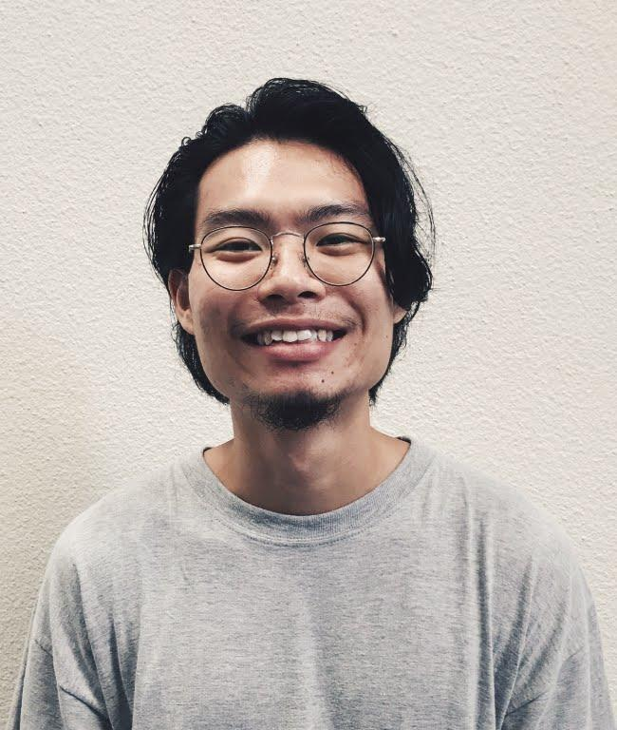
Name of Artist: Ernest Foo Mao Ern
Bio: A contemporary electronic music artist, Ernest first picked up music in his pre-teen years. At LASALLE, he was exposed to many new forms of music making and production – from psychedelic rock to neo-soul, he now tinkers with more abstract genres as a sound designer exploring avant-garde concepts and experimental techniques. Infatuated with granular synthesis, he recreates the technique through a host of programs and has generated content for both live and in-studio sessions.

Artwork: Potion

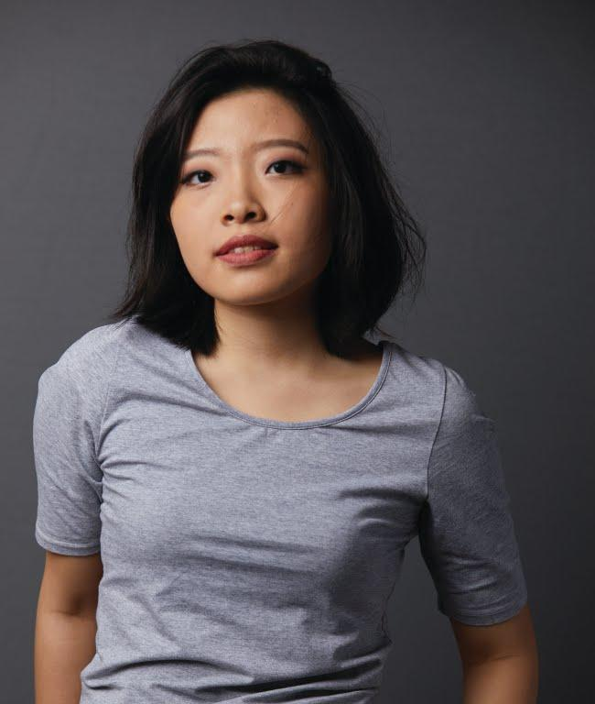
Name of Artist: Koh Ming-Min Emmeline
Bio: Emmeline is an electronic musician who aims to incorporate the use of natural, organic sounds into her electronic music. As a vocalist, she enjoys processing clean vocals into more complex sounds to create a vast, intricate soundscape that brings listeners to another world. She wants to eventually combine the genres of electronic and soul R&B to create music with a warmer, softer touch.

Artwork: The Photo Synth

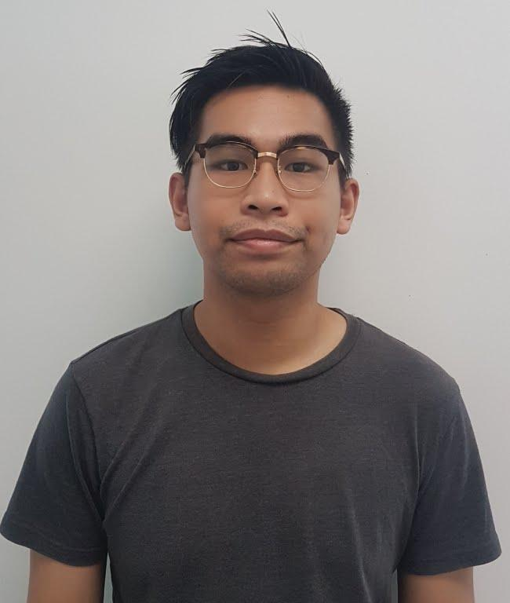
Name of Artist: Cheng Yu Heng
Bio: Cheng is an electronic musician and sound designer. His works are primarily in the electronic dance music (EDM) spectrum, though he is also very interested in exploring extended techniques of playing either a traditional or non-traditional instrument.

Artwork: Replay

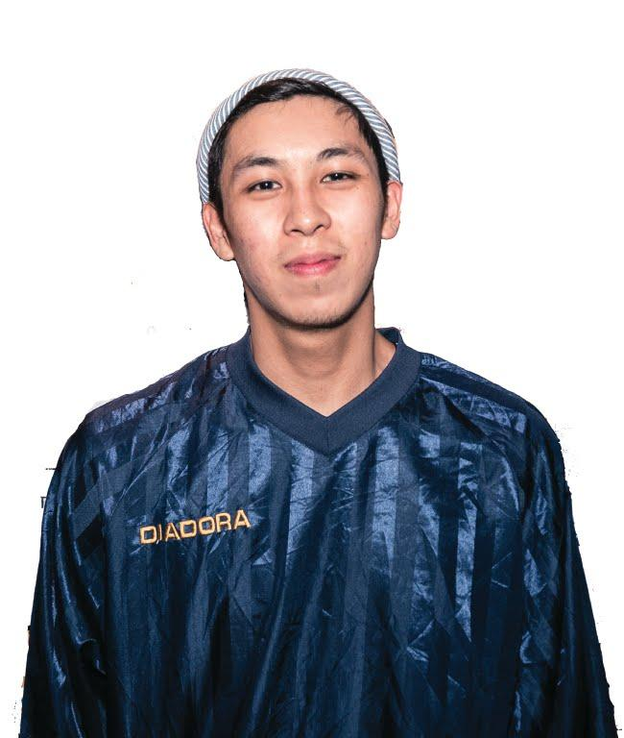
Name of Artist: Cravis Chang
Bio: Cravis is an electronic sound artist interested in exploring the relationship between the human body and sounds. His works often involve the interaction between user and instrument to produce sounds.

Artwork: Nunchuck Synthesizer

BA(Hons) Fine Arts

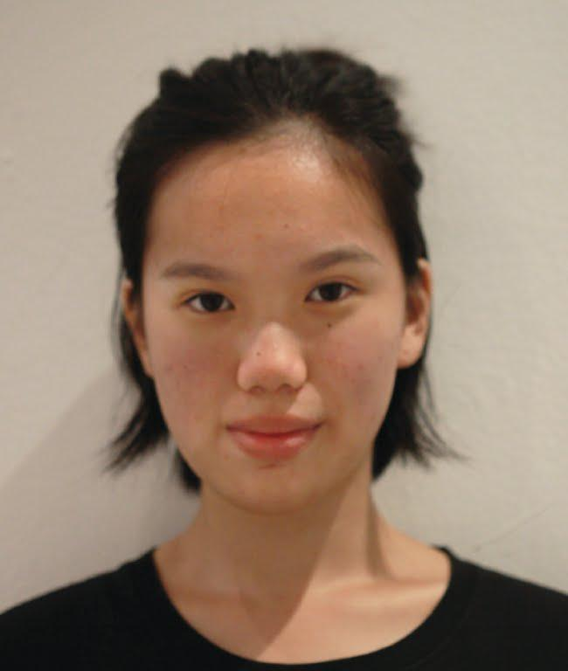
Name of Artist: Chok Si Xuan
Bio: Through material exploration, 3D printing, Arduino and various forms
of mechanics, Si Xuan’s practice attempts to develop an aesthetic
language, akin to science fiction movies and soft actuators.

Artwork: Affect

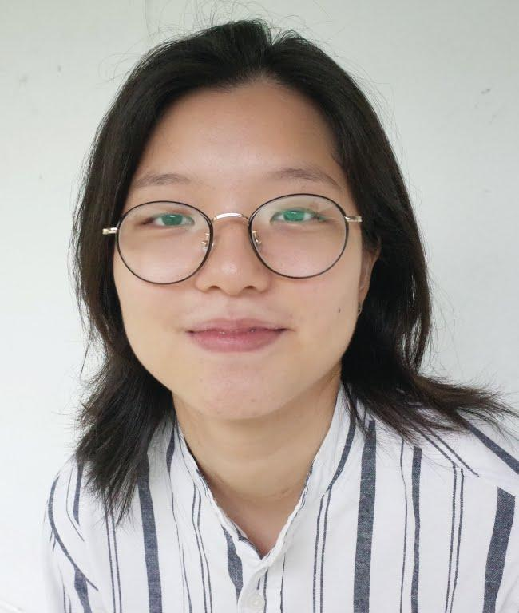
Name of Artist: Denise Yap
Bio: Denise is an artist whose multidisciplinary practice is a convergence between new materialism, speculative fiction and queer politics. She seeks to explore the complexity of human and non-human conditions by employing the queer perspective as a deconstructive lens, to examine relationships between matters. Her recent group exhibitions include 2018 Untapped at Chan+Hori Contemporary, Singapore, and Limits at TOMO Gallery, Kyoto.

Artwork: Ongoingness

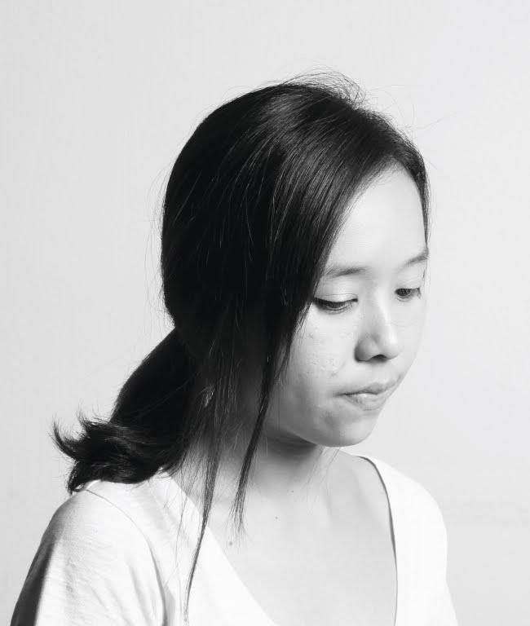
Name of Artist: Desiree Tham Xue Ping
Bio: Desiree is interested in relationships between human and modernisation. She employs personal narratives and performance as a platform to challenge the discourse with urban culture and the spaces we live in. She believes we live in a world that is both timeless, and ceaseless in its ever negotiation between past and present. Her works evoke and provoke multiple interpretations and sentiments.

Artwork: Face of Fortune

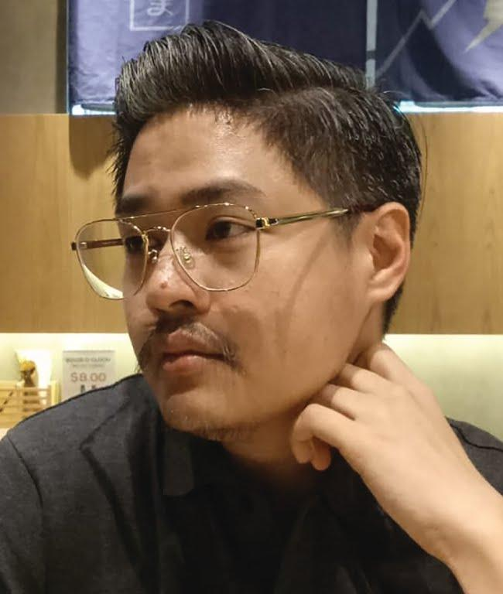

Name of Artist: Guyrence Tan
Bio: Guyrence is a multidisciplinary creative born and based in Singapore. His practice largely consists of illustrative and experimental collages, ranging from traditional and digital prints to drawing and mark-making. He is greatly inspired by the mundane of everyday life, finding inspiration from every crook and cranny of society.

Artwork: Distance Matters

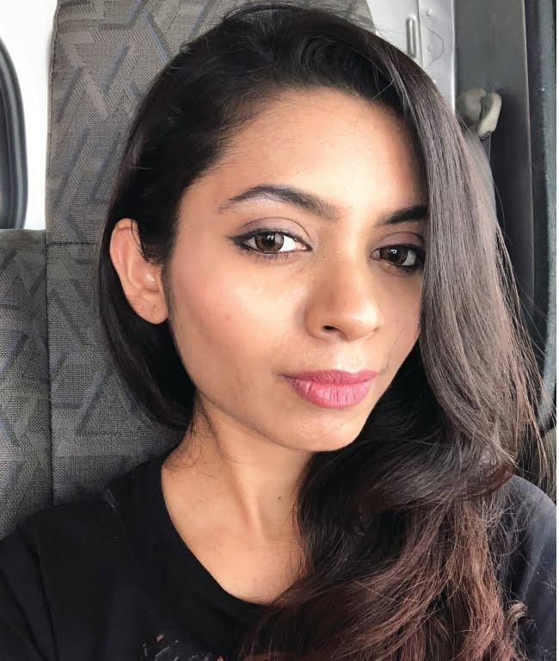
Name of Artist: R. Yashini
Bio: Yashini is a multidisciplinary artist whose practice seeks to explore the speculative grounds of modern cosmology. Given her experimental curiosity and inventive methodologies in materiality, she aims to stage distant wonders by creating experiential spaces. She has recently participated in the International Virtual Art Exhibition at Grifio Art Gallery, Rome, 2018.

Artwork: Sabaism

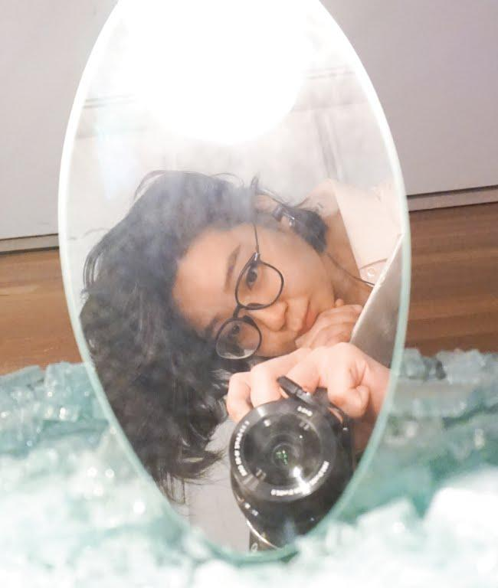
Name of Artist: Odelia Yen
Bio: Odelia Yen is a multi-disciplinary artist that ventures into analogue/digitised photography and 2D drawings; in particular, experimental mark-making, blindfold-drawing and mapping. She also delves into the making of assemblages.

Artwork: From Another Lens

Diploma in Broadcast Media

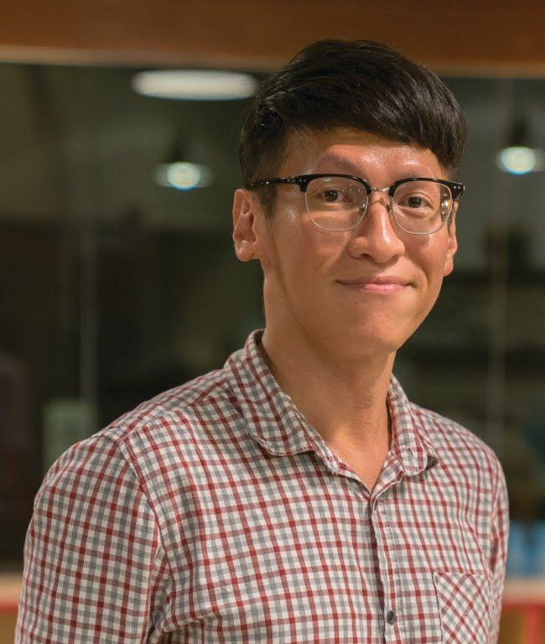
Name of Artist: Alex Pan
Bio: Alex is a multidisciplinary creative who is passionate about creating moving visuals across documentaries, music video and computer graphics. He believes that images have the power to alter perceptions and impact society for the better. In recent years, he is interested in exploring human conditions through speculative fiction and employing technology to create hyper-realistic experiences that evoke empathy.

Artwork: Amusement Park 2100

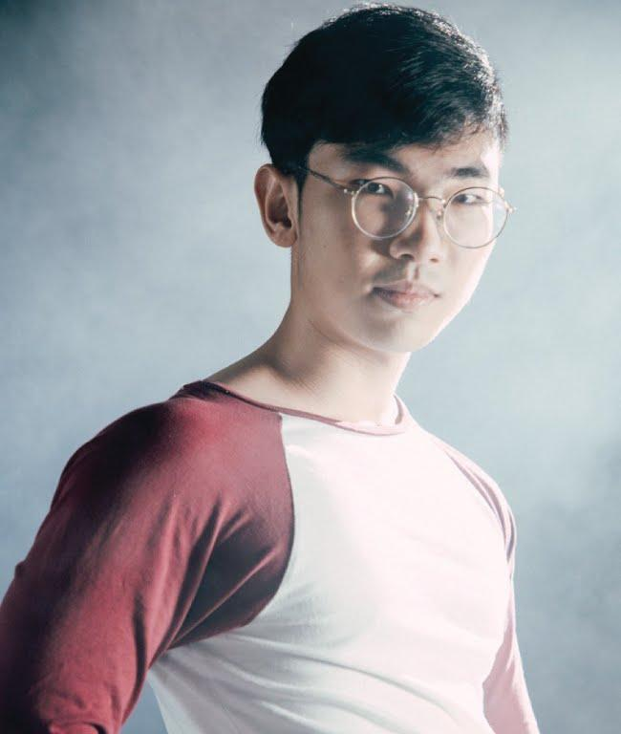
Name of Artist: Leon Oh
Bio: Leon’s works are not confined to any one aesthetic. He enjoys multiple types and variations of aesthetics such as cyberpunk, medieval, colour-scapes etc. He believes in incorporating the best parts from other styles and pushing the boundaries to bring the definition of aesthetics to a whole new level.

Artwork: Amusement Park 2100

