|  |  |
| --- | --- |
|  | **Contact:** Rejne Rittel  Wildcorn GmbH  Paul-Lincke-Ufer 41  10999 Berlin  Germany  Tel: +49 176 2447 4906  press@wildcorn.de |

FOR IMMEDIATE RELEASE Berlin - September 12, 2018

# Innovia and Wildcorn develop a fully recyclable and sustainable pack

**Berlin, GER, For Immediate Release -** Innovia Films and the German snack manufacturer, Wildcorn have worked together to produce a fully recyclable and sustainable pack for their Wildcorn organic popcorn range.

Wildcorn founded 2016 in Berlin, produces a range of 100% organic, healthy and flavourful snacks, including dry roasted popcorn as a healthy alternative to crisps. In 2017 the company launched its first sustainability program in partnership with Mellifera (the German head organisation for bee protection) to offset their use of agricultural resources by planting flower strips to rebuild/maintain ecosystems.

The joint project to establish a new sustainable packaging standard began soon after the launch of Innovia’s Propafilm™ Strata high barrier film which quickly achieved the ‘Made for Recycling’ logo from Interseroh, an Independent German recycling and consulting company.

Alasdair McEwen, Global Product Manager Packaging, Innovia Films explains “This certification proves the recyclability of our new Strata BOPP film. It has been designed to be a standalone mono filmic solution or, to be used in laminate constructions to be ‘recycle ready’, or recyclable in countries which have the infrastructure to recycle polypropylene.”

Tobias Enge, Founder of Wildcorn explains “Our products are wholesome natural organic snacks, providing a healthier alternative to consumers. But as a consumer goods company we are responsible to look at the complete ecological impact of our product and packaging waste is one of the key challenges of our generation. Today’s emphasis on a ‘circular economy’ is very prominent so we decided to find a structure for our packaging that is fully recyclable while providing premium product protection. Ensuring that our consumers still experience the same high quality and taste they have come to expect. ”

To make the Wildcorn pack, a lamination of Propafilm™ Strata and a white cavitated OPP was used. This construction was also tested by Interseroh and they confirmed that it was fully recyclable, awarding the pack the ‘Made for Recycling’ certification.

Propafilm™ Strata provides a very effective barrier to aroma, mineral oils and oxygen even at high relative humidity levels ensuring increased shelf life and reduced food waste. It is glossy, is food contact compliant and chlorine free. The film is suitable for use in a range of markets, is printable and offers a wide seal and hot tack range.

Enge continues “Moving forwards, we plan to move all our products to the new sustainable format and continue the development of a sustainable packaging.”

Examples of these packs will be on display on Innovia’s Fachpack stand 7-143 in Hall 7, also on Interseroh’s stand 9-126 in Hall 9. Kopp Packaging will also be running Wildcorn’s packaging on their Vertical Fill, Form and Seal machine in Hall 4, stand 4-419. If you are visiting the show, come along to find out more about these fully recyclable and sustainable packs.

## About Wildcorn

Wildcorn was founded in September 2016 by Rejne Rittel, Max Lion Scherer and Tobias Enge. Wildcorn's 100 % natural ingredients do not only refer to new taste experiences. During production, the company neither adds preservatives, nor sugar or flavor enhancer.

For further information visit

[www.wildcorn.de](http://www.wildcorn.de)

## About Innovia Films

Innovia Films Ltd is a major producer of highly differentiated speciality Biaxially Oriented Polypropylene (BOPP) films using a proprietary ‘bubble’ manufacturing process. It holds a leading global position in the markets for high performance coated films, tobacco overwrap, labels and security films. Innovia employs >1200 people worldwide and has production sites in Australia, Belgium, Mexico and the UK. The company is focused on high quality value added products, strong customer relationship, R&D and excellent service.

For further information contact:

Patricia Potts  
Communications Manager

Innovia Films Ltd, Lowther R&D Centre, Wigton, Cumbria, CA7 9XX, UK

Tel: +44 (0) 16973 42281

Email: [patricia.potts@innoviafilms.com](mailto:patricia.potts@innoviafilms.com)

[www.linkedin.com/company/innovia-films](http://www.linkedin.com/company/innovia-films)

Twitter: [www.twitter.com/InnoviaFilms](http://www.twitter.com/InnoviaFilms)

You Tube: [www.youtube.com/innoviafilms](http://www.youtube.com/innoviafilms)

[www.innoviafilms.com](http://www.innoviafilms.com)

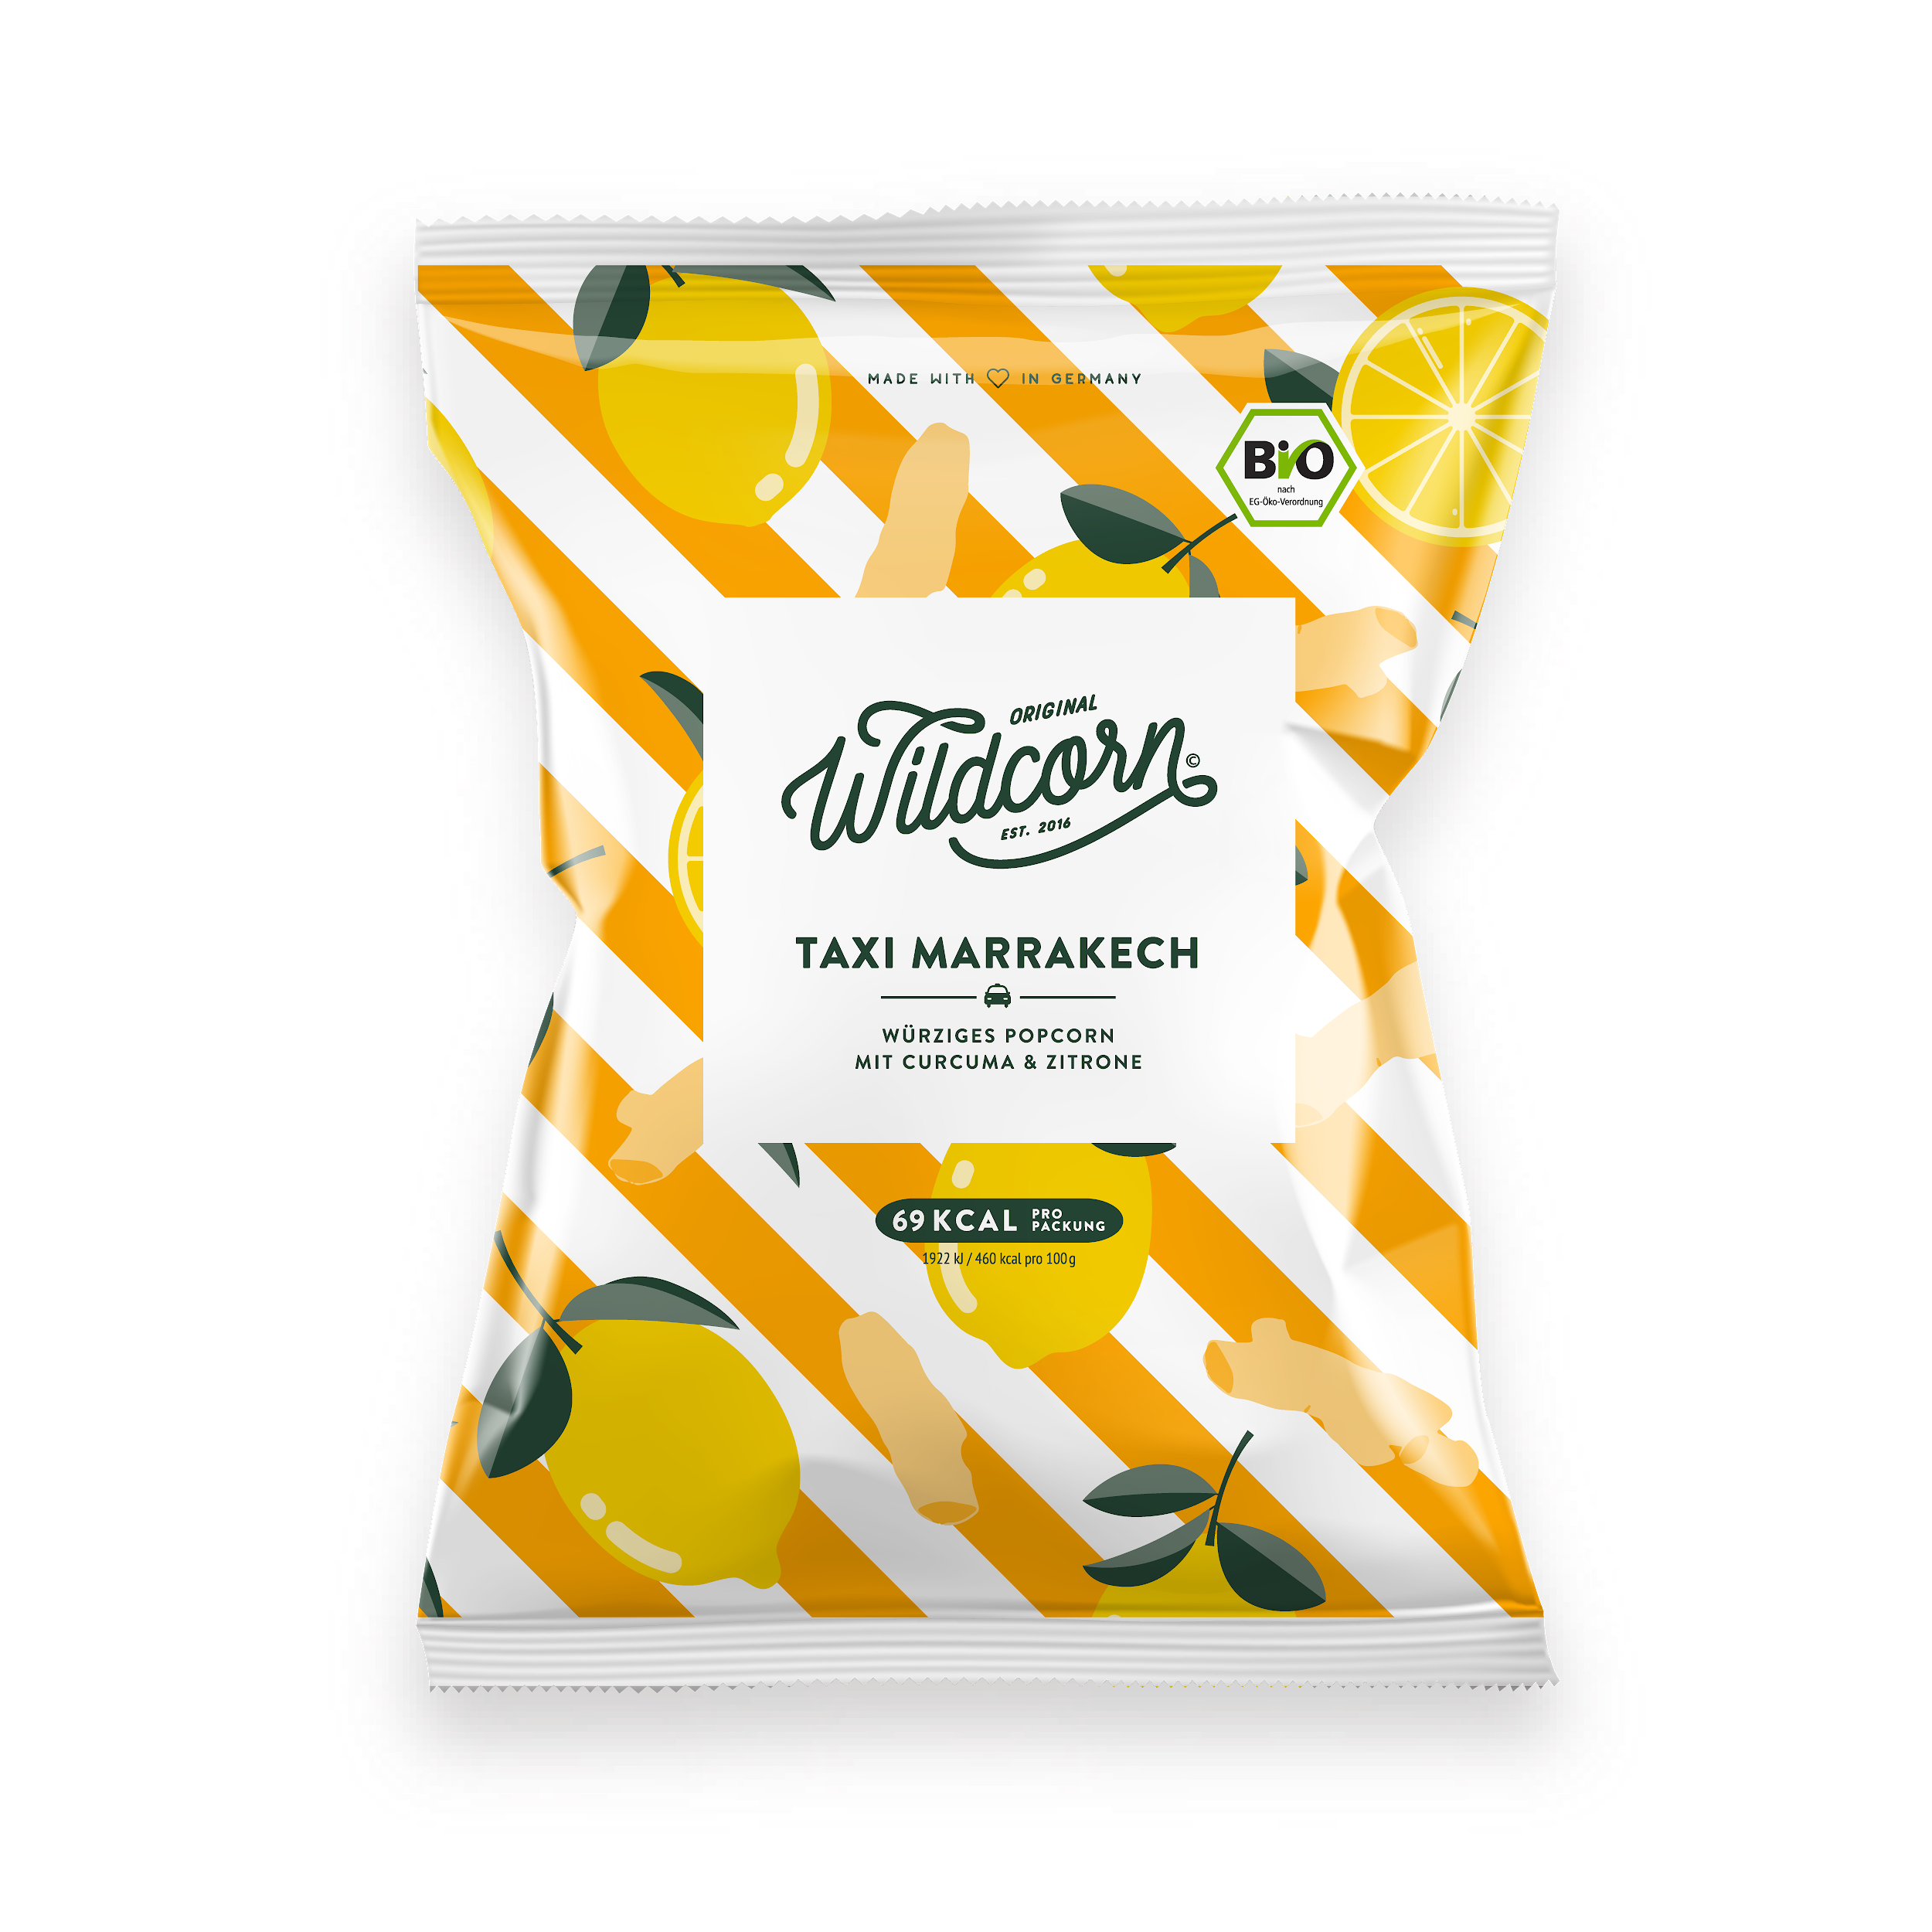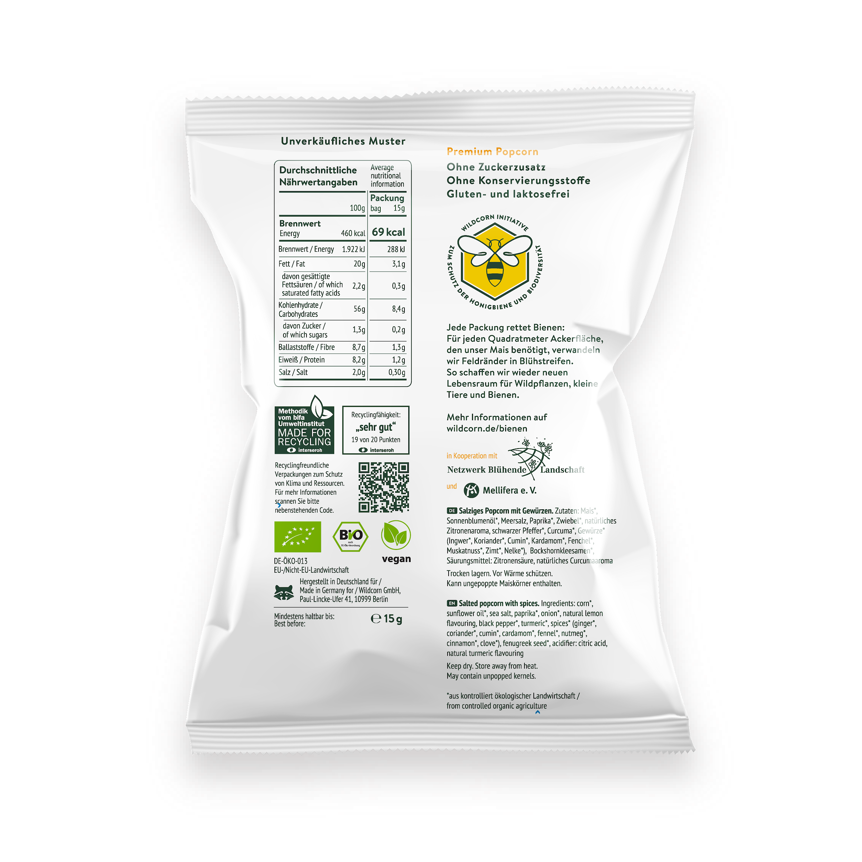

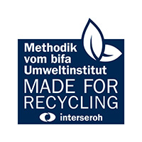

<https://www.interseroh.de/leistungen/beratung/verpackungsoptimierung/>

PICTURE CAPTION:   
Wildcorn’s turmeric and lemon organic popcorn packs are now fully recyclable and sustainable thanks to Innovia’s Propafilm™ Strata film.

# # #