**RIVAL SONS RELEASE NEW SINGLE “RAPTURE”**

**NEW ALBUM *DARKFIGHTER* NOW SET FOR GLOBAL RELEASE ON JUNE 2ND**

**VINYL PRE-ORDERS AVAILABLE TODAY**

**SHARE DETAILS OF COMPANION ALBUM *LIGHTBRINGER* ARRIVING THIS YEAR**

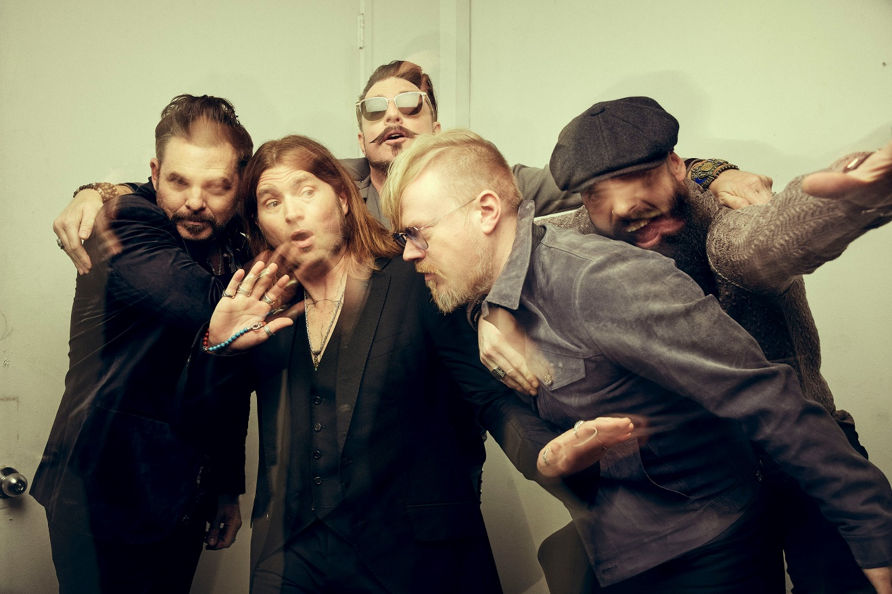

**PHOTO CREDIT: PAMELA LITTKY**

**JANUARY 20, 2023** – 2x GRAMMY-nominated band Rival Sons have shared their new single “Rapture,” which is available today on [all streaming platforms](https://rivalsons.lnk.to/darkfighter) and accompanied by a [visualizer](https://youtu.be/oFmd0l8o1yY).

It stands out as the latest anthem to be unveiled from the group’s anxiously awaited new full-length album, *DARKFIGHTER*, now releasing on June 2, 2023. It is available for [pre-order / pre-save](https://rivalsons.lnk.to/darkfighter) now [album art / tracklisting below]. Additionally, they have unlocked the [pre-order](https://rivalsons.lnk.to/darkfighter) for the limited-edition vinyl of *DARKFIGHTER* also arriving worldwide on June 2nd.

Heightening excitement for this next chapter of Rival Sons, the band have also shared details of a companion album entitled *LIGHTBRINGER*—due out in late 2023.

Expanding on the two album set,vocalist Jay Buchanan commented, "In comparison to our previous records, we certainly took our time both writing and recording this collection. When we set out, the intention was mostly to dig as deep as possible. Even in the beginning before the body had formed, we agreed to throw the map away and chop our way through the woods to make a new path. Then lockdown hit and it felt like the whole damn country decided to throw the map away too. For myself, 2022 was like an eight-stage rocket of life changing events, so every time I thought I was finished writing, a new bull would come tearing through the clothesline and I’d have to illustrate it in some way. By the end, there were really two different sides to the same story being told. On one side, you’re fighting the darkness and, on the other, you’re bringing your own light to where there is none. One side in a corner, on the ropes, and the other advancing, cleaning the ring. Without an intermission, a refractory period, the collection would be too big a bite, so splitting it in two was the only way to do it."

*DARKFIGHTER* is led by the explosive single “[Nobody Wants to Die](https://youtu.be/IF1lYMiBcWc)” which is joined by the Eli Sokhn-directed music video streaming on [Rival Sons’ YouTube channel](https://youtu.be/IF1lYMiBcWc). Thus far, “Nobody Wants To Die” has tallied over 1 million streams and counting. Right out of the gate, [*Rolling Stone*](https://www.rollingstone.com/music/music-news/rival-sons-nobody-wants-to-die-kill-bill-1234610195/) hailed it as “hard-charging” and proclaimed, “the video has Kill Bill grindhouse vibes for days and is a literal blast.” [*Guitar World*](https://www.guitarworld.com/news/essential-guitar-tracks-blink-182-psychedelic-soul) applauded, “It would be cliché to say it’s been worth the wait, but the phrase applies: ‘Nobody Wants to Die’ has enough high-gain riffage and classic rock fretboard throwdowns to more than make up for Rival Sons’ absence.”

*DARKFIGHTER* and *LIGHTBRINGER* were both produced by longtime collaborator and multi GRAMMY Award-winner Dave Cobb. These albums mark the first new music from Rival Sons since the release of 2019’s *FERAL ROOTS*, which earned the band two GRAMMY Award nominations.

In support of their forthcoming album, Rival Sons will embark on a run of North American tour dates alongside Whiskey Myers next month which are set kickoff February 16th in Knoxville, TN at the Knoxville Civic Auditorium. Furthermore, Rival Sons will join Great Van Fleet for a handful dates beginning March 26th at the Tucson Arena in Tucson, AZ and perform at *Welcome To Rockville* in Daytona Beach, FL on May 20th and *Sonic Temple* in Columbus, OH on May 27th. For tickets and more information on Rival Sons’ upcoming live dates, visit [www.rivalsons.com](http://www.rivalsons.com).

In 2021, Rival Sons celebrated the 10th anniversary of their 2011 album, *Pressure and Time*, by performing the landmark long player live in its entirety on the Pressure and Time Tour for the first time. They also lit up Southern California with a two-night livestream event, Rival Sons – “PAIR OF ACES” - Live from the historic Catalina Casino on Santa Catalina Island. They performed their debut LP, *Before the Fire* [2009], in its entirety on the first night and their self-titled EP, *Rival Sons* [2010], on the second.

[album art / tracklisting / tour itinerary /new press photos below]

1. Mirrors
2. Nobody Wants to Die
3. Bird in the Hand
4. Bright Light
5. Rapture
6. Guillotine
7. Horses Breath
8. Darkside

**2023 TOUR DATES:**

2/16 Knoxville, TN Knoxville Civic Auditorium*

2/17 Tallahassee, FL Donald L. Tucker Civic Center*

2/18 Augusta, GA James Brown Arena*

2/19 Savannah, GA Enmarket Arena*

2/22 Kalamazoo, MI Wings Event Center*

2/24 Toledo, OH Huntington Center*

2/25 Johnstown, PA Cambria County War Memorial*

2/26 Saginaw, MI Dow Event Center*

3/20 Tucson, AZ Tucson Arena^

3/21 El Paso, TX Don Haskins Center^

3/24 Anaheim, CA Honda Center^

3/26 Reno, NV Reno Events Center^

3/28 Sacramento, CA Golden 1 Center^

5/20 Daytona Beach, FL Welcome To Rockville+

5/27 Columbus, OH Sonic Temple Festival+

*w/ Whiskey Myers

^w/ Greta Van Fleet

+Festival

#Rival Sons only

**About Rival Sons:**

Rival Sons - Jay Buchanan [vocals, harmonica, rhythm guitar], Scott Holiday [lead guitar], Mike Miley [drums], and Dave Beste [bass] - play rock ‘n’ roll in its purest form without apology or pretense. Instead, they simply plug in, turn up, and rip on a path of their own. Along the way, they’ve architected a critically acclaimed catalog, including *Pressure & Time* [2011], *Head Down* [2012], *Great Western Valkyrie* [2014], *Hollow Bones* [2016], and *FERAL ROOTS* [2019]. The latter represented a creative and critical high watermark, scoring a pair of GRAMMY® Award nominations in the categories of “Best Rock Album” and “Best Rock Performance” for the single “Too Bad.” Elevating the band to another level, “Do Your Worst” vaulted to #1 at Rock Radio as their biggest hit to date, tallying north of 60 million streams and counting. Speaking to their impact, *Rolling Stone* attested, “Rival Sons have done their part to introduce new fans to rock.” Beyond sharing stages with everyone from Black Sabbath, The Rolling Stones, and AC/DC to Guns N’ Roses and Lenny Kravitz, they’ve ignited television shows such as *The Late Late Show with James Corden*. During 2021, they launched their own label Sacred Tongue Recordings distributed by Thirty Tigers and celebrated the tenth anniversary of *Pressure & Time* by performing the album in its entirety on tour. Ultimately, Rival Sons aren’t here to tell you exactly what to think or what to feel, but they’ll give you one hell of a ride if you let them. That ride twists and turns like never before on their 2023 full-length LP, *DARKFIGHTER* [Low Country Sound / Atlantic Records] kickstarted by the single “Nobody Wants to Die.”

[New Press Photos](https://www.dropbox.com/sh/cd03w9itujhroie/AADZyWvDLoq8x7yhv7lNd91Ia?dl=0)

# # #

**CONNECT WITH RIVAL SONS**

[OFFICIAL SITE](http://www.rivalsons.com/)

[FACEBOOK](http://www.facebook.com/rivalsons)

[TWITTER](http://www.twitter.com/rivalsons)

[INSTAGRAM](http://www.instagram.com/rivalsons)

[YOUTUBE](https://www.youtube.com/user/RivalSons)

[SPOTIFY](https://open.spotify.com/artist/356c8AN5YWKvz86B4Sb1yf)

[APPLE MUSIC](https://itunes.apple.com/us/artist/rival-sons/413542573)

