**SIKAFLEX® 290 DC PRO TO BE USED FOR HISTORIC ‘HAVENGORE’S’ DECK RESTORATION**

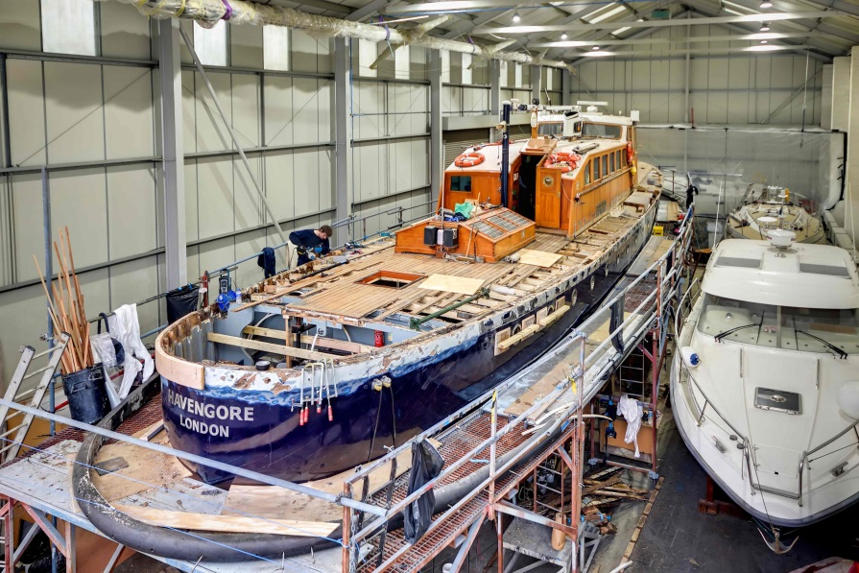

Sika’s professional marine deck caulking system, Sikaflex® 290 DC PRO has been chosen by Fox’s Marina and Boatyard for the deck restoration of one of the country’s most famous motor launches, MV Havengore. Famously used for carrying the body of [Sir Winston Churchill](https://en.wikipedia.org/wiki/Sir_Winston_Churchill) along the River Thames during his [State Funeral](https://en.wikipedia.org/wiki/State_Funeral), the classic launch is currently undergoing an extensive restoration of its deck and associated structure at Fox’s Marina & Boatyard’s refit and repair facility in Suffolk.

An important part of Havengore’s restoration is the replacement of its outstanding oak deck beams. To ensure the deck remains watertight and durable over a long period of time, Sikaflex® 290 DC PRO was the primary choice for this part of the refurbishment. Used by the majority of the world’s most reputable boat builders, Sika’s marine caulking systems are renowned for setting the benchmark for deck caulking.

Extensively tested during a two and a half year development program, Sikaflex® 290 DC PRO is primarily used for sealing watertight joints in traditional timber for boat construction. It offers extremely strong performance, fast curing times in low humidity and excellent weather and UV resistance.

Managing Director, Fox’s Marina & Boatyard, Will Taylor-Jones said, “"Having worked alongside Sika for many years, the team at Fox’s Marina & Boatyard has built a solid and trusted relationship, whilst enjoying excellent technical advice and the extensive range of Sika marine products.  Havengore’s deck - 22mm thick, solid teak, laid and over coated - is slightly different from a modern bonded deck, but following extensive testing alongside Sika’s technical department, we are confident that Sikaflex® 290DC PRO will provide the best solution for this outstanding, but challenging project."

Gareth Ross, Sika’s Marine Market Field Specialist said, “The restoration of MV Havengore’s decks provide’s the perfect opportunity for us to demonstrate the effectiveness of our new professional caulking system. Introduced last year as the successor of Sikaflex® 290 DC, we believe that Sikaflex® 290 DC PRO is the most effective premium caulking product available in the industry today.”

MV Havengore is currently used as a classic, ex Port of London survey vessel and her permanent home berth is St Katharine Docks on London’s River Thames. She is also used for corporate hospitality and is often called upon to take part in various ceremonial duties on the River Thames. Restoration is planned for completion in July this year.

Ends

Further press information & images from:

Karen Bartlett

Saltwater Stone

Tel: +44 (0) 1202 669 244

E: [k.bartlett@saltwater-stone.com](mailto:k.bartlett@saltwater-stone.com)

**Notes to Editors:**

Sika Limited is a wholly owned subsidiary of Sika AG, a global company based in Switzerland specialising in the manufacture and supply of chemical based products for construction and industry. A world-leader in its field Sika has subsidiaries in more than 70 countries, generates annual sales of CHF 4.6 billion and is committed to providing quality, service, safety and environmental care.

In the UK, Sika provides market-leading solutions for flooring, sealing and bonding applications, waterproofing, roofing, structural sealing and strengthening and many other construction applications.

Sika’s head office is based in Welwyn Garden City at Watchmead, Welwyn Garden City, Hertfordshire, AL7 1BQ. Call 01707 363866, or visit [www.sika.co.uk](http://www.sika.co.uk).