Press release
Düsseldorf, 11/03/2024
How crystalline solar modules are manufactured: insights into the production process
With around 11% of the EU’s electricity generation coming from solar energy in 2024, it has for the first time surpassed coal-fired power generation. For photovoltaics to continue expanding its role in the energy transition, solar modules must be produced efficiently, cost-effectively, and in large quantities. Automated manufacturing processes play a key role in achieving this. How crystalline solar modules are manufactured—from the electrical interconnection of solar cells to the final quality control …
Solar energy is a cornerstone of the energy transition, and crystalline solar modules dominate the market due to their efficiency and durability. To ensure economic large-scale production, automated manufacturing processes are essential. From precise stringing of solar cells to the lamination process and final quality control, these are the key steps in modern solar module production.
Introduction: crystalline solar cells and module structure
Crystalline silicon modules are the most widely used technology in photovoltaics. They are composed of multiple solar cells, which in turn are made from silicon wafers. These wafers contain doped silicon, which enables charge separation through the targeted addition of foreign atoms. Thin metal contacts—known as busbars and fingers—conduct the generated electricity. The fine fingers collect the electricity across the entire cell surface and pass it on to the busbars, which act as current collectors for further electrical transport.
A solar module consists of multiple interconnected solar cells. To protect these delicate cells from mechanical and environmental influences, they are embedded in multiple layers. A glass plate at the front ensures stability, while a plastic film (usually EVA = ethylene vinyl acetate) serves as encapsulation material. The rear side consists of either an additional protective polymer film or a second glass layer, which also houses the junction box that transmits the generated DC power. An aluminium frame encases the module, providing stability and facilitating installation.
The production of a solar module – step by step
The production of silicon wafers is a highly specialised process, typically carried out by high-tech companies. The actual production of solar modules begins with finished solar cells, which are already doped and coated with an anti-reflective layer.
Step 1: connecting the solar cells – the stringer process
The first step in solar module production is connecting individual solar cells. This process, known as stringing, involves soldering the cells together using thin copper ribbons over their busbars. The cells are arranged in rows—known as strings. Precision is crucial to avoid breakage and microcracks in the delicate silicon cells. The soldering process must be optimised to minimise mechanical and thermal stress.
Step 2: cutting and layer positioning – the layup process
After all layers of the solar module—glass, EVA film, strings, and the backsheet—have been cut to size, they are precisely stacked in the next step. This process is known as layup. The automatic placement ensures a positioning accuracy of ±0.1 mm.
Step 3: lamination
Once positioned, the individual layers are fused into a stable and durable unit—a process known as lamination. During this step, the module is heated in a vacuum bag or autoclave, typically to around 140°C, while either negative pressure or overpressure (up to 10 bar) is applied. During this process, the previously milky EVA film polymerises into a clear, cross-linked plastic layer, ensuring permanent adhesion between the solar cells, glass, and backsheet.
Step 4: edge trimming and framing
After lamination, the module is prepared for final use. The first step is edge trimming, where excess material—such as EVA film and the backsheet—is removed. The junction box is then installed. In the final step, the aluminium frame is attached to provide mechanical stability and facilitate installation. The frame is fixed using silicone or specialised adhesive tape.
Step 5: quality control and classification
Before a solar module leaves production, it must undergo extensive testing. A solar simulator measures the electrical performance, while electroluminescence and insulation tests detect potential defects or material flaws. Finally, the modules are classified by performance rating, packaged, and prepared for distribution.
Cost pressures in solar module production
The solar module industry is under immense cost pressure. While the demand for renewable energy continues to rise, government subsidies in many countries have been reduced or eliminated. Additionally, competition—particularly from Asian manufacturers—has further intensified the market landscape.
To remain economically competitive, manufacturers in Europe and elsewhere must reduce production costs—without compromising quality. One way to achieve this is by using pre-owned production equipment. Until 27 March, various solar module production machines are available for auction at Surplex.

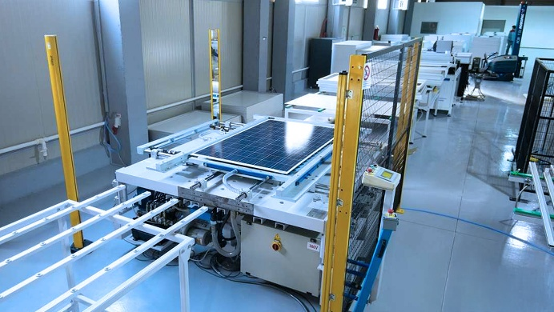 | Photo 1  Automated solar module production is key to reducing costs—and accelerating the energy transition.  (© Surplex).
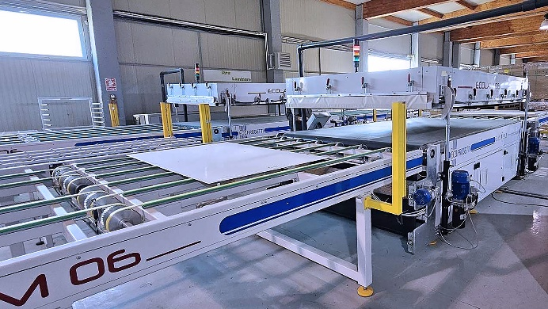 | Photo 2  During lamination, the individual layers of the module—glass, EVA, strings, and encapsulation materials—are fused into a single unit.  (© Surplex).
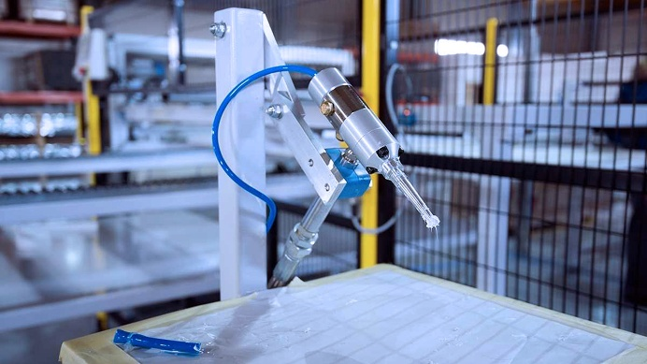 | Photo 3  Precision silicone application ensures a secure aluminium frame attachment to the solar module.  (© Surplex).

