News Release

GREAT NEW PLACES AT CLARKE QUAY –
INJECTING FRESH CONCEPTS FOR
A UNIQUE & DYNAMIC DINING AND ENTERTAINMENT EXPERIENCE!

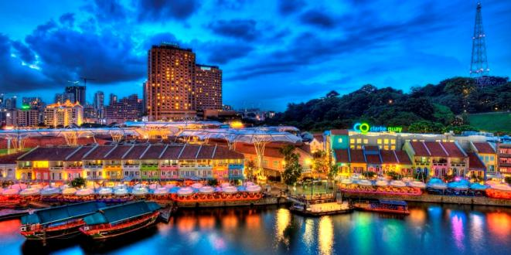

Singapore January 2016 - Clarke Quay, Asia’s leading riverside F&B and entertainment hub, is amping up its hip factor with the introduction of new nightspots and eateries.
Keeping the visitor experience fresh and exciting, Clarke Quay continually looks out for new concepts and tenants to add to its tenant mix. These include three tenants in Block A – McGettigan’s, an authentic modern Irish pub from Ireland; Motorino, a popular pizza joint from New York; and Catch Beer & Batter, a new home grown eatery offering fish and chips, which opened in the first half of 2015.

Following that, Block A welcomed two new concepts to Singapore; namely The Butchers Club Burger, one of Hong Kong’s best burger joints serving gourmet burgers with dry-aged beef, and Faigo Hotpot (小辉哥火锅) – a well known and popular chain of premier hotpot restaurants from China.
In the coming months, Clarke Quay’s Block C will unveil six new F&B and entertainment concepts operated by seasoned local and overseas operators to meet the needs of both partygoers and families alike. These tenants include DV8 Club, a top notch live Mandopop concert club; Warehouse, a restaurant and bar with live music; Privé Clarke Quay, a new concept by Privé Group; Maziga Café & Bollywood Club, an Indian restaurant helmed by the team behind the famed Punjab Grill; and the highly anticipated Ramen Keisuke Lobster King. Zouk completes the new line-up at Block C.
These new offerings reinforce Clarke Quay’s position as Singapore’s most popular riverfront F&B and entertainment hub and a must-visit destination for locals and tourists to wine, dine and have an enjoyable time. Last year, Clarke Quay was awarded the 2015 Certificate of Excellence by TripAdvsor and identified as one of 50 iconic places to visit in Singapore, based on the travel website’s data on the most-reviewed attractions and eateries. With the expanded offerings, party-goers, as well as families and friends bonding over good food and quality ambience will be able to find an ideal venue out of Clarke Quay’s over 55 restaurants, wine bars and entertainment outlets.
(Refer to Appendix for full listing of new tenants)
Looking ahead to the rest of the year, Clarke Quay’s will continue with its signature activities which include value Set Lunch and Happy Hour promotions, Halloween and the New Year countdown party. Visitors can also look forward to the Clarke Quay Music Festival scheduled for May to July this year that will showcase a stellar line-up of local and regional bands together with delectable food and drinks.
###

Media contact
Elene Foo (Ms)
Manager, Marketing Communications
Clarke Quay
Tel : +65 6557 7063
Email : elene.foo@capitaland.com

Website: www.clarkequay.com.sg
Like us on Facebook: https://www.facebook.com/ClarkeQuay
Follow us on Instagram: https://www.instagram.com/clarkequaySG/

List of New Entrants to Clarke Quay

Faigo Hotpot 小辉哥火锅
Block B, #01-06/07

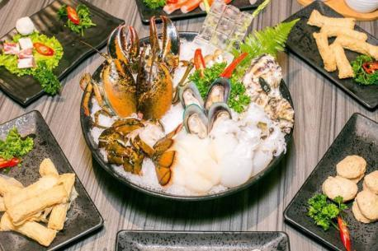
Founded in Shanghai, the well-known and popular premier hotpot chain from China - Faigo Hotpot 小辉哥, arrives in Singapore with its first outlet in Clarke Quay.

This premium hotpot concept uses high quality ingredients and a wide variety of soup bases, to cater to any palette.

The Butchers Club Burger
Block A, #01-01
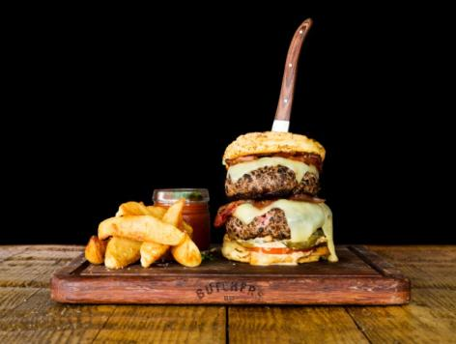
Founded in April 2013, The Butchers Club established itself in Hong Kong bringing the trend of dry-aged beef from the US and Europe to Asia – making a dream come true for foodies.

Following on from the firm’s strong belief to use the whole animal – nose to tail – The Butchers Club Burger was born in Wan Chai in May 2014, later expanding into Central in December of that year. With the vision to spread the trend of dry-aged beef beyond Hong Kong, the group established its first international outlet with The Butchers Club Burger in Bali in December 2014. The Butchers Club Burger opened in Singapore at Clarke Quay in November 2015.

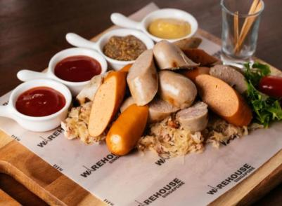
Warehouse
Block C, #01-09
A relaxed venue with live music every night, Warehouse caters to a more mature crowd with an eclectic menu of both Asian and Western favourites served on platters for sharing, an extensive wine list from around the world and the only place in Clarke Quay to get a pint of UK brewed Fullers London Pride, on tap!
Warehouse is also home to one of Singapore’s best rock bands Tania. Headed by legendary guitarist Zul, they have become famous for covering classic rock hits from Pink Floyd to the Beatles and can be found playing live on Monday, Thursday, Friday, Saturday and Sunday nights.
DV8 Club
Block C, #02-04
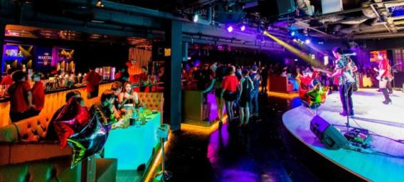
DV8 Club aims to be a top-class destination club for connoisseurs of the Asian music scene. Courageous in the face of the unfamiliar, DV8 Club will bring to the discerning party goers at Clarke Quay an all new experience in its live Mandopop and Cantopop concert and dance club entertainment concept.
Showcasing top Asian acts that include quarterly performances from A-list artists and live performances from its pool of local and regional club talents. DV8 Club aims to deliver high standards of quality content and reinvent Asian nightlife entertainment in Singapore.
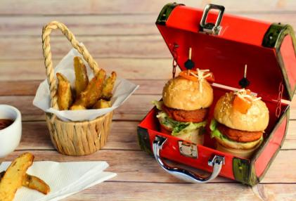
Maziga Café & Club
Block C, #01-10 / #02-03
A dining experience at Maziga takes patrons on a culinary journey through the diverse flavours of India. The smoky flavour of dishes coming straight from a tandoor to the dining table is an experience to be had. Augmenting the experience is the food presentation, as the dishes are presented in unique combinations, promising an exotic burst of flavours.
Helmed by the team behind the famed Punjab Grill, Maziga Café presents Indian food in formats and flavours which most have not experienced before. Maziga Club is located right above Maziga Café, where one can dance to the beats of the best Bollywood music.

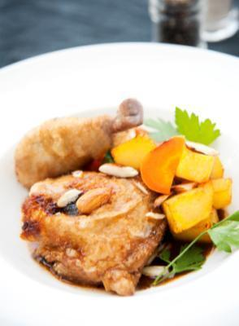
Privé Clarke Quay
Block C, #01-09A
Privé Clarke Quay is an exciting new one-stop food, cocktail and entertainment venue located in the heart of bustling Clarke Quay. Bringing together The Privé Group’s refined, casual dining and quality service with specially crafted drink presentations, interactive events, live music, and a late night DJ driven party, Privé Clarke Quay promises to entertain your senses.
Privé Clarke Quay takes its beverage programme seriously. In addition to the premier list of vodka cocktails, here one will find specialty crafted cocktails and an extensive frozen drink menu. Guests will have an opportunity to be their own bartender and order individual personal beer kegs that will be placed at their table in 1.8L (starting at $60) or 4L (starting at $128) for sharing among friends.

Ramen Keisuke Lobster King (Opening Soon)
Block C, #01-07
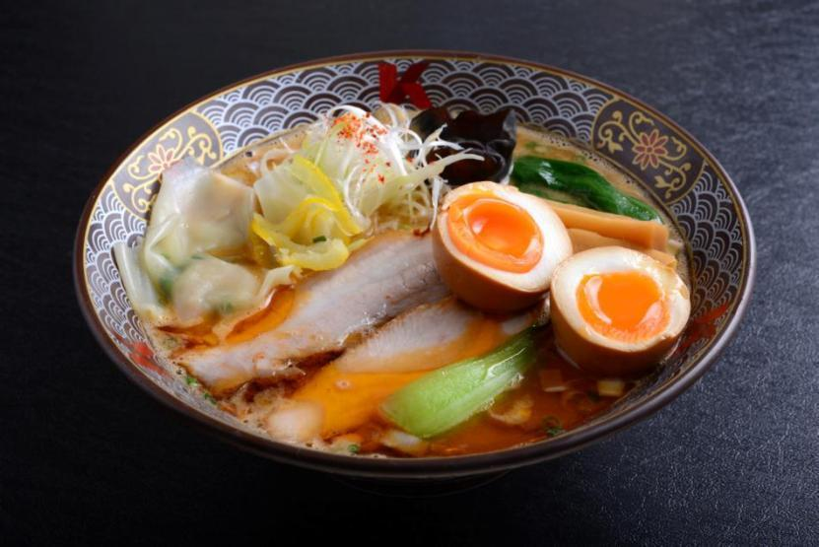
Ramen Keisuke Lobster King hails from the highly popular ramen chain Ramen Keisuke. Often billed as one of the top ramen brands in Singapore with its legendary queues, Ramen Keisuke fans can look forward to new and exclusive lobster broth ramen creations at this outlet in Clarke Quay.
Ramen Keisuke Lobster King is poised to create yet another buzz in the ramen scene when it opens its doors in Clarke Quay in Q1 2016.

Zouk (Opening Soon)
Block C, #01-05, #02-05/06
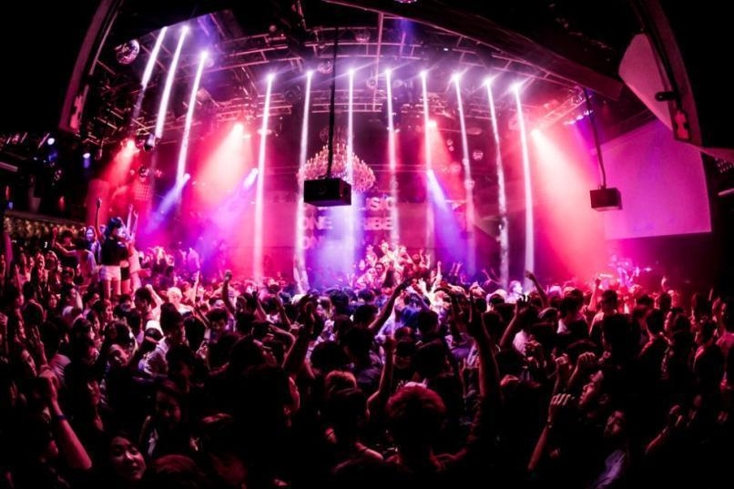
Zouk is a 24 year-old music-driven entertainment institution that provides a world-class clubbing experience by pushing the boundaries of electronic dance music and bringing in a constant flow of internationally renowned DJs such as Hardwell, Tiesto and Disclosure just to name a few. With the mission to remain forward thinking,
Zouk strives to be the pacesetter in propelling Asia’s dance music scene forward and leading Singapore to the forefront of global clubbing culture by balancing edginess and uniqueness with viable commercial success and continued support for the local music, arts and fashion communities.
Our focus is to provide the highest standards of service satisfaction while assuring ample security and safety, and at the same time, delivering a matchless and unforgettable visitor experience for all customers.

– End –

