Jessica Bäckman takes her fourth victory in ADAC TCR Germany at Salzburgring
Last weekend, June 17-19th, Jessica Bäckman took her fourth victory of the season in Race 2 at the Salzburgring track in Austria. After engine failure during Friday and Saturday and minimal driving time, Jessica managed to show what she can do on Sunday when the car is running properly. She has now won a total of 4 out of 6 races this season and is now 8 points behind championship leader Martin Andersen in the championship table.
- The weekend has been a roller coaster, everything from engine failure to Pole Position and my fourth victory of the season. For a while I did not know if I would be able to drive all weekend considering all the issues, so with this in concern, I am incredibly happy that I managed to round off the weekend on top, Jessica Bäckman says.
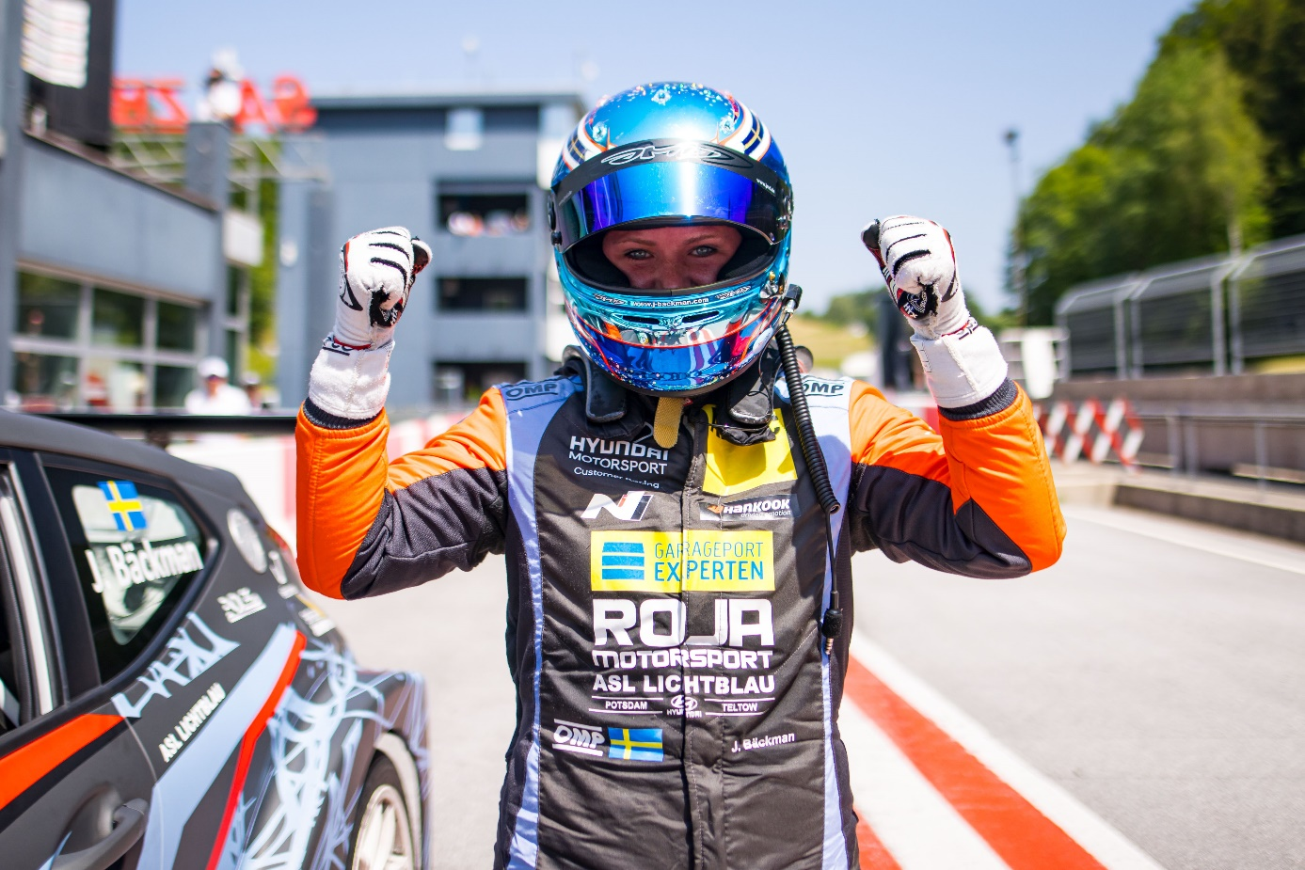
TCR Germany is one of the toughest TCR series in the world and has a high status of drivers coming from several different countries around Europe. Each race weekend is built on two free practice sessions on Friday, one time qualifying on Saturday which determines the starting position in Race 1 on Saturday, and one time qualifying on Sunday which determines the starting position in Race 2 on Sunday. Points are awarded to the top 8 in the time qualifying’s and the top 15 in each race. The driver with the most points after the last race at the Hockenheimring at the end of October will take home the driver title "ADAC TCR Germany Drivers Title" in the ADAC TCR Germany series. Last weekend, June 17-19th, the third race was run on the Salzburgring track in Austria, where Jessica had an engine failure that resulted in an engine change on Saturday and a start from the last position in Race 1 and drove up to a solid fifth place. Then on Sunday when the car and engine worked properly without technical issues, Jessica took her first Pole Position on the qualifying 2, which she then followed up with a Race win by over 5 seconds margin, topped with the fastest lap time in the race. Jessica is still 2nd in the Championship with 8 Points behind the leader Martin Andersen.
Engine failure on Saturday for Jessica Bäckman
Jessica's weekend started with engine trouble from the first practice session, which then continued in the second practice and eventually resulted in an engine failure. This meant that the mechanics had to work late into the evening to change the engine so Jessica could drive the time qualifying on Saturday morning. Jessica started the qualifying with her new engine, but it did not take long before the same problem arose again, which meant that Jessica had to cancel the qualifying. During the long break between the qualifying and the race, the team did not know if Jessica would be able to drive the rest of the weekend, as there was something else wrong, but after careful searching, they finally found the problem and Jessica could drive the race The Sweden National Team driver started from the last starting position due to the engine change, and then drove up to a nice fifth place in Race 1 after many good overtaking’s.
-Extremely tough start to the weekend, for a while I did not know if I would be able to drive the rest of the weekend. It was nice that we finally found the fault and that I could drive myself up to a fifth place, and then I knew that I had new chances for top places on Sunday, Jessica Bäckman says.
﻿
﻿
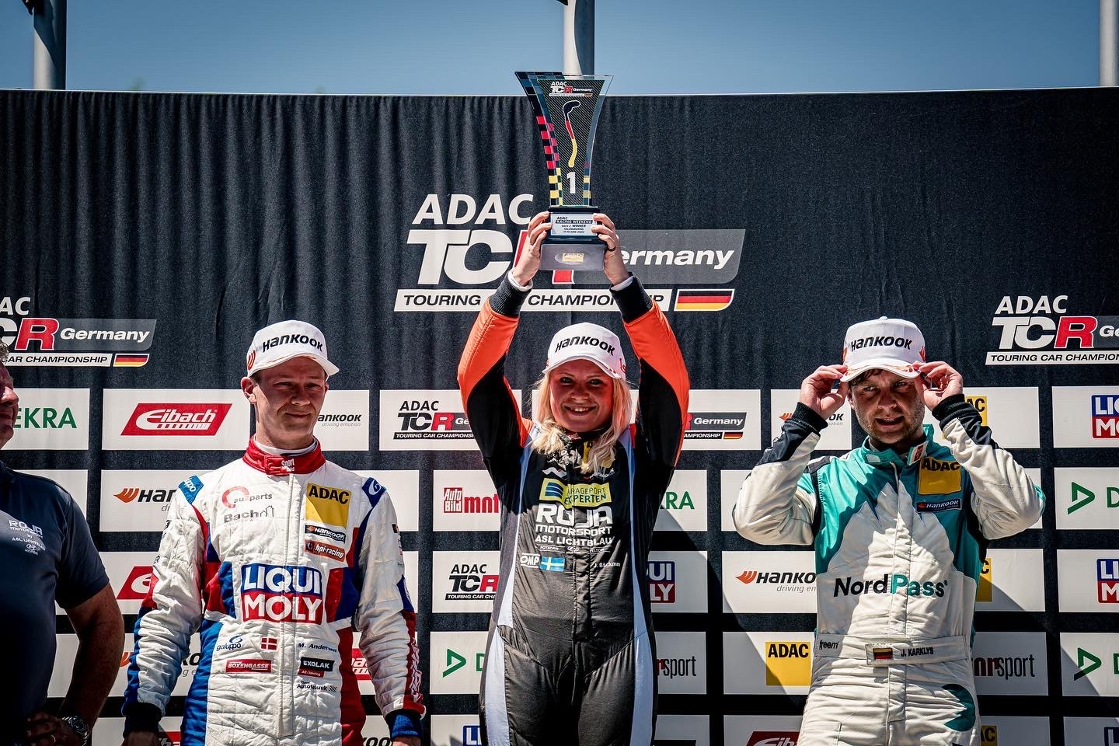
﻿﻿
Pole Position and fourth victory of the season for Jessica Bäckman
During qualifying 2 on Sunday, Jessica was charged to get revenge after the rough start to the weekend. With a little driving in the car, she did not know what to expect, but it turned out to go well. Jessica managed to take her first Pole Position by almost 2 tenths of a second in margin. Then in the Race from the first starting position, Jessica managed to get a very good start that she then could control all the way to the finish. When she crossed the finish line, she had won with over 5 seconds, adding a fastest lap time to that glory, Jessica was satisfied with the end of the weekend.
-Everything was falling in place on Sunday, the car was perfect both during the qualifying and the race, and I was able to drive home another important victory. The facts that I now have 4 wins out of 6 possible already this season just feels indescribably good. Nice receipt that once the car runs as it should without technical issues, I'm up there. It bodes well for the rest of the season, Jessica Bäckman says.﻿
Jessica’s results:
Free Practice 1: 5th place
Free Practice 2: No laptime
Qualifying 1: 6th place
Race 1: 5th place
Qualifying 2: 1st place
Race 2: 1st place
Championship standings:
ADAC TCR Germany – Total (Top three)
ADAC TCR Germany 2022 (after 3 of 7 rounds)
1: Martin Andersen (DKK), 164 p.
2: Jessica Bäckman (SWE), 156 p.
3: Szymon Ladniak (POL), 137 p.
Click to watch the full Championship standings
TV links in case you missed last weekend’s races:
TV link for Race 1
TV link for Race 2
Free rights to use images.

