Epson launches new high-speed dye-based production signage printer, the SureColor SC-B9070

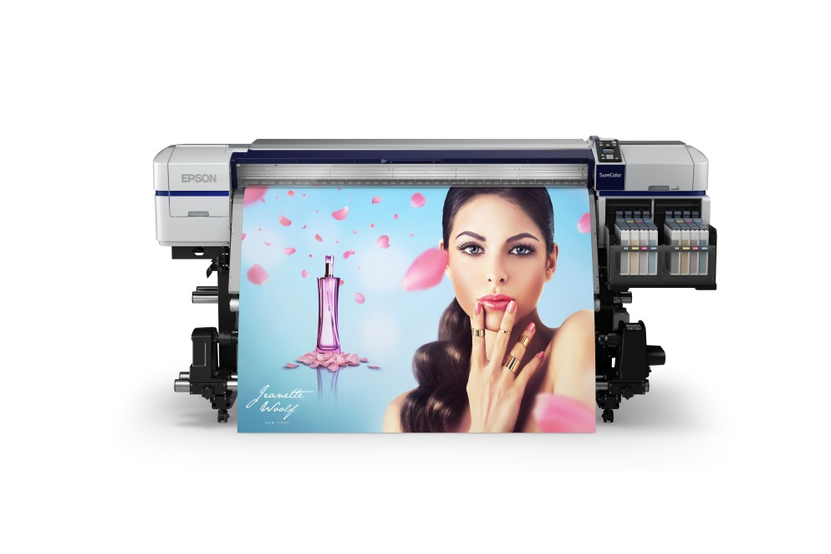
SureColor SC-B9070 Signage Printer

Kuala Lumpur, Malaysia, October 12, 2017 – Epson, a leading professional printing solutions provider, has launched the new SureColor SC-B9070 signage printer. A high performance dye-based production signage printer, the SC-B9070 is Epson’s fastest B-series signage printer and is ideal for use for high-volume and short term indoor signage installations for retail and advertising.

With its dual PrecisionCore Thin Film Piezo printheads, the new SC-B9070 signage printer delivers high speed printing and increased productivity to businesses, printing at a maximum speed of up to 100sqm per hour. The PrecisionCore TFP printhead nozzles enable multi-size dot control for precision printing for high-volume printing applications, delivering outstanding print quality.

The SC-B9070 signage printer comes with large 1.5L capacity ink tanks, which reduces the frequency of ink refills while enabling high-volume printing for increased efficiency. The high-volume ink tank system helps to lower total costs of ownership for greater cost savings to customers.

The SC-B9070 printer comes with advanced image processing technology, Epson’s Precision Dot Technology, that delivers high quality precision printing – Epson’s Half Tone Module, Look Up Table (LUT) and Micro Weave technologies that help to reduce graininess and banding and ensure smooth colour gradation for brilliant colours and exceptional quality prints.

The SC-B9070 printer’s precise media feeding system ensures continued stable printing for high reliability and minimum downtime. The Advanced Auto Tension Control (AD-ATC) feature and an automatic initial skew correction ensure smooth media feeding and minimal errors for high volume production. The after heater of the printer improves ink drying performance, reducing risk of wet ink transferred to the roll.

The printer comes with Epson Edge Print, a dedicated RIP software with a flexible and user-friendly interface for enhanced workflow, for image editing and colour management. It comes with the Epson Control Dashboard software that enables control of up to 4 printers, providing remote maintenance, real-time monitoring of consumables and other updates.

“The new SC-B9070 is feature rich dye-based production signage printer that delivers high quality prints, bringing enhanced business value to customers looking to boost their productivity and efficiency. We are confident this product will meet the high demands of our customers to deliver high volume output in the outstanding quality that they expect,” said Danny Lee, General Manager, Sales & Marketing, Epson Malaysia.

***

About Epson
Epson is a global technology leader dedicated to connecting people, things and information with its original efficient, compact and precision technologies. With a lineup that ranges from inkjet printers and digital printing systems to 3LCD projectors, smart glasses, sensing systems and industrial robots, the company is focused on driving innovations and exceeding customer expectations in inkjet, visual communications, wearables and robotics.
Led by the Japan-based Seiko Epson Corporation, the Epson Group comprises more than 72,000 employees in 91 companies around the world, and is proud of its contributions to the communities in which it operates and its ongoing efforts to reduce environmental impacts.
http://global.epson.com/

About Epson Southeast Asia
Since 1982, Epson has developed a strong presence across major markets in Southeast Asia. Led by the regional headquarters Epson Singapore, Epson’s business in Southeast Asia spans an extensive network of 11 countries with a comprehensive infrastructure of close to 500 service outlets, 7 Epson solution centres and 7 manufacturing facilities. http://www.epson.com.sg

About Epson Malaysia
Epson Malaysia Sdn Bhd was established in Malaysia in 1991 as Epson Trading (M) Sdn Bhd, a sales company of the Seiko Epson Corporation, Japan. The company has exclusive rights to market, distribute and support a complete range of leading-edge Epson consumer and business digital imaging products in Malaysia and Brunei. Today, Epson Malaysia has 84 employees and an extensive network of 59 authorised service outlets nationwide. For more info, please visit www.epson.com.my or connect with us at www.facebook.com.my/EpsonMalaysia

Media Enquiries:
Epson Malaysia Sdn Bhd  Chua Li Tinn  Manager – Marketing Communications  Tel: (03) 5628 8288 Ext 274  Email: ltchua@emsb.epson.com.my | SWOT Communications Sdn Bhd  Vino Nair  Tel: 016 3656268  Email: vino@swotcommunications.com

