**Made in Britain, yoomi shows how it can be done...**

Nov 2013, London

Young British baby brand, yoomi, the creators of the world’s first self warming baby bottle continues to grow from strength to strength. Designed and manufactured in Britain, yoomi is currently selling in 16 countries across the globe, grabbing the attention of parents and retailers worldwide - yoomi is showing that innovative British design and manufacturing is still in demand around the world.

Yoomi was created by Farah and Jim, a mum and dad whose experiences of bottle warming (stumbling around the kitchen in the early hours and begging waiters for hot water) inspired them to look for a better solution. A stylish bottle and warmer in one, yoomi cleverly warms baby’s feed to the perfect temperature of breast milk in just 60 seconds... at the touch of a button.

The clever invention has not only received the thumbs up from the British consumer and industry experts, winning Gold and Silver in the Loved By Parents Awards for 3 years running and Gold at the Baby and Nursery Trade Awards this year, but is now being recognised by The British Library as an example of how British innovation can revitalise economic growth.

Yoomi was invited to showcase its innovative feeding range at two high profile events held at The British Library this month. The first was at the launch of the ‘Business is Great’ campaign at which yoomi was introduced as a fast growing British manufacturer to Vince Cable MP, Secretary of State for Business, Innovation and Skill and Matthew Hancock MP, Minister of State for Skills and Enterprise.

The second, and arguably the more exciting, was to be presented to HRH The Duke of Edinburgh, as a young British business to watch.

Commenting on this success, Dr Jim Shaikh, CEO, said:

‘Yoomi is proud to be seen as a fine example of British design, innovation and manufacturing. We are delighted that the Government is getting behind small businesses who are the foundation for jobs and growth in the next decade. We were thrilled by the level of interest shown by Prince Philip and Vince Cable MP. Without this recognition and focus, small businesses will not reach their full potential”

END

**Notes to Editors:**

**For more information or to request images or arrange an interview with the inventor please contact Michaela Middleton on** [**michaela@yoomi.com**](mailto:michaela@yoomi.com) **or call 0208 853 9835**

**A bit about yoomi:**

* **flexible:** the yoomi bottle can be used on its own or with a yoomi warmer. Combined with a warmer, yoomi gently warms baby’s feed to breast milk temperature in just 60 seconds!
* **safe**: as well as being entirely BPA free, yoomi means no more guesswork and no more overheating the feed. The warmer has been specially designed to warm to the exact temperature of breast milk every time preserving the nutrients in every drop of baby’s feed
* **convenience, always**: when baby is hungry, there’s no time to waste, yoomi can be used anytime, anywhere, anyplace
* **no-fuss latch on**: thanks to its natural breast shaped and super-soft silicone teat, yoomi allows for a breast-from-breast experience
* **transition sorted**: unlike any other bottle, the consistent breast milk temperature and warm teat ensures babies have the familiarity they need to support weaning from breast to bottle and back again
* **reduced likelihood of colic**: with its 6 anti-colic vents (most bottles have 1-3) yoomi is one of the best vented bottles on the market!
* **rechargeable:** the warmer can be used 150 times! Using patented technology, the yoomi recharging pod enables warmers to be recharged in the microwave in approx 2 minutes

**The technology:**

The yoomi warmer, which contains the same gel used in hand warmers, is activated by simply pressing the orange button. By using a clever ‘phase change’ material (meaning it changes from a liquid to a solid) yoomi generates heat. The cold feed is gently warmed as it flows through the specially designed channels on the outside of the warmer. By the time the feed reaches the teat, it is at natural breast milk temperature (32-34˚C). The warmer has been cleverly designed so that it cannot overheat the feed and stays warm for up to an hour.

**About Jim Shaikh:**

Jim Shaikh is an entrepreneur and CEO of yoomi Ltd. Jim completed a Masters in Engineering at Imperial College (1988) before obtaining a PhD from Cambridge University (1993). Initially an academic, Jim quickly moved into mainstream engineering with Rover-BMW and then into consulting engineering. He completed an MBA at London Business School (2003) and was bitten by the entrepreneurial bug when awarded first prize at the LBS Entrepreneurship School. Jim is married to Farah, a lawyer, they have two sons, Danial aged ten and Niall aged six, and live in London, UK.

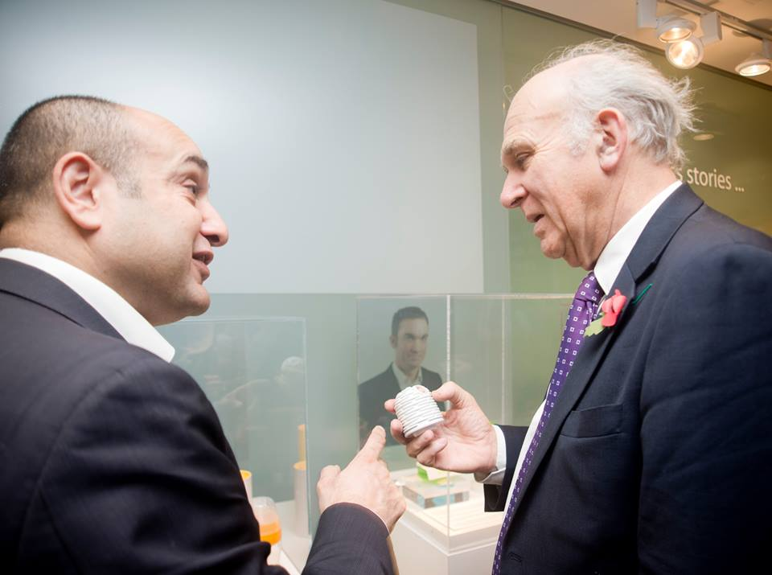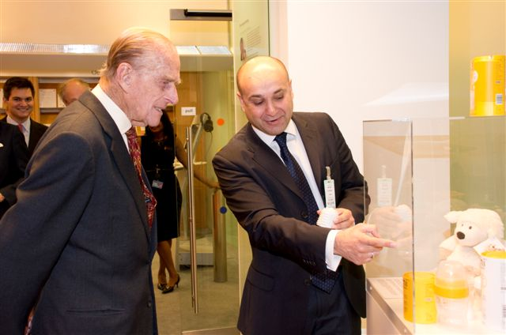 **Images:**