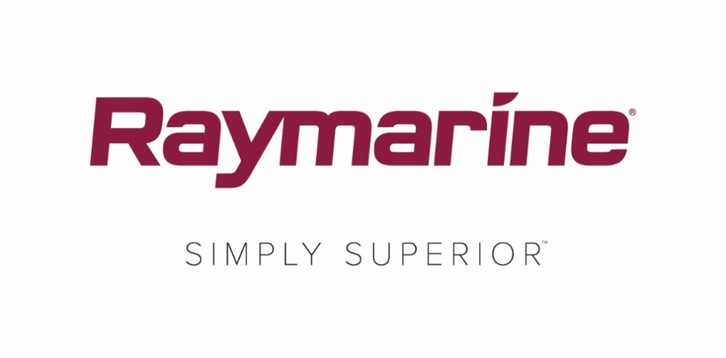

Raymarine to play a bigger role in the 2018 Round the Island Race in association with Cloudy Bay

Official Technical Partner, Raymarine, takes on the additional role as Official Tracking Partner

FAREHAM, UK – 10 May 2018 – Raymarine, a brand of FLIR Systems, has confirmed its commitment to the British sailing community by announcing its continued role as Official Technical Partner for the 15th consecutive year to the UK’s Round the Island Race in association with Cloudy Bay. Organised by the Island Sailing Club, the Round the Island Race is one of the world’s largest sailing events, regularly attracting more than 1,600 boats with more than 16,000 sailors from around the world.

As Official Technical Partner, Raymarine will once again team with leading marine meteorologist, Simon Rowell, to deliver the all-important pre-race weather strategy using the high precision Theyr weather and ocean forecasting app via Raymarine’s Axiom multifunction navigation system and powerful LightHouse 3 operating software.

For the first time, Raymarine will also take on the newly created role as the Race’s Official Tracking Partner. The safety of all participants is paramount to the organisers so this year they have announced that all boats must register a minimum of one mobile phone per team to enable them to sign up to use the Race’s live GPS tracking system. Although not mandatory, it is also recommended that participants transmit an AIS signal (Automatic Identification System), which not only enables safer tracking and accountability for the organisers but also offers enhanced benefits for the sailors who can enjoy post-race analysis through the bespoke tracking system.
As Tracking Partner, Raymarine will play an integral part of this year’s Race campaign - #ItsYourRace – encouraging racers of all levels to create a ‘race within the race’ by using the official live GPS tracker to select individual boats to follow and race against. Participants should register their phone for access to the GPS tracker here.
Speaking about their new role, Harry Heasman UK Sales and Marketing Manager for UK and Ireland said, “This is an exciting addition to the race for Raymarine and aligns with the brand’s expertise in electronics. AIS developments are enabling boaters to enjoy safer navigation than ever before. Raymarine are keen to support the safety of those on the water so we are also offering all participants £150 cash back on the purchase of a new Raymarine AIS700.”

Commenting on the sponsorship, Dave Atkinson, Head of Race Management for the Round the Island Race, said, “We are thrilled that Raymarine is supporting our quest to make this the largest and safest race in the world. We have worked with them for many years, so it felt right to have them on board as Official Tracking partner.”

Raymarine also confirms its continued sponsorship of the Round the Island Race’s Young Sailor’s Trophy, which is presented to the fastest young skipper the day after the race.

ENDS

Notes for editors

The 2018 Round the Island Race in association with Cloudy Bay takes place on Saturday 7th July 2017. www.roundtheisland.org.uk.

The Raymarine Weather Briefing takes place Friday July 6th at the Cowes Yacht Haven Events Centre at 6pm. Participants can register online at www.raymarine.co.uk/rtir for a reminder to watch online if they can’t be there in person.

About FLIR Systems, Inc.
Founded in 1978 and headquartered in Wilsonville, Oregon, FLIR Systems is a world-leading maker of sensor systems that enhance perception and heighten awareness, helping to save lives, improve productivity, and protect the environment. Through its nearly 3,500 employees, FLIR’s vision is to be “The World’s Sixth Sense” by leveraging thermal imaging and adjacent technologies to provide innovative, intelligent solutions for security and surveillance, environmental and condition monitoring, outdoor recreation, machine vision, navigation, and advanced threat detection. For more information, please visit www.flir.com and follow @flir.

Media contacts:

Karen Bartlett
Saltwater Stone
+44 (0) 1202 669 244
k.bartlett@saltwater-stone.com

