PrimaveraReader brings new features for Project Organizations
Introducing Baselines and Auto Filters as some of the new features in PrimaveraReader 3.1
Malmoe, Sweden (January, 2017) – After the successful introduction of the first .xer and .xls reader for Mac OS X, PrimaveraReader continues to bring new useful features for improving project team efficiency. The new PrimaveraReader 3.1 has Baselines, Auto Filters, Encoding in different languages, set Date formats and Collapse to WBS level.
“We are following the market needs and customer requests coming from different industries working with Oracle® Primavera P6. In year 2017 we have a fruitful roadmap of new releases that will find a great use and expand our features portfolio – Stojan Ganchev, R&D Manager.”
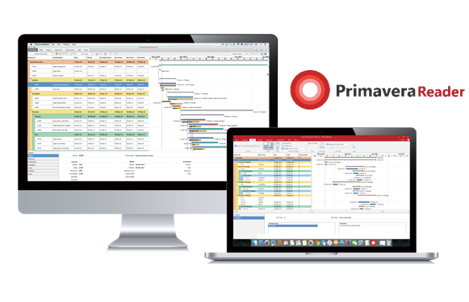
Most of the client organizations have totally replaced the flow of sending their Project Schedules in PDF files to their teams and replaced the flow with opening the native .xer file in PrimaveraReader.
New features
Baseline comparison of different project versions
Easy visual comparison of the Activity updates from previous .xer file version. This way the user automatically see the difference in bars, charts and what has been changed in the Project Schedules. It allows comparison of up to 4 different project versions by simply importing them where the software automatically compares by Activity ID. Video

Auto Filters
Auto filtering allows users to filter data in one or more columns based on the cell contents. You can select values from a list to control which activities you want to see or activates you may want to exclude from current schedule view.

Key product features:
- Complete preview of project data from .xer and .xls files
- Import custom layouts and user defined filters
- Display WBS, EPS and OBS views
- Resource Assignments
- Baseline comparison
- Dedicated customer support

As a reminders, PrimaveraReader allows users to open and view project data exported from Oracle® Primavera P6 in .XER or .XLS file format. PrimaveraReader is designed to deliver the well-known view of project information among all parties involved, providing quality of data, interactive views and complete preview of data. PrimaveraReader is applicable to all project oriented organizations, from smaller projects to large scale project and portfolio oriented enterprise corporations and is available for Windows and Mac OSX platform.
All interested parties can schedule a free demo session for further details or download a free 15 day trial.
To find out more about PrimaveraReader, visit: www.primaverareader.com

About the company:
Seavus is an international software development, outsourcing and consulting company with a proven track-record in providing successful enterprise-wide business solutions. The company has over 650+ IT experts worldwide and offers a variety of products and service options, successfully covering the European and US market from several offices in the world. Seavus’s expanding portfolio covers: Telecom BSS/OSS, Billing solutions, CRM, CEM, Business Intelligence and DWH solutions, Banking, Insurance and Financial platforms, Embedded solutions, Business and consumer products, Mobile and gaming solutions, Managed services, as well as custom development, quality assurance, consultancy and resourcing. The Seavus portfolio includes over 3,500 customers, including leading worldwide telecoms and handset manufacturers, organizations from the banking and finance industry, consumer electronics, technology, education, government, and health, to name but a few.
Seavus is a globally authorized master distributor for the software product family PrimaveraReader.
Products Marketing, Seavus Group
Phone: +46 40 645 9956
Email: productsmarketing@seavus.com

