NEW RENAULT CAPTUR:
THE B-SEGMENT
car for LIVING

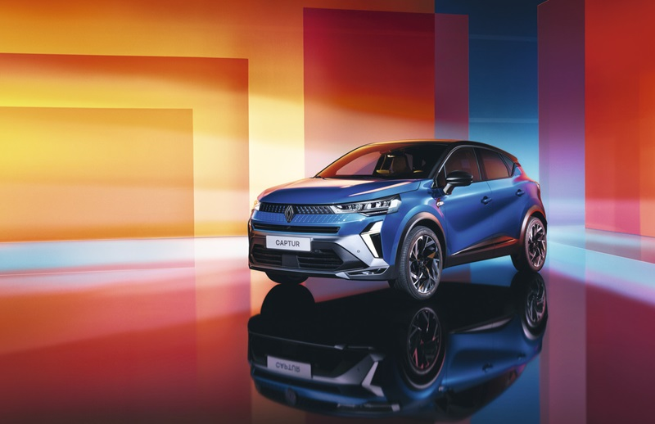

CONTENTS

CONTENTS 2
INTRODUCTION 4
EXTERIOR DESIGN
A MORE DYNAMIC LOOK 7
New front end 7
New light signature 8
A more contemporary rear end 8
Three options depending on the finish 8
Two-tone bodywork: 14 possible configurations 8
A wide range of new exterior accessories 9
INTERIOR DESIGN
A MORE ENJOYABLE RIDE AND A RICHER EXPERIENCE 10
Cutting-edge connectivity and multimedia technology with OpenR Link 10
New upholstery and a new Esprit Alpine finish 11
Exceptional interior space 11
Modular loading space 11
No leather or chrome 11
A complete offering 12
Soundscape by Jean-Michel-Jarre 12
Customisable interior ambience 12
Exclusive interactive content 12
POWERTRAINS:
A WIDE RANGE OF MULTI-ENERGY ENGINES 14
A complete range 14
The E-Tech full hybrid 145 engine in detail 15
Enhanced running gear and all-news tyres 15
Several driving modes with Multi-sense and Extended Grip 15
SAFETY AND DRIVING AIDS :
OFFERING THE BEST IN ACTIVE AND PASSIVE SAFETY 17
Safety score and safety coach 17
Active Driver Assist 18
Predictive hybrid driving 18
Other driving aids 18
ADAS customisable at a touch of a finger 18
TECHNICAL DATA SHEET 19
Dimensions 19
Powertrain characterics 20

INTRODUCTION

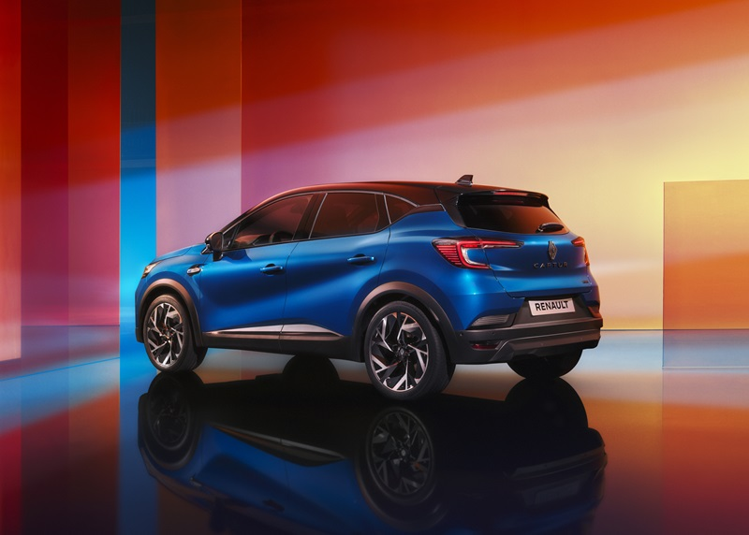Captur is the B-segment “car for living”. It is versatile and multi-talented, both compact on the outside (4,23m) and spacious on the inside, modular to adapt to the uses of customers, equally at home in the city or off the grid. Its high driving position is appreciated by the customers, allowing easy access to the vehicle and good visibility of the road. All these qualities explain the success of a car that has sold over two million units in 90 countries around the world since its launch ten years ago.

New Captur adopts the new design language initiated by Gilles Vidal, Renault's Head of Design. Playing on light and matter with taut lines and precise detailing, the new language creates a more stylish and dynamic effect. With its new front end, New Captur gains a more premium look.

New Renault Captur will continue to set the standard in urban SUVs, a market accounting for half of all sales in the B-segment, which itself makes up 30% of the total market. New Captur maintains its versatility, two-tone body colours and generous interior space, along with a range of ingenious high-tech equipment. Alongside these qualities, which are all part of its DNA, new-generation Captur gains a range of new features. More expressive inside and out, the styling delivers a unique twist of elegance and sporting spirit with the new Esprit Alpine finish. The cabin is showcased by new upholstery and new dashboard screens. Available depending on the version, the OpenR Link multimedia system with Google built-in provides the very best in on-board technology with Android Automotive 12, a world first in the B segment. The entirely new electronic architecture takes safety to new levels, with a range of latest-generation driving aids including the predictive hybrid driving function and Active Driver Assist, for Level 2 autonomous driving.

Depending on the country of sale, New Renault Captur will be available with a range of five engines, including the 145 bhp E-Tech full hybrid option, already selected by over 41% of customers in France. For enhanced driving pleasure and a more dynamic ride, the running gear has been revised and the power steering recalibrated. Depending on the version, the Extended Grip system optimises traction in all driving conditions.

Still built at the Valladolid plant, New Renault Captur will be available in Europe from April 2024.

More than 10 years ago, Renaut broke with the codes of the B segment by infusing Captur with the DNA of the "car for living". This vision has been embodied by a maximum of comfort: a high driving position, a livable interior that can be adapted to suit the lives of the driver and passengers. All this while remaining compact: 4.23m. Building on its success, with over 2 million vehicles sold, Captur continues to stand out from the crowd. It is even more in tune with the times, with a new, more assertive design, a E-Tech full hybrid engine, and OpenR Link with integrated Google. These are all useful technologies, and they're being acclaimed by our customers.

Translated with DeepL.com (free version)

Fabrice Cambolive, CEO Renault brand

While retaining the strengths that have made it a success to date, New Captur asserts its personality with new, more athletic and dynamic proportions.
The completely transformed, horizontal front end is both graphic and technological, giving it a strong stylistic identity.

Paula Fabregat, Design Projects Director, Renault

THE VALLADOLID SITE GETS READY FOR NEW CAPTUR
Renault has already built over 8 million vehicles in Valladolid (Spain) since 1953. The site has built 2.2 million Captur units since the launch of the first generation in 2013. Today, Valladolid is getting ready for New Captur while pursuing its transformation. Process digitisation and the arrival of artificial intelligence have significantly reduced the use of energy and water, while maintaining a focus on quality. The deployment of machine vision cameras and artificial intelligence improves traceability and response.
Finally, New Captur will undergo ‘Confirmation Run’ tests. To this end, 70 vehicles will be driven for a distance of 1 million kilometres ahead of market launch. The aim is to identify areas for improvement and to ensure that New Captur is on a par with the best in terms of driving pleasure, quality and reliability.
Exterior design
A MORE DYNAMIC LOOK

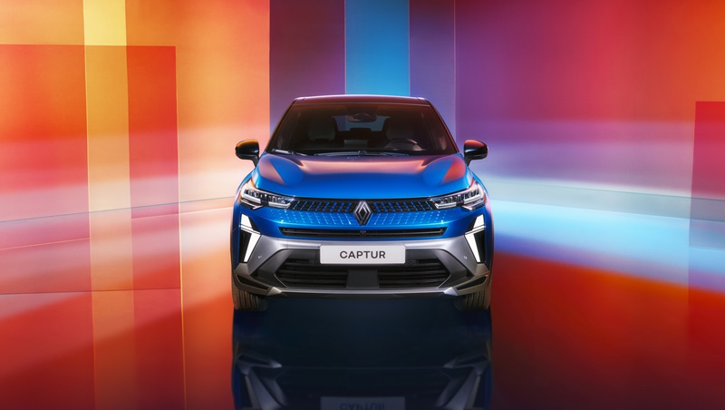Showcased by the new Rafale Grey bodywork and Esprit Alpine finish, New Captur takes on a more athletic look with premium styling The front end takes pride of place in the new design, its myriad reflections turning heads with a play on light and matter. Featuring a new light signature and two-tone bodywork offering 14 possible configurations, New Captur gains even greater appeal.
New front end
The new front end takes on a more elegant, more technological look, with the Nouvel'R one-piece logo built into the multi-faceted grille, and a higher, more horizontal bonnet. All these details underline the stronger identity of New Captur.
The upper part of the grille creates a play of light with its shapes in relief, and the contrast between the dark glossy background and the transparent inserts. This sets off multiple reflections across the radiator grille, like a wave rippling out from the diamond in the centre towards the headlamps and the bumper, with its tiny embossed parallelograms. A mesmerising visual effect created through a meticulous process of design involving light, matter and texture.
For purposes of engine cooling, the front end features a horizontal air intake above the aerodynamic splitter, with another in the bumper. Two air inlets positioned on either side of the front end, next to the daytime running lights, contribute to aerodynamics and the cooling of the front brakes.
This sophisticated new design contributes to the more upmarket feel of New Captur.

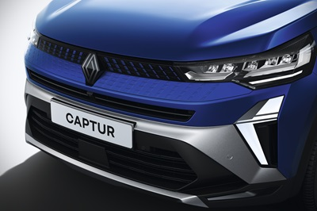
New light signature
The new front lights feature full LED technology as standard on all levels of trim. In the same way as on New Clio, the LED daytime running lights take on a vertical half-diamond shape, freely inspired by the brand logo. The headlights come to life in a new welcome sequence when the doors are unlocked remotely, creating a friendly, modern effect.

A more contemporary rear end
The rear light housing is now transparent, revealing the inside of the lamps. Combined with the new logo and redesigned diffuser, this feature gives the rear end a more contemporary look with a higher level of perceived quality.

Three options depending on the finish
The Evolution finish features 17-inch Flexwheel wheel embellishers (17-inch alloy wheels available as an option) with a matt black paint trim on the lower body and beltline long, black front and rear skid plates.
The higher Techno finish features all-new 18-inch alloy wheels and a High Gloss Black paint trim on the lower body and beltline.
The new Esprit Alpine finish is immediately identifiable, with its Ice Black logos, High Gloss Black window surrounds, 19-inch wheels of specific design and size, aerodynamic splitter and front and rear skid plates with Slate Grey matt paintwork.

Two-tone bodywork: 14 possible configurations
Six body colours are available: Pearl White, Oyster Grey, Starry Black, Gunmetal Grey, Iron Blue and Flame Red. The optional two-tone colour scheme is popular with customers, who can select Highland Grey, Starry Black or Perle Beige for the roof and door mirrors. This last colour is a new champagne hue. It is not available with the Esprit Alpine finish.
New Renault Captur is available in a choice of 14 colourful configurations.
Taking personalisation even further, the optional Exterior Colour Pack includes Highland Grey or Perle Beige door mirrors (High Gloss Black is standard), with front and rear skid plates and side mouldings in Highland Grey, Perle Beige or High Gloss Black.

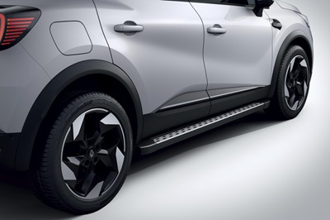
A wide range of new exterior accessories
New Captur can be personalised with a wide range of equipment available on order or through the aftersales network, including side lighting, running boards, a towing hook, a bicycle rack and backlit door sills.

INTERIOR DESIGN: a more enjoyable RIDE and a richer experience

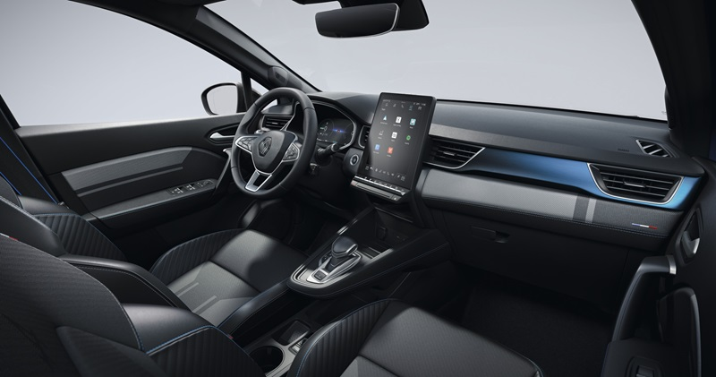
The more upmarket style of the outside is also visible on the inside. The cabin takes on a more modern look with the OpenR Link multimedia system and a new dashboard screens (up to 10.25 inches). With new upholstery on all trim levels, the car gains a more premium look and feel. Featuring a wealth of standard equipment for a sporty interior ambience, the new Esprit Alpine finish is an invitation to take to the road.

Cutting-edge connectivity and multimedia technology with OpenR Link
New Captur gains the OpenR Link multimedia system with Google built-in (depending on finish). It includes the best of onboard technology with Android Automotive 12. A world first for a B-segment vehicle.
In the centre of the main console, the new 10.4-inch vertical touchscreen (960 x 1280 pixels) lets users take full advantage of exclusive interactive content, together with a wide range of services (see page 13).
OpenR Link makes every journey easier. Simple to use and hyperconnected, it is as intuitive to use as a smartphone.
As well as being fully customisable, the interface is compatible with Android Auto and Apple Carplay for wired and wireless smartphone connectivity.
Google services such as Google Maps, Google Assistant, and over 50 (depending on the country) Google Play apps can be accessed at the touch of a finger, just like on a smartphone.

New upholstery and a new Esprit Alpine finish
The interior ambience is immediately modern and welcoming, with its all-new upholstery.
The grey and heather grey seat fabric on the Evolution finish gains yellow top-stitching on Techno, with a Renault diamond pattern (¾ view) on the interior side supports of the front seats.
The new Esprit Alpine finish features multi-textured grained cover material fabric on the seats and door panels and a blue-grey insert on the dashboard.
The cabin also makes many nods to the Alpine brand, a symbol of sporting elegance the French way, with the national flag in the side piping, seatbelts with blue top-stitching, aluminium-plated sports pedals, branded door sills and a special steering wheel.

Exceptional interior space
Passenger knee room at the rear is still among the best on the market, at 221 mm, thanks to a rear bench seat designed to slide back over 16 cm. An ingenious feature has become the hallmark of Captur. This allows users to create more space for cargo or passengers as required.
The cabin includes a total of 24.7 litres of storage space, including a 7-litre glovebox and, depending on the version, map pockets on the backs of the front seats.

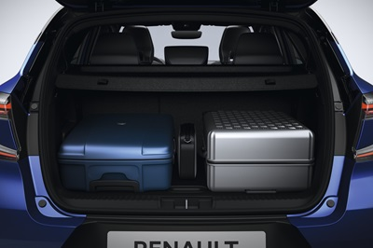
Modular loading space
In terms of boot capacity, New Captur ranks among the best on the market, with maximum volume of 616 litres (536 dm3 VDA) when the rear bench seat is pushed fully forward (a gain of 132 litres / 114 dm3 VDA).
The boot is modular, with a rear bench seat sliding over 16 cm and a removable floor creating a flat space. With the rear seats folded (2/3-1/3 split), the load length is 1.57m.

No leather or chrome
As well as limiting its use of chrome, Renault is replacing leather with grained cover material. This confirms the brand’s aim of completely phasing out animal-derived materials by 2025.
In New Captur, all the upholstery includes recycled fabrics selected for their small carbon footprint, without compromising on perceived quality, feel or comfort. The Esprit Alpine finish includes over 26% of recycled and recyclable fabrics in its upholstery, through the use of bio-sourced materials such as grained cover material and hemp.

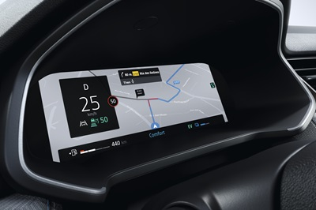
A complete offering
New Captur gains new dashboard screens measuring up to 10.25 inches (24x9 cm) diagonally, depending on the version. This size is compatible with the Navigation option, providing a colour display on the instrument cluster, facing the driver.
For real listening pleasure, the Harman Kardon hi-fi system, available depending on the version, includes nine speakers (two tweeters and two woofers at front and rear and a subwoofer in the boot). Delivering an immersive sound experience, it comprises five programmes specially created for Renault by Jean-Michel Jarre: Studio, Podcast, Concert, Immersion and Club.
Bathing the cabin in light, a glass sunroof is available as an option from the Techno finish.
For digital in-car entertainment, front passengers have access as standard to two USB-C sockets and a 12V socket (with another in the boot). Depending on the finish, two further USB-C sockets are available behind the central armrest for rear passengers, together with an induction charger in the centre console. This last feature is standard with the Techno and Esprit Alpine finishes.

Soundscape by Jean-Michel Jarre
As you enter the Renault Captur cabin, you can hear one of the two new welcome sound sequences, one of which is specific to the Esprit Alpine trim level. Jean-Michel Jarre, the internationally renowned French artist, composer and author, collaborated on the design of these sequences, as well as the new VSP (Vehicle Sound for Pedestrians). Available only with the 145 bhp E-Tech full hybrid engine, the VSP is a low-speed (up to 30 km/h) exterior warning sound for pedestrians. Jean-Michel Jarre was also involved in developing the two audio systems available: Arkamys Auditorim as standard and Harman Kardon as an option.

Customisable interior ambience
MULTI-SENSE settings can be accessed using the central touch-screen or a button on the steering wheel. Users can choose between four views for the digital instrument panel, five widgets (interactive apps or thumbnails), eight colours for the speedometer display and 48 colours for the LED ‘Living Lights’ mood lighting strips on the door panels.
To create a more relaxing mood, the colour of the lighting is adjusted automatically every 30 minutes based on the circadian cycle (24-hour biological clock) and the time of day (cool colours during the day, warm colours at night).

Exclusive interactive content
Renault is deploying exclusive connected services on New Captur, based primarily on partnerships with developers and content creators.
Ten unique apps specially designed for Renault users are already accessible via the OpenR Link multimedia system: Waze, Amazon Music, L'Equipe pour Renault (French-language app with content for France), Vivaldi, Radio Player for Renault, Kabriol, Karacal, Les Incollables for Renault, Easypark and Sybel.
At the same time, the smartphone app My Renault provides access to a library of content (depending on the country). Users can take advantage of exclusive offers and start downloading apps with the OpenR Link system.
With this level of connectivity, users can stay up to date without visiting their garage or dealership. With FOTA (firmware over the air) technology, the operating system receives updates and maintenance becomes predictive.

A wide range of multi-energy engines

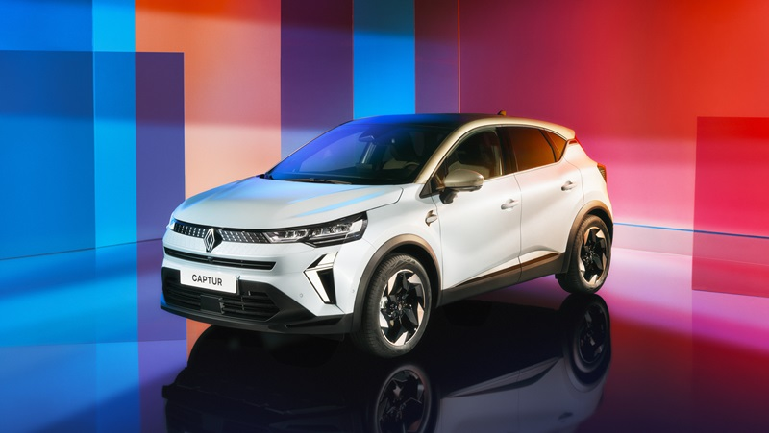New Captur is versatile in terms of both its interior design and its use. With a range of modern, efficient powertrains, it is equally at home in the city, on the motorway or on country roads. The 145 bhp E-Tech full hybrid engine meets the highest standards in fuel efficiency and CO₂ emissions, at just 105 g/km and is as quiet as an electric car in the city without the charging constraints. The dual-fuel petrol-LPG system offers a range of up to 1,100 km with two tanks. Traction can be optimized in all circumstances thanks to Extended Grip (available as an option only with 18-inch tyres for the full hybrid powertrain).

A complete range
Under the bonnet, six engines and three types of fuel are available:
Petrol:
- 1.0 TCE 90 bhp turbo - 160 Nm of torque, 3-cylinder engine paired with a 6-speed manual gearbox. Fuel consumption: 5.8 - 5.9 L/100 km.
- 1.3 TCE 140 bhp turbo mild hybrid 48V - 260 Nm of torque, 4-cylinder engine paired with a 6-speed manual gearbox. Fuel consumption: 5.8 - 5.9 L/100 km
- 1.3 TCE 160 bhp turbo mild hybrid 48V - 270 Nm of torque, 4-cylinder engine paired with an EDC automatic gearbox. Fuel consumption: 5.8 - 5.9 L/100 km
- 1.3 TCE 155 bhp turbo (not available in all countries) - 270 Nm of torque, 4-cylinder engine paired with an automatic gearbox.
LPG:
- 1.0 TCE 100 bhp turbo - 160 Nm of torque (170 Nm with LPG), 3-cylinder dual-fuel petrol/LPG engine paired with a 6-speed manual gearbox. Fuel consumption: 6.0 - 6.1 L/100 km on unleaded and 7.7 - 7.9 L/100 km on LPG.

E-Tech full hybrid:
- 1.6L 145 bhp - 205 Nm of torque, 4-cylinder engine combined with a smart automatic dog clutch gearbox. Fuel consumption: 4.7 - 4.9L/100 km
The E-Tech full hybrid 145 engine in detail
New Captur E-Tech full hybrid 145 gains a “full hybrid” powertrain with a “series-parallel” architecture. Two electric motors (a 36 kW e-motor and an 18 kW HSG - High-Voltage Starter Generator) are combined with a 69 kW (94 bhp) 1.6 L 4-cylinder petrol engine and a 1.2 kWh battery.
The smart multi-mode dog clutch gearbox is actually clutchless. It has 4 gears for the petrol engine and 2 gears for the main electric motor. Energy efficiency is optimised by the 14 possible operating combinations of the combustion engine and the electric motor.
The vehicle always starts up in electric mode and can operate in all-electric mode for up to 80% of the time in the city. In an urban cycle, for example, it delivers fuel savings of up to 40%, compared with a conventional petrol engine.
The new E-SAVE function, which is activated by a button to the left of the steering wheel on the dashboard, maintains a battery charge of at least 40%. This ensures optimum performance when driving uphill, for example.
The highly efficient powertrain cuts CO₂ emissions compared with the previous generation to just 105 g/km, placing the vehicle on a par with the best-in-class. It also delivers the silence of an electric vehicle, without the charging constraints.

Enhanced running gear and all-new tyres
New Renault Captur features MacPherson suspension at the front and a semi-rigid axle at the rear. For a more dynamic ride, engineers revised the suspension geometry and force-velocity characteristics of the shock absorbers, as well as the calibration of the power steering. The 1.3L 160 bhp mild hybrid and E-Tech full hybrid 145 engines gain all-new shock absorbers.
All these changes to the running gear deliver greater control over vehicle body movement, for a shorter response time and significantly increased driving pleasure.
The new Esprit Alpine finish ships with special wheels and all-new 19-inch tyres (Michelin 225/45R19), available for the first time on Captur.

Several driving modes with MULTI-SENSE and Extended Grip
Accessible via the central display, MULTI-SENSE includes four driving modes: ECO, SPORT, COMFORT and MYSENSE. The driving sensations (steering effort, engine response, agility of the chassis) change for each mode, as do the colour of the interior lighting and dashboard display.
On the multimedia screen, in the 'driving modes' tab, Extended Grip (optional) includes two specific modes: Snow and All-terrain. This lets users optimise traction to suit driving conditions, primarily through the ESP settings.
Extended Grip is available with the E-Tech full hybrid 145 engine, exclusively with 18-inch tyres.

Safety and driving aidS: OFFERING THE BEST IN ACTIVE AND PASSIVE SAFETY

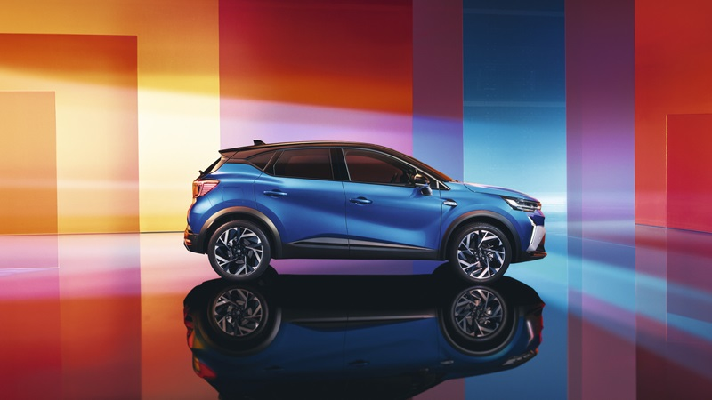With the Human First Program launched in 2023, Renault restated its commitment to improving safety for drivers, passengers, and other road users around the world, through a range of technological advances. Taking full advantage of this progress, New Renault Captur is on a par with the best in terms of passive and active safety. It features 28 new-generation driving aids (ADAS), divided into three categories: safety, driving and parking. Safety Coach provides personalised advice for more responsible driving.

Safety Score and Safety Coach: proactive aids
Predictive Eco Driving Advice helps drivers to reduce fuel consumption and drive safely. Real-time recommendations and a driving score (from 0 to 100 scale) encourage drivers to maintain their speed, course and distance, and to be more vigilant and attentive. A monthly summary of each journey is available in the form of a bar chart detailing consumption and the distance travelled in all-electric mode.

Active Driver Assist, for context-aware driving assistance
Active Driver Assist is available with the navigation system and Advance Driving pack from the Techno and Esprit Alpine finish levels. With this function, Renault’s existing motorway and traffic assistant becomes now context-aware, extending its field of application beyond motorways. Its purpose is to help drivers deal effectively with situations arising on any type of road. This is a Level 2 autonomous driving function, combining adaptive cruise control with Stop & Go, lane centering assist, geolocation data and specific mapping enabling the vehicle to adapt to the road ahead.

Intelligent speed assistance
Integrated with Active Driver Assist, traffic sign recognition with overspeed warning (OSP) can also be used on its own. This function displays the authorised speed limit on the instrument panel and on the navigation screen. If the vehicle's speed is higher than the recognised speed, a visual warning is displayed. A button on the steering wheel activates the speed limiter, cruise control or intelligent adaptive cruise control to adapt automatically (or not) to the legal speed limit depending on following distance.

Hybrid Predictive driving
Available as an option, this function maximises the use of electrical energy while driving. Connected mapping data, such as the topography of the road over the next seven kilometres (or the most likely route if no destination is recorded), provides advance information to the battery management system to maximise the use of electric power.

Other driving aids
- For safety: Automatic Emergency Braking System (AEBS) / Blind Spot Warning (BSW) / Lane Keeping Assist (LKA) / Lane Departure Warning (LDW) / Driver Attention Alert (DAA)
- For the driving experience: Cruise control and speed limiter / Adaptive Cruise Control (ACC) with Stop & Go / Distance Warning (DW) / Hill Start Assist (HSA)
- For parking manoeuvres: 360° around view camera (based on four cameras) / front, rear and side parking sensors / Rear Cross Traffic Alert (RCTA) / Occupant Safe Exit Alert (OSE).
The optional Driving and Safety pack includes Blind Spot Warning (BSW), Rear Cross Traffic Alert (RCTA), Occupant Safe Exit Alert (OSE) and Active Driver Assist (ADAS available only with the automatic gearbox).

ADAS customisable at the touch of a finger
A new button to the left of the steering wheel – My Safety Switch – lets the driver activate or deactivate the preferred settings of no fewer than five ADAS at the same time, at the touch of a button. These customised settings on the multimedia screen include whether to activate the function, to what level, to allow sound alerts, and so on.

TECHNICAL DATA SHEET

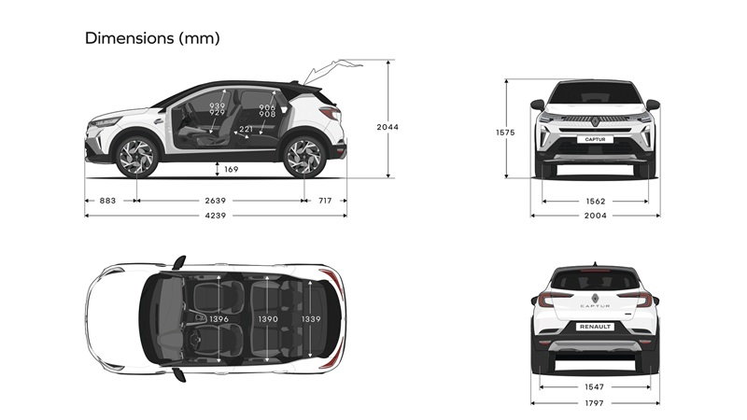Dimensions

TRUNK VOLUME | All versions except full hybrid | Full Hybrid Version
With row 2 moved forward / moved back to stop (+ 132L) in litres | 484 / 616 | 348 / 480
With row 2 advanced / retracted to stop (+ 114 dm3) in VDA standard dm3 | 422 / 536 | 326 / 440
Maximum volume (up to the height of the seat) - rear bench folded down | 1 596 | 1 458

DIMENSIONS (mm)
Overhall lenght | 4 239
Wheelbase | 2 639
Front overhang | 883
Rear overhang | 717
Overall width with folded mirrors / unfolded mirrors | 1 797 / 2 003
Front track ground | 1 562
Rear track ground | 1 547
Overall height without/with longitudinal roof bars | 1 575
Open tailgate height | 2 044
Trunk sill height | 779
Ground clearance unladen / with max. load | 169 / 132
Rear Knee radius row 2 advanced / retracted to stop | 61 / 221
Front elbow room | 1 396
Rear elbow room | 1390
Front shoulder width | 1371
Rear shoulder width | 1340
Front headroom | 889 / 879 - 939 / 929
Rear headroom | 849 / 849 - 906 / 908
Trunk entry maximum width | 953
Interior width between wheel arches | 976
Maximum load length with rear bench folded | 1 571

Powertrain characteristics

 | RENAULT CAPTUR
Powertrain | 1.0 TCE 90 | 1.0 TCE 100 LPG | 1.3 TCE 140 mild hybrid | 1.3 TCE 155 | 1.3 TCE 160 mild hybrid | E-Tech full hybrid 145
Fuel | Petrol | Petrol | Petrol | Petrol | Petrol | Petrol
Electification | No | No | MH12  Costing stop 7kph | No | MH12  Costing stop 20kph | HEV  245V
Cylinder Capacity [L]/[cm3] | 1.0 / 999 | 1.0 / 999 | 1.3 / 1330 | 1.3 / 1330 | 1.3 / 1330 | 1.6 / 1598
Number of Cylinder | 3 | 3 | 4 | 4 | 4 | 4
Number of valves | 12 | 12 | 16 | 16 | 16 | 16
Torque [Nm/tr] | 160 Nm @2750rpm | 160 Nm petrol mode / 2750rpm  170Nm LPG mode / 2000rpm | 260 Nm @3500rpm | 270 Nm @1700rpm | 270 Nm @1750rpm | 145 Nm @ 3200rpm ICE mode / 250Nm ICE+EM
Air Alimentation | Turbo | Turbo | Turbo | Turbo | Turbo | Atmo
CO² gr/km WLTP | 131 | 119 | 133 | 149 | 133 | 105
0 to 100 km/h (s) | 14 | 13 | 10.4 | 8.5 | 8.5 | 10
Fuel consumption | 5,8 - 5,9 | 6,0 - 6,1 L with unleaded / 7,7-7,9 L with LPG | 5,8 - 5,9 | 6.2 | 5,8 - 5,9 | 4,7 - 4,9

About Renault
Renault, a historic mobility brand and pioneer of electric vehicles in Europe, has always developed innovative vehicles. With the ‘Renaulution’ strategic plan, Renault has embarked on an ambitious, value-generating transformation, moving towards a more competitive, balanced and electrified range. Its ambition is to embody modernity and innovation in technology, energy and mobility services in the automotive industry and beyond.

