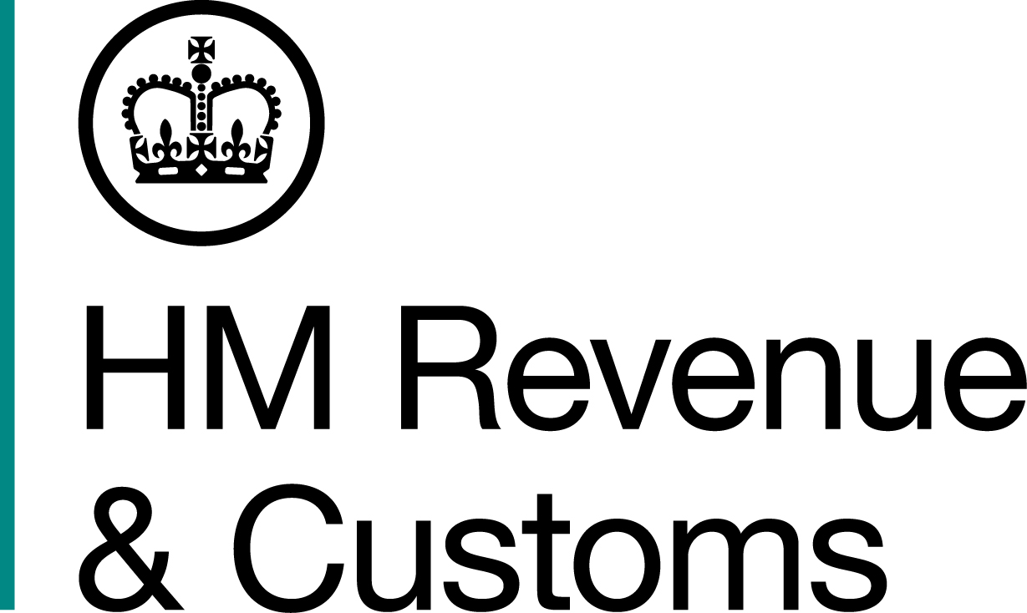
News Release

 | For the attention of News Desks |  | No of pages: 3
 | Date: | 04 01 2019 | Ref: | NW 02 19

Fugitive fraudster behind bars after Prague hideaway smoked out

A fugitive £17 million tax fraudster is finally behind bars after he was tracked down to his Prague hideaway and brought back to the UK to serve his eight-year sentence.

Robert Zduniak, 43, was part of an organised gang that processed smuggled raw tobacco in illegal factories in Preston, Blackburn, Bury and Essex, a HM Revenue and Customs (HMRC) investigation revealed.

Zduniak, who had been living at addresses in Blackburn and Bury, fled during his trial but was convicted and sentenced to eight years in prison. HMRC officers tracked him down in the Czech Republic and he was extradited three days after Christmas.

He was back in court yesterday (Thursday 3 January 2019) where his sentence was confirmed.

Tony Capon, Assistant Director, Fraud Investigation Service, HMRC, said:

“A new year and a new start for Zduniak – behind bars. He’ll have plenty of time to carefully consider any resolutions he wants to make.

“This is another demonstration that HMRC will relentlessly pursue criminals who try to cheat and evade justice. Zduniak must have thought he was free and clear, but we’ve brought him back to face justice.”

Zduniak, from Katowice in Poland, was part of a criminal network that used sites in the North West and Essex to produce illegal tobacco products to try and evade Excise Duty and VAT. He was found to be involved in the importation, transporting and processing of the raw tobacco.
HMRC investigations led to tobacco being seized in Preston in 2013, followed by more seizures of tobacco and manufacturing equipment the following year in Bury, Greater Manchester; Blackburn, Lancashire; and Halsted, Essex.
In April 2014, HMRC raided a farm in Essex, as well as four premises near Bury and another in Blackburn. Officers seized around three tonnes of raw tobacco that was being converted into counterfeit hand-rolling tobacco (HRT), £15,000 in cash, chemicals, counterfeit packaging and tobacco packing machinery.
HMRC investigators found the gang smuggled more than 100 tonnes of raw tobacco into the UK from the Czech Republic over 15 months by deliberately mislabelling it as furniture. If converted into counterfeit HRT it would have been worth £17 million in tax evaded.
Zduniak’s co-conspirators, Hubert Jankowski, and Lukasz Pawelec, were each jailed for four years in May 2017. Pawelec had also tried to flee but was caught at Doncaster Airport and remanded in custody for the remainder of the trial.
Zduniak is the latest in a string of tax fugitives caught and returned by HMRC to face UK justice, including Thomas O’Connor, Emil Dworak, Asad Chohan, Jamie and Brian Colwell and Geoffrey Johnson.

Information about any type of tax fraud can also be reported to HMRC online at www.gov.uk/report-an-unregistered-trader-or-business

Notes for Editors

- Robert Zduniak, DOB 26/09/75, was found guilty on 26 May 2017 of conspiracy to Cheat the Revenue, contrary to Common Law. He was sentenced to eight years jail in his absence. He appeared at Manchester Crown Court on 3 January 2019 where his sentence was confirmed.

- The original press release from Zduniak’s trial can be found at http://www.mynewsdesk.com/uk/hm-revenue-customs-hmrc/pressreleases/three-men-jailed-in-ps17m-tobacco-fraud-1994843

- HMRC’s flickr site www.flickr.com/hmrcgovuk

- Follow HMRC’s press office on Twitter @HMRCpressoffice

Issued by HM Revenue & Customs Press Office

Press enquiries only please contact:

Ed Casson
Tel: 03000 524697
Email: ed.casson@hmrc.gsi.gov.uk

Or

Will Lyon
Tel: 03000 519451
Email: will.lyon@hmrc.gsi.gov.uk

Out of hours
Tel: 07860 359 544
Website: www.gov.uk/hmrc

