Press release
Marinvest set to boost its digitalization process and cut fuel consumption with Kongsberg Digital’s Vessel Insight

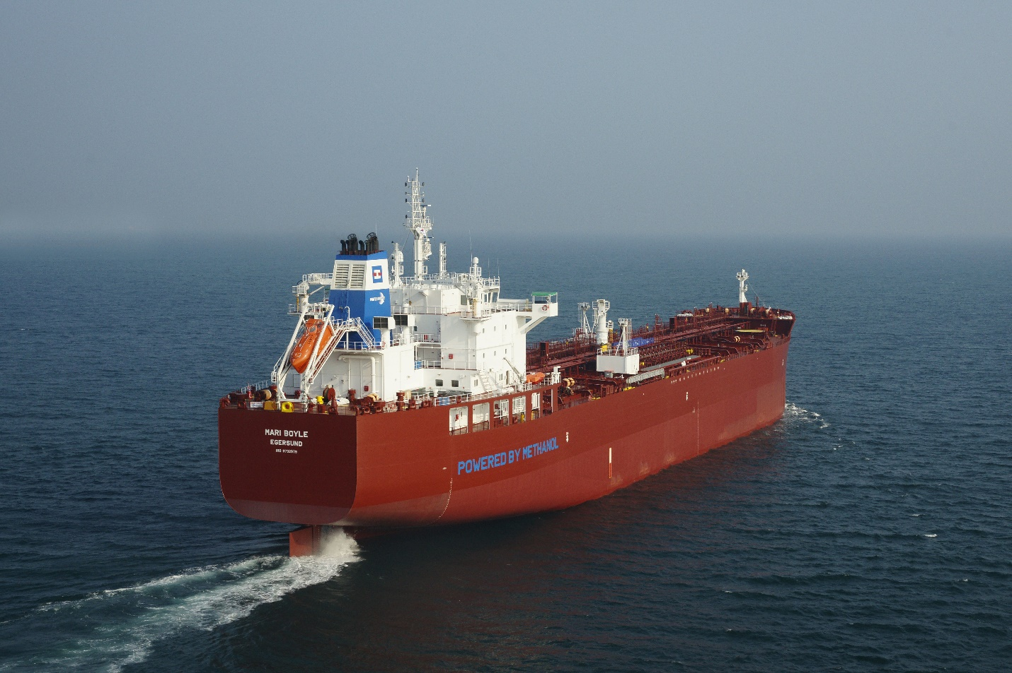
Ship management company Marinvest will use Kongsberg Digital’s Vessel Insight to optimize performance on five tankers

Kongsberg Digital is pleased to announce that it has signed a contract with Marinvest, a private ship management company based in Sweden, to install Vessel Insight on five of its fleet of 10 oil and chemical tankers. By installing Vessel Insight, Marinvest will collect vital data for vessel performance optimization and emissions reduction. The installations have already commenced.
Marinvest have been using Kongsberg Maritime’s Autochief 600 propulsion control system for five years, leveraging its Fuel and Speed Pilot functions to aid fuel and speed optimization. Vessel Insight, which builds on KONGSBERG’s long-standing history as a system integrator and leading provider of automation and information management systems, will work in tandem with the Fuel and Speed Pilot applications to facilitate vessel performance optimization by measuring emissions that are not currently monitored. This integrated approach – enabled by Vessel Insight – is expected to deliver significant savings, in addition to giving Marinvest a common infrastructure for all critical data signals and making them ‘digital-ready’ for integration with future software applications.
“We are delighted to be chosen to assist Marinvest in their digitalization journey,” says Andreas Jagtøyen, EVP of Digital Ocean, Kongsberg Digital. “As the importance of cutting emissions and fuel consumption increases, we are happy to see that so many shipowners realize that digital transformation is a pathway to achieve this goal and to meet international standards put forward by the IMO. Our team will cooperate with Marinvest to implement the latest software technology available, ensuring that they remain in the competitive vanguard towards 2023, 2030 and beyond.”
Leveraging digitalization
Amid rising regulatory pressure to combat global warming, the shipping industry is adopting measures to become more energy efficient in an effort to meet requirements such as those set by Energy Efficiency Existing Ship Index. With Vessel Insight, Marinvest plans to expand their digital approach to the challenge, collecting critical data to measure and reduce emissions through increasing ship efficiency.
Vessel Insight provides vessel-to-cloud data infrastructure, capturing and aggregating quality data in a cost effective and secure way for vessels and fleets. By providing instant and easy access to critical data from all data points on a vessel through one common infrastructure, the service reduces the complexity of data gathering from ships. Issues presented by having several vendor systems onboard, such as price and lack of data for contextualization to gain optimal insight into processes, is thereby eliminated. In addition, Vessel Insight subscribers gain access to the Kognifai Marketplace, where they can download top-ranked software applications, already integrated with Vessel Insight.
“To have intimate knowledge of the performance of our ships, over a wide range of speeds and conditions, lays a solid foundation for efficient day to day operations,” says Fredrik Stubner, Director Ship Management, Marinvest. “Marinvest has in the past conducted several speed and consumption related projects which has resulted in our fleet consistently improving and staying competitive, irrespective of market conditions and bunker prices. We believe that our new agreement with KONGSBERG will help us further improve our performance, and we look forward to this collaboration.”
The contract between Kongsberg Digital and Marinvest was signed on February 10th, 2021, and Vessel Insight is expected to be installed on all five vessels by September 2021.

KONGSBERG DIGITAL
Kongsberg Digital, a subsidiary of KONGSBERG, is a provider of next-generation software and digital solutions, to customers within maritime, oil and gas, and renewables and utilities. The company consists of more than 500 software experts with leading competence within the internet of things, smart data, artificial intelligence, maritime simulation, automation and autonomous operations. Kongsberg Digital is the group-wide center of digital expertise for the KONGSBERG group. www.kongsbergdigital.com
KONGSBERG
KONGSBERG (OSE-ticker: KOG) is an international, leading global technology corporation delivering mission-critical systems and solutions with extreme performance for customers that operate under extremely challenging conditions. We work with nations, businesses and research environments to push the boundaries of technology development in industries such as space, offshore and energy, merchant marine, defense and aerospace, and more. KONGSBERG has about 11,000 employees located in more than 40 countries, creating a total revenue of NOK 25.6bn in 2020.

MARINVEST
Marinvest is a private ship manager serving investment groups that are part owners of product- and chemical tankers. Holdings include investments in tankers of approximately 75,000 DWT, chemical tankers between 20,000 to 50,000 DWT, a developing coastal shipping company as well as investments in both listed and unlisted instruments.

CONTACT:  Mathilde Magnussen  VP Communication and Marketing  Kongsberg Digital  (+47) 456 78 255  mathilde.magnussen@kdi.kongsberg.com  kongsberg.com | David Pugh  Account Manager  Saltwater Stone  (+44) 1202 669244  d.pugh@saltwater-stone.com  saltwater-stone.com

