May 10, 2012

Press release

# Cloudbase flight scheduling software will release at EBACE 2012

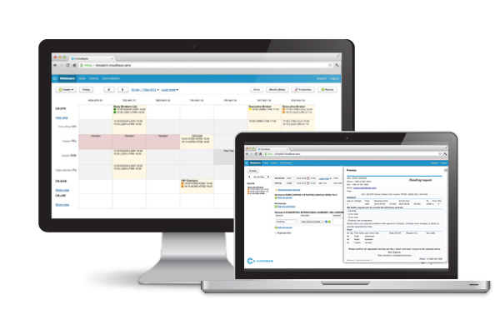Online flight scheduling software, Cloudbase will be released at EBACE 2012, European Business Aviation Convention and Exhibition, on May 13th, in Geneva.

The Swedish Start-Up company Cloudbase AB announces the release of their new generation flight scheduling software at EBACE 2012 in Geneva. The system targets small to mid-sized Business Aviation Operators and has been praised for its modern approach and ability to improve efficiency in operations planning.

* With Cloudbase in place, we have been able to expand our business by more than 40% without increasing our operations department staff, says Magnus Henriksson, Flight Operations Manager at WaltAir. The system opened completely new possibilities for us. It's easier to share work, and our pilots are better informed and involved in the planning process of their upcoming flights. It has resulted in a higher, more even quality of service to our customers.

Cloudbase offers a modern approach to flight scheduling that is simple to use and focuses on the main work patterns of the operators.

* I am a pilot, says CEO and Co-Founder Robin Kahlbom , and I have been flying for years and planning flights, of all sizes, all over the world. I know about the problems that occur when organizing business aviation flights. Together with the best programmers we made Cloudbase as a solution to those problems. We are proud to introduce Cloudbase to the business aviation market at EBACE.

Cloudbase runs on any computer with an internet connection. Cloudbase is an online tool with a monthly fee, with no-installation or update charges. Cloudbase will be exhibiting at EBACE 2012 with their software in Booth #2205.

* Over the last year we have been evaluated and tested by several operators, which have all been impressed by the simplicity and efficiency our system brought to their operations planning, says Fredik Jonsson, CTO at Cloudbase AB. The business aviation industry is ready to move online to this new generation planning tool.

For more information:

Fredrik Jonsson, CTO Cloudbase AB, +46 703 60 70 95, [fredrik.jonsson@cloudbase.aero](mailto:fredrik.jonsson@cloudbase.aero)

**Cloudbase offers a simple to use, online flight scheduling software for business aviation operators.** The software contributes to significant time efficiency and quality improvements. Cloudbase was founded in 2010 in Norrköping, Sweden and has a high experience within business aviation and software development. [www.cloudbase.aero](http://www.cloudbase.aero/)

**LEAD is a Swedish Business Incubator** supporting the development of unique and innovative start-ups with high growth potential. Through a quality assured process, LEAD supports start-ups for a three year period. The process is led by qualified business coaches that prepare the companies for sustainable growth. www.leadincubator.se