***Quick and easy: get the right battery with the VARTA® Automotive app***

* New VARTA Automotive app identifies the right replacement battery, whenever and wherever it's needed
* Quick and easy searching by vehicle type and battery code
* Helpful replacement information, such as installation time and battery position
* Integrated dealer search for end customers
* Free app now available in the Apple App Store for all Apple iPhones and iPads

**Hannover – March, 2014**Johnson Controls has developed a new mobile battery search facility to give garages and end customers a quick and easy way to determine the right VARTA battery for every kind of vehicle. The VARTA Automotive battery search mobile application identifies the right battery by vehicle type, European part number or short code and boasts a comprehensive dealer search facility. The free application is now available in the Apple App Store for iPhones and iPads.

**Benefits for garages and consumers**

The VARTA battery search mobile application has various quick and easy search functions for finding the right battery. The vehicle search begins by selecting the construction year, make, model and engine type. Once the correct vehicle model has been selected, the application shows the right VARTA battery and provides helpful product information. The perfect battery can also be identified using the European part number or short code. The user can achieve even faster results by directly entering the KBA code from the vehicle registration document.

The battery search mobile application provides helpful information for garages to speed up battery swaps. The precise installation position and estimated installation time are also displayed for fast battery replacement.

The integrated dealer search helps end customers locate a VARTA dealer near them. It lists all battery dealers near the current or desired location, plus their contact details, and indicates the closest VARTA dealer.



**New VARTA®battery search mobile application with four functions:** Search by vehicle type, European part number, dealer identification and a detailed VARTA battery catalog.

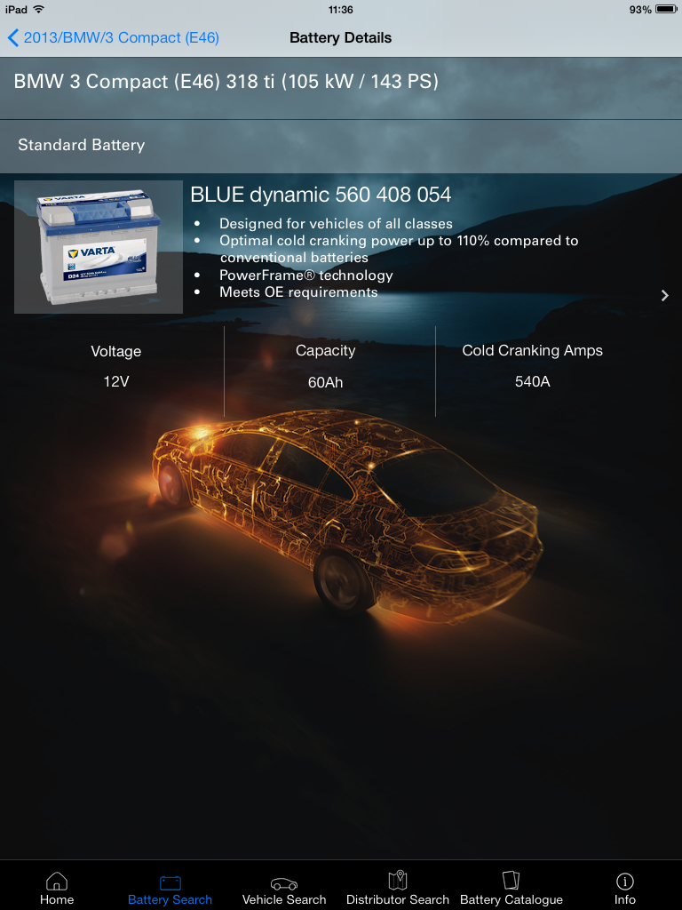

**The perfect VARTA® battery:** Once the vehicle has been identified from the make, model and construction year, the VARTA battery search application indicates the perfect battery and provides technical information.

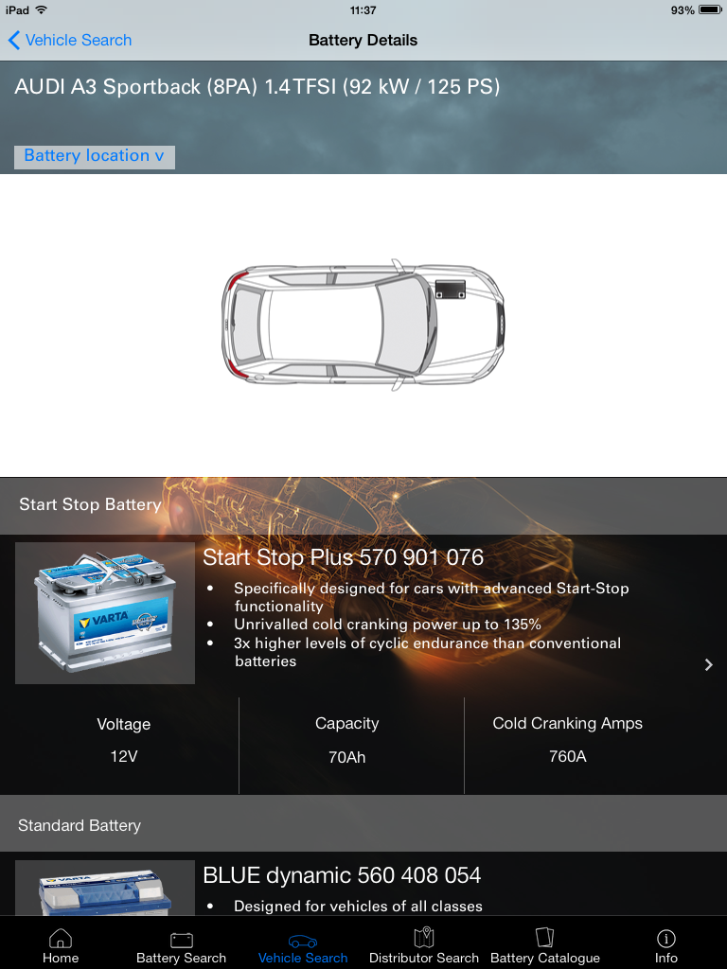

**All the information needed for a battery swap:** The VARTA®battery search application shows the specific position of the battery.

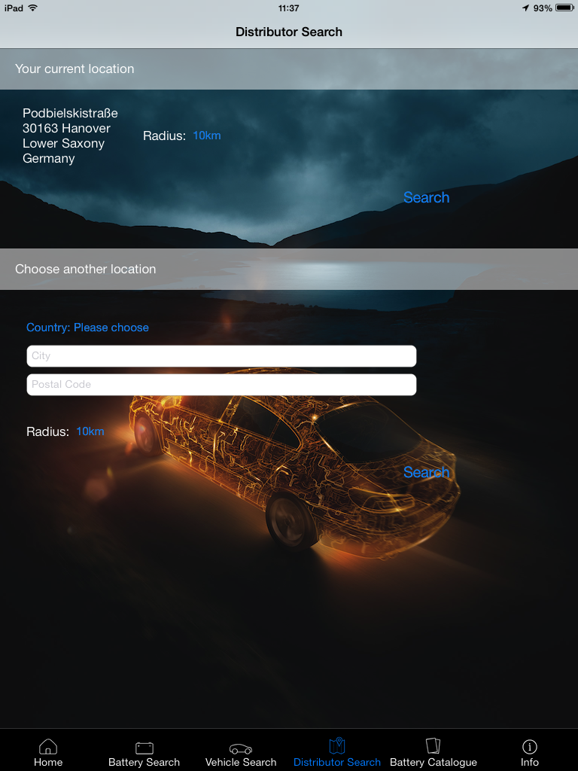

**Dealer search:** The battery search mobile application lists all VARTA® battery dealers near the end customer’s current or desired location, plus their contact details, and indicates the closest dealer.

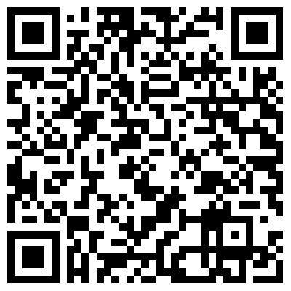

Now available in the App Store.

*For further information, please contact:*

*Johnson Controls Power Solutions EMEA*

*Max Mustermann  
Am Leineufer 51  
30419 Hannover  
Tel: +49 (0)511 975 0000*

*E-mail: max.mustermann@jci.com*

**About Johnson Controls Power Solutions**

Johnson Controls Power Solutions is the global leader in lead-acid automotive batteries and advanced batteries for Start-Stop, hybrid and electric vehicles. Our 50 manufacturing, recycling and distribution centers supply more than one third of the world’s lead-acid batteries to major automakers and aftermarket retailers. Through our innovations we are building the advanced battery industry for hybrid and electric vehicles. We were the first company in the world to produce lithium-ion batteries for mass-production hybrid vehicles. Our commitment to sustainability is evidenced by our world-class technology, manufacturing and recycling capabilities