March 22, 2023

**ABLIC Launches the S-19114 Series of Automotive High Withstand Voltage Battery Monitoring ICs Combining the Industry’s Fastest (*1) Voltage Detection Response with Low Current Consumption**

Helps Improve System Safety and Lowers Cost

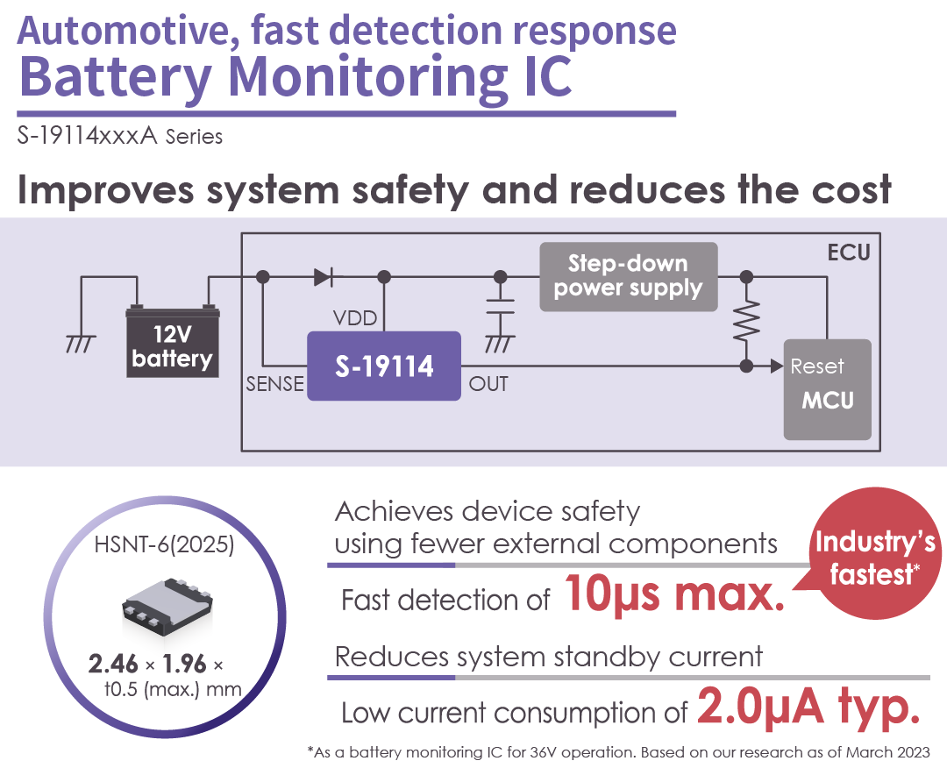



MInebeaMitsumi Group

Green Products

ABLIC (President: Nobumasa Ishiai, head office: Minato-ku, Tokyo hereinafter “ABLIC”), a group company of MinebeaMitsumi Inc., today launched the S-19114 Series of automotive high withstand voltage battery monitoring ICs with the industry’s fastest (*1) voltage detection response.

A battery monitoring IC is used to monitor battery voltage and when the voltage set by the IC is reached, it outputs a detection signal.

The automobile industry is currently making efforts to improve the quality of automobile parts to prevent traffic accidents and to implement functional safety (*2) to reduce the impact of an accident that may occur in the rare event of a failure.

Automobiles contain a variety of safety mechanisms, one such example is a countermeasure against interruption of voltage supply from the battery to the ECU (*3). When the supply of power from the battery is interrupted, the voltage to the ECU drops. As soon as the voltage drop is detected, the ECU tries to safely reset itself. A reset requires certain amount of time, which can normally be provided by installing a capacitor at the input to the ECU. Since the voltage supplied to the ECU drops also while the battery monitoring IC sends detection signals, capacitor settings must provide the ECU with enough time to perform a safe reset also at such times.

The growing complexity of automotive functions has led to a greater integration of ECUs. More ECUs require more power and more capacitors. All of which results in higher costs and larger board footprint.

Lowering the number of capacitors while still ensuring the safe reset of ECUs requires a faster detection response from the battery monitoring IC.

The S-19114 Series launched today is a battery monitoring IC that operates at 36V and has the industry’s fastest detection response time of Max. 10μs (*4). Two components impact the detection response time: the resistance components and the capacitance components in the IC. However, they are not much of a problem as the resistance components of the S-19114 Series are 1/5 of earlier models and capacitance components have been reduced to such an extent that detection response time is 1/20 of earlier models. These features help resolve issues such as higher costs and larger board size due to an increase in ECU capacitors.

A battery monitoring IC needs to have low current consumption to be able to continuously monitor battery voltage. However, the S-19114 Series have few resistance and capacitance components that impact detection response time and current consumption during operation is a low 2.0µA typ. This makes the series ideal for low standby current systems (*5) where continuous sensing is required.

Another advantage is that the S-19114 Series is housed in the ultra-compact HSNT-6(2025) (1.96 x 2.46 x t0.5mm) package making it a product that amply meets today’s ever-increasing need for smaller automotive devices.

(*1) As a battery monitoring IC for 36V operation. Based on our research as of March 2023

(*2) Functional safety: To build in functional tweaks to ensure an acceptable level of safety

(For further reading, <https://www.ablic.com/en/semicon/products/automotive/asil/>)

(*3) ECU: Abbreviation for Electronic Control Unit. It is the generic term for automotive electronic control units. They are mainly used in automobiles. Currently, the majority of ECUs integrate microcontrollers

(*4) 1/20 the detection time of our previous products

(*5) Standby current: Quiescent current, or current that flows even when the ignition is turned OFF

**Major Features**

**1. Shorter voltage detection response times as well as low current consumption**

**2. Smaller footprint through ultra-compact package**

**3. The monitoring voltage input pin (SENSE pin) has a wide rated voltage of -30V to 45V**

**4. Automotive quality**

These products have been subjected to the three-temperature test (low, normal and high temperature). According to the AEC (Automotive Electronics Council), this series will comply with AEC-Q100 Grade 0 reliability and quality test defined by the Council. They are also in compliance with the Production Part Approval Process (PPAP). This means these ICs are well suited for the harsh environment that automotive applications present.

**Application Examples**

Voltage detection of automotive batteries

Automotive components such as engines, transmissions, suspensions or ABS as well as EV, HEV or PHEV vehicle parts

**S-19114 Series Product Details**

https://www.ablic.com/en/semicon/products/automotive/automotive-voltage-detector-reset-ic/s-19114xxxa/

**Website**

https://www.ablic.com/

s

**About ABLIC Inc.**

ABLIC Inc. started analogue semiconductor business based on the development of CMOS ICs for the world’s first practical quartz watches in 1968.

Since then, we have been continuing to provide small, low-power consumption, and high-precision analog semiconductor products, not only for watches, but also for a wide range of consumer, mobile, automotive devices, and healthcare equipment.

We joined as one of the MinebeaMitsumi Group companies in April 2020, and will keep contributing to the enrichment lives around the world under our vision of inspiring customers with “Small, Smart, Simple” analog semiconductor solutions.



MInebeaMitsumi Group

Green Products

This product has been certified as [a MinebeaMitsumi Group "Green Product"](https://www.minebeamitsumi.com/english/news/newproducts/2021/1201087_16444.html) for its outstanding contribution to the environment.

**Contacts**

ABLIC Inc.

Masae Onuma

E-mail: pr@ablic.com

https://hub.ablic.com/en/pr-inquiry?rf=support