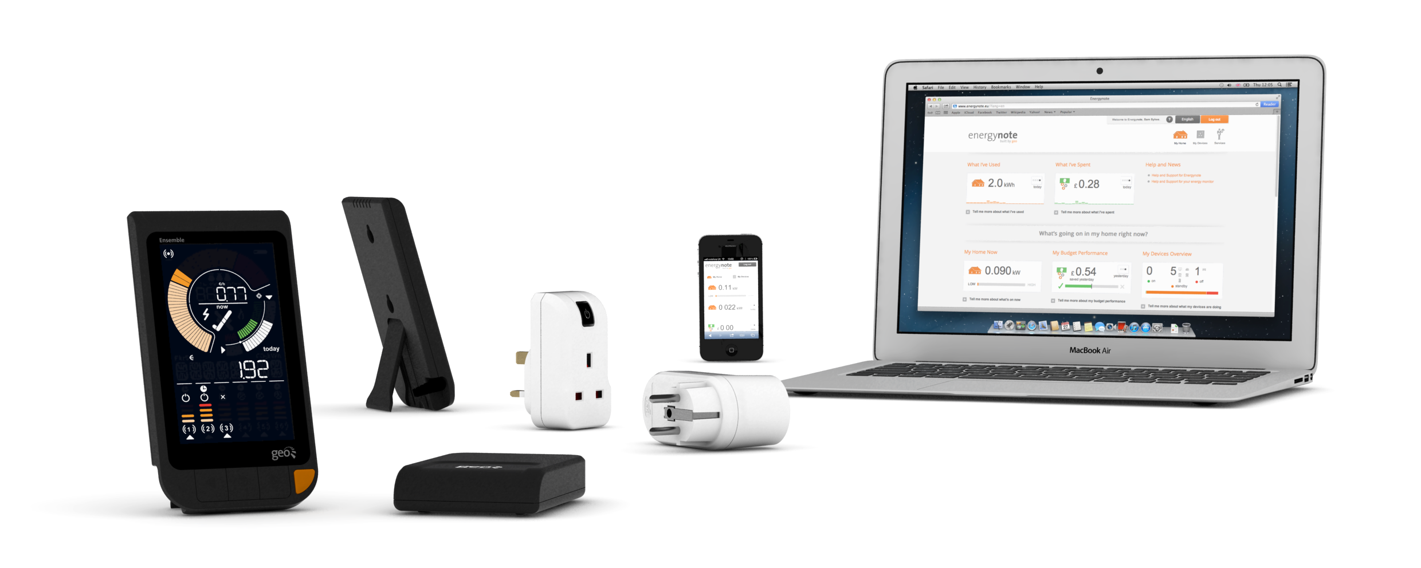

Press release

For immediate release

# geo’s answer to rising energy prices Monitor, control and reduce energy costs with the new Ensemble Colour

**March, 2013 (Cambridge, UK) – Green Energy Options (geo) is adding to its impressive home energy management service with a new full-colour in-home display. The Ensemble Colour shows home electricity consumption on a simple, easy-to-read screen. With the addition of optional Smart Plugs consumers can measure and control individual appliances, whilst keeping track of the bigger picture with geo’s online service, energynote. The Ensemble Colour helps homeowners understand and engage with their energy use, spot trends, identify overspend and take control in the face of rising energy costs.**

Energy prices are on the rise again which means consumers are looking for ways to reduce their bill and take control. **geo**’s Ensemble Colour makes the complicated business of energy use and cost easy to understand – whether it’s just a quick glance to check on budget or in-depth analysis to assess seasonal behaviour and/or carbon prevention.

With the Ensemble Colour:

* Time-poor consumers can easily understand spend from nothing more than a quick glance
* Additional Smart Plugs can measure and monitor individual appliances on your display
* An optional **geo** web pack gives access to the online service:
  + Simple snapshots, ideas and tips on how savings can be made
  + In-depth, meaningful analysis to support energy efficiency
  + Monitor, control and schedule appliances connected to Smart Plugs
  + View and control Smart Plugs away from home (on a PC, tablet or smartphone)

The Ensemble Colour works with most electricity meters, and can be supplied with either a CT clip to attach to the cable or a LED sensor to sit on the front.

“*The new Ensemble provides a much clearer view”, says* Chief Executive Officer for **geo**, Patrick Caiger-Smith. “*With the help of an attractive and intelligent display we can give householders the peace of mind they need to stay on top of their energy spend. One of the best things about it is the flexibility: you can view detailed energy spend not just on the display but also on a PC, tablet or smartphone. As energy costs continue to rise, the Ensemble Colour – as part of a powerful home energy management service – makes it easy to take control of energy consumption in the home, online or on the move.”*

The Ensemble Colour is available from **geo**’s online store <http://store.greenenergyoptions.co.uk> and some European distributors.

Notes for Editors

Interviews can be arranged with Patrick Caiger-Smith.

**About Green Energy Options (geo)**

**geo** designs and produces in-home energy displays, online energy services and mobile applications that make energy engaging. We enable energy suppliers, meter manufacturers and installers to strengthen relationships with their customers by putting them in control of their energy consumption, their home appliances and their energy budget in a visual, informative and engaging way. Our products and services work together with pre-smart and smart meters and microgeneration to enable the energy-efficient home.

**Media Enquiries: Christine Rush, geo, +44 1223 851 390,** [**christine@greenenergyoptions.co.uk**](mailto:christine@greenenergyoptions.co.uk)