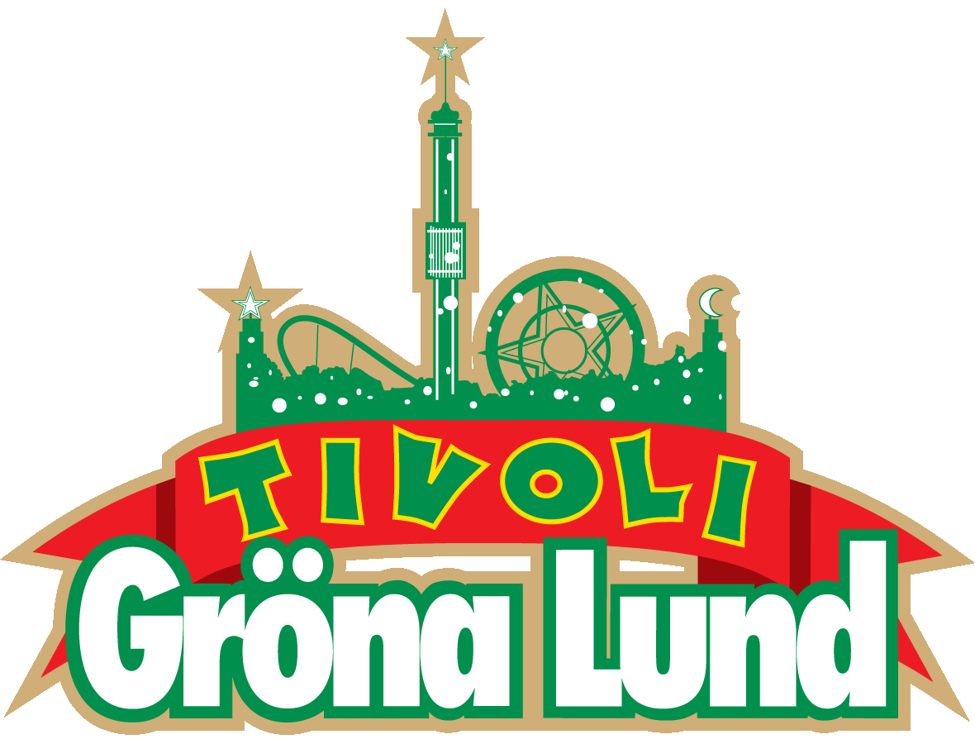

Pressmeddelande 2019-06-26

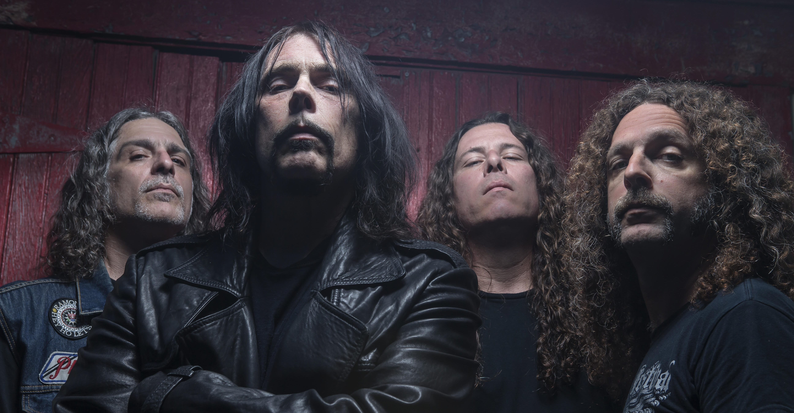
KONSERTEN MED MONSTER MAGNET PÅ GRÖNA LUND STÄLLS IN
Konserten med Monster Magnet som var inplanerad den 29 juli på Gröna Lunds Lilla Scen ställs in. Bandets sångare Dave Wyndorf behöver genomgå en operation, vilket innebär att Monster Magnets planerade europaturné ställs in.
Den 29 juli var Monster Magnet bokade att spela på Gröna Lunds Lilla Scen, men eftersom bandets sångare Dave Wyndorf behöver genomgå en operation kommer hela europaturnén att ställas in. Dave Wyndorf skickar med en personlig hälsning till alla fans:

"Unfortunately, due to a recent medical diagnosis that requires treatment to start immediately, I am forced to cancel this summer’s Monster Magnet tour of Europe. I am hopeful that we will return to the road in early 2020 with a tour celebrating Powertrip and more. Tonsils! Who knew they could be such a big deal? Well, my doctors do and by the way I'm feeling now I'm in agreement. I’m to undergo surgery right away or risk chronic sickness and sounding like Jabba The Hutt forever (some may say the latter may be an improvement but I’m not willing to risk it). I’m so sorry to cancel on everybody. Playing live and being with my Magnet road family (of which you are the BIGGEST part) is the joy of my life and I hate to let everybody down. And that includes myself. Simply put, this SUCKS but it is what it is. Gotta take care of the voice. I hope you understand.
ROCK! - Dave"

För mer information kontakta Annika Troselius, Informationschef på telefon 0708-580050 eller e-mail annika.troselius@gronalund.com. För pressbilder besök Gröna Lunds bildbank www.bilder.gronalund.com

