Tsui Wah (翠華) opens its first Southeast-Asian restaurant in Singapore on 15 June 2018. From its humble beginnings as a neighbourhood “Ice Café” in the bustling streets of Mong Kok back in 1967, Tsui Wah today is synonymous with Hong Kong delicacies of great quality, at great value. It is one of the biggest and most successful “Cha Chaan Teng” (港式茶餐廳) chains with a network covering Hong Kong, Macau, the People’s Republic of China, and Singapore.

Retaining traditional culinary methods and an emphasis on quality in the preparation of all dishes, experience a taste of Hong Kong’s culture and be delighted by the traditional preparation styles of authentic Hong Kong fare – freshly made using only the best ingredients.

For more information and updates on Tsui Wah in Singapore, connect with us at www.facebook.com/TsuiwahSingapore

Quick Facts and Figures (as of 14 June 2018)

1 | : Number of restaurants in Singapore
15 June 2018 | : Opening date for Tsui Wah’s first restaurant in Singapore
Clarke Quay  (3A River Valley Road, Clarke Quay, #01-03, Singapore 179020) | : Location of the first contemporary-style restaurant in Singapore
3002 square feet (Indoors)  1005 square feet (Outdoors) | : Size of restaurant
Over 140 | : Seating capacity, with both indoor and alfresco dining  options
11am – 11pm | : Opening hours on a daily basis
#TsuiwahSG | : Social media hashtag

Notes to the Editor
Media Photo Bank for Tsui Wah Singapore (Photo Credits: Tsui Wah /翠華):
http://bit.ly/TWSGPhotos

For media enquiries, please contact:
Asia PR Werkz on behalf of Tsui Wah Singapore
Jacalyn Chua  +65 9723 7177  weisin@asiaprwerkz.com | Elly Saad  +65 8811 9550  elynur@asiaprwerkz.com | Lim Wee Ling  +65 9768 6827  weeling@asiaprwerkz.com

Selection of Signature Dishes and Hot Favourites

 | Image | Menu | Highlights
1 | 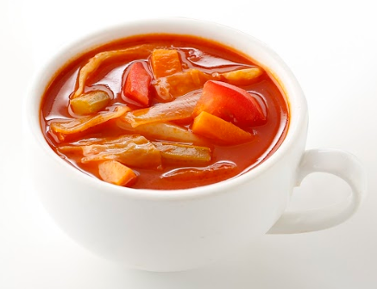 | Borscht with Thick Toast  羅宋湯配厚多士  Ingredients include: Tomato, Cabbage, Onion, Carrot, Celery, Beef chunks  Price: $5.50++ | - Prepared daily using the original Tsui Wah recipe of more than 30 years  - Stewed for about 3 hours
2 | 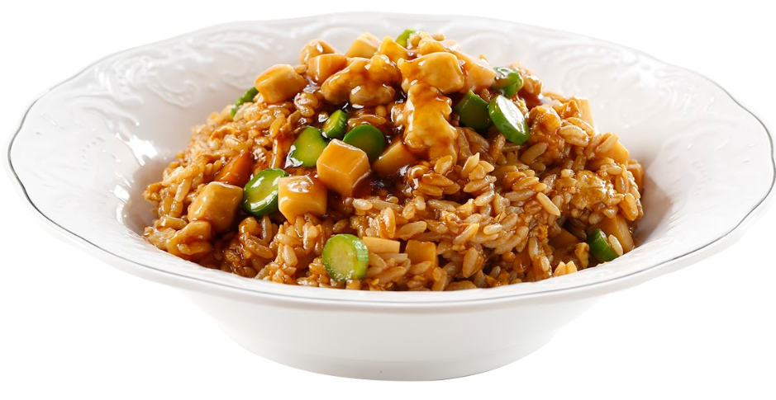 | Braised Abalone Rice with Diced Chicken and Kale  鮑汁玉蘭雞粒炒飯  Ingredients include: Diced Chicken, Kale and Abalone Sauce  Price: $14.00++ | - Original recipe from Tsui Wah  - Uncommon in Singapore
3 | 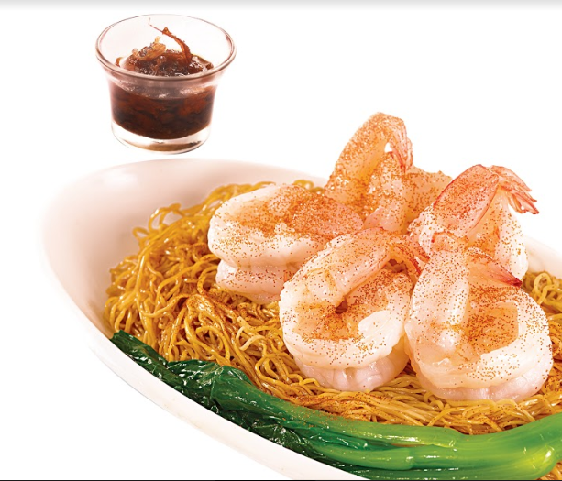 | King Prawns in XO Sauce with Tossed Noodles  XO醬海蝦球撈麵  Price: $11.00++ | - Prawns are meticulously sourced and selected to ensure high quality and taste  - XO Sauce - Localized recipe
4 | 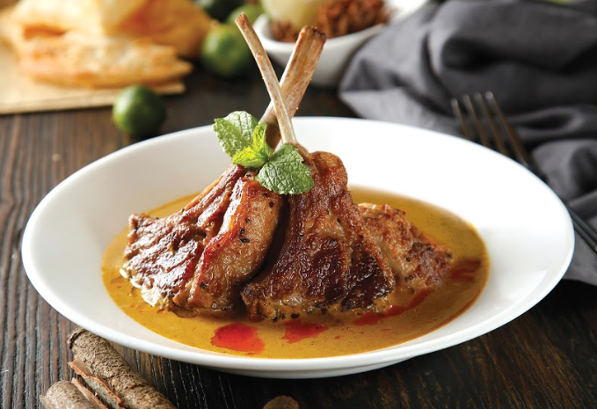 | Lamb Chop Curry with Steamed Rice  咖喱特嫩羊仔扒 配飯  Using Australian fresh lamb rack  Price: S29.00++ | - Curry recipe dates back to the 1960s  - The signature curry is stewed for over 6 hours and combines the fragrance of more than 30 spices  - Curry paste imported from Hong Kong  - Mild spiciness ensures the dish is still child-friendly
5 | 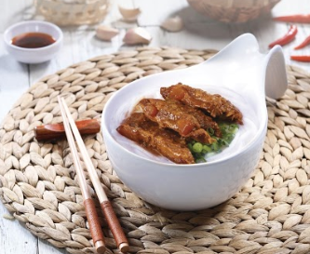 | Kagoshima-style Pork Cartilage in Fish Soup w/ Mixian  鹿兒島豬軟骨米線  From a recipe shared by a Japanese chef  Price: S8.50++ | - Pork Cartilage is stewed for many hours to achieve a melt-in-your-mouth tenderness  - Mixian is cooked to a springy perfection
6 | 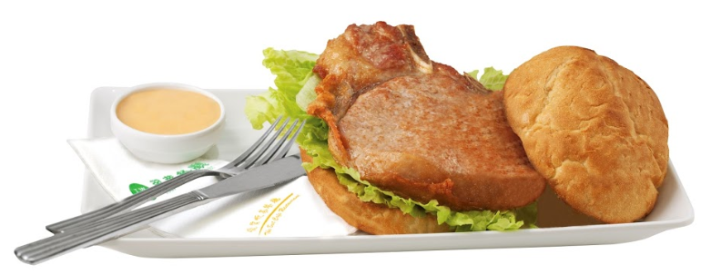 | Tsui Wah Signature Pork Chop Bun  翠華招牌豬扒包  Price: $7.50++ | - Original Tsui Wah recipe
7 | 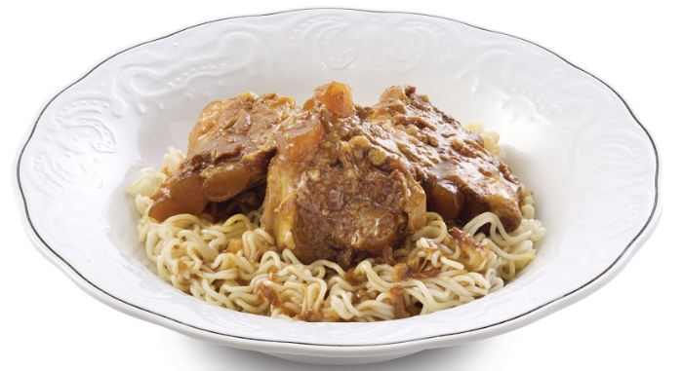 | Kagoshima-style Pork Cartilage with Tossed Instant Noodles  鹿兒島豬軟骨撈即食麵  From a recipe shared by a Japanese chef  Price: $9.50++ | - Pork Cartilage is stewed for many hours to achieve a melt-in-your-mouth tenderness  - Served with Instant Noodles, a Hong Kong favourite
8 |  | Iced/Hot Milk Tea  香滑奶茶 - 凍/熱  Iconic beverage that represents Hong Kong’s food culture  Price: $3.50++ (Hot)  $4.00++ (Iced) | - Milk Tea with condensed milk is called “茶走” for its sweet and smooth texture  - Using imported tea leaves from Tsui Wah Hong Kong  - Tea brewed daily and kept for a max of 30mins to ensure freshness and optimal taste and texture
9 | 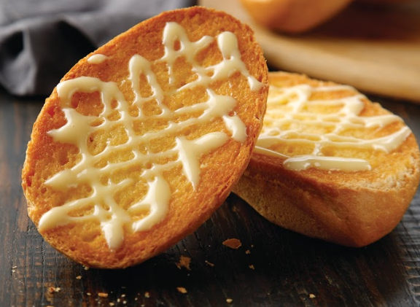 | Crispy Bun w/ Condensed Milk  脆嘩奶油豬  Tsui Wah’s rendition of a classic Hong Kong snack  Price: $4.00++ | - Each bun is freshly toasted with a crispy golden brown crust on the surface and pillowy-soft on the inside  - Topped with sweet condensed milk and butter
10 | 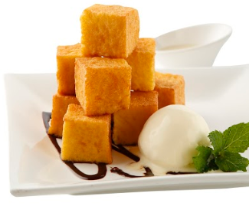 | Savoury French Toast Bites Served w/ Vanilla Ice Cream  雪糕西多士 | - Toast is freshly cut upon ordering and prepared daily

###

