**Jessica Bäckman kick off the season at the Oschersleben track in ADAC TCR Germany**

**This weekend, April 22-24th, it's time for Jessica Bäckman to kick off the season in the German TCR championship ADAC TCR Germany - with a new car model Hyundai Veloster N TCR car and for a new team ROJA Motorsport.  
- I am looking forward to competing again and extra fun to be back in ADAC TCR Germany. It will once again be a completely new car for me to learn and also a new team, so it will be exciting to see how I stand against my competitors in the first race weekend, Jessica Bäckman says.  
  
**Jessica Bäckman in her Hyundai Veloster N TCR car (Photo: MameMedia, free rights to use the image)

After the approximately 7-month break since last year's competition in both the World Cup; FIA World Touring Car Cup and a one-off appearance in STCC at Anderstorp, it is now time for Jessica to compete again, this time she will drive a full season in ADAC TCR Germany. The first round takes place at the Oschersleben track in Germany, where Jessica last competed in 2019 in the TCR Europe championship, where she finished in sixth place, in other words, it is a track that Jessica enjoys. Jessica will compete for a new team ROJA Motorsport and with a new car model, Hyundai Veloster N TCR.

- We are very proud to welcome Jessica to our team for the ADAC TCR Germany season 2022. I am absolutely convinced that Jessica will achieve fantastic results in her first full season in the ADAC TCR Germany series with her strong driving ability and fighting spirit, **Andreas Klinge** says, team manager for ROJA Motorsport.

**﻿Structure of the ADAC TCR Germany series**The 2022 season in ADAC TCR Germany will consist of five races in Germany and two races in Austria. The series is one of the toughest TCR series in the world and has a high status of drivers who come from several different countries around Europe. The start of the season will be on the Oschersleben track in Germany and will end on the well-known Formula 1 track Hockenheimring. In addition to the Hockenheimring, the world-famous Formula 1 tracks Nürburgring and Red Bull Ring will also be on the 2022 calendar. Each race weekend consists of two free practice sessions on Friday, one time qualifying on Saturday which results in the starting position for Saturday’s Race 1-, and one time qualifying on Sunday which results in the starting positions for Sunday’s Race 2. Points are awarded to the top 10 in each time qualifying and the top 15 in each race. The driver with the most points after the last race at the Hockenheimring at the end of October will take home the driver title "ADAC TCR Germany Drivers Title" in the ADAC TCR Germany series.

- I am looking forward to competing again after the long brake from racing and extra fun to be back in ADAC TCR Germany. It will once again be a completely new car for me to learn and also a new team, so it will be exciting to see how I stand against my competitors in the first race weekend, **Jessica Bäckman** says.

**Timeschedule for this weekend:***(all times is in CET)*

**Friday April 22nd:**13:00 Free Practice 1  
16:15 Free Practice 2  
**﻿﻿﻿Saturday April 23rd:**08:45 Qualifying 1 (Q1)  
14:40 Race 1**﻿﻿﻿Sunday April 24th:**09:55 Qualifying 2 (Q2)  
16:05 Race 2 ﻿﻿

**Live broadcast**Both races will be live streamed at [www.adac.de/motorsport](http://www.adac.de/motorsport) and Motorsport.tv

Both races will be re-live: [www.youtube.com/adacmotorsports](http://www.youtube.com/adacmotorsports) and Motorsport.tv

**﻿Live-timing**All free practice sessions, time qualifyings and races can be followed via live timing [**https://www.adac-motorsport.de/adac-gt-masters/live-timin**](https://www.adac-motorsport.de/adac-gt-masters/live-timing)**g﻿ ﻿**

**About the track:  
﻿**

**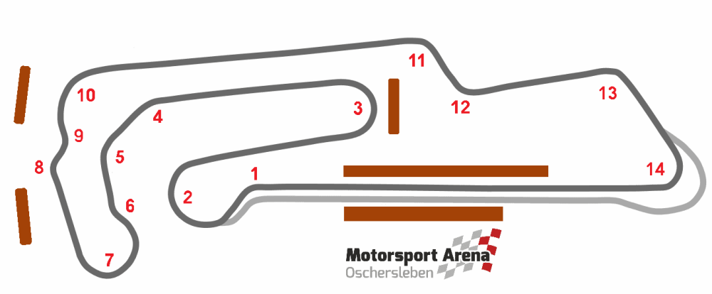  
﻿**

**﻿  
Place:**Oschersleben, Germany **﻿﻿Length:**3,667 km **﻿﻿Number of corners:**14  
**﻿﻿Race length:**30 minutes + 1 lap

**﻿ADAC TCR Germany Calendar 2022:***April 22–24th*- Oschersleben, Germany  
*May 20-22nd* - Red Bull Ring, Austria  
*June 17-19th*- Salzburgring, Austria  
*August 5-7th*- Nürburgring, Germany  
*August 19-21st* - Lausitzring, Germany  
*September 23-25th* - Sachsenring, Germany  
*October 21-23rd*- Hockenheim, Germany ***Free rights to use images.***

***﻿  
Download press photos here:***[***http://bit.ly/jabaeckman-photos***](http://bit.ly/jabaeckman-photos)[***https://www.mynewsdesk.com/se/ja-backman/images***](https://www.mynewsdesk.com/se/ja-backman/images)

