**Volvo Polestar using TeXtreme® wins the STCC team championship**

Volvo Polestar Racing for the second consecutive year won the the team championship of the Swedish Touring Car Championship (STCC). The victory was in hand when driver Tommy Rustad finished first in the last race of the season. The team missed the driver championship when driver Robert Dahlgren finished on second place with the least possible margin, but the season summary was still positive.

Volvo Polestar Racing is using TeXtreme® to reduce weight and to improve the mechanical performance of their composites parts.

To read more about: [Volvo Polestar Racing](http://www.polestar.se)

To read more about: [TeXtreme®](http://www.textreme.se)

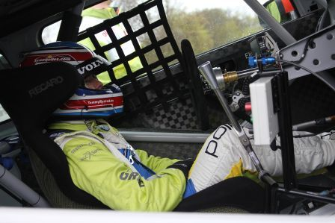

Image: Driver Tommy Rustad in the car.