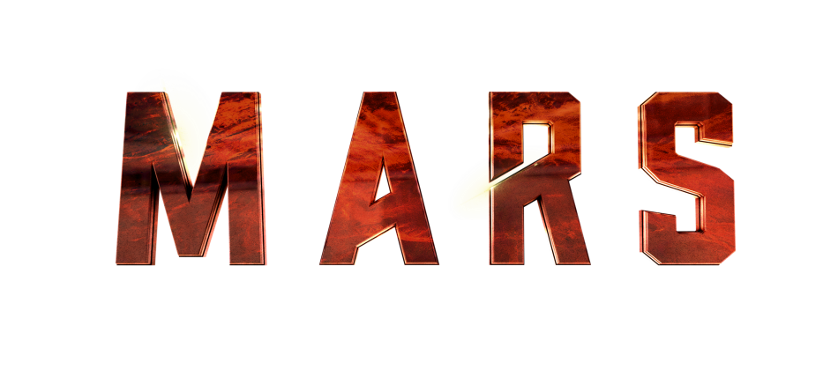

CREW MEMBER: Leslie Richardson

ASSIGNMENT: Nuclear physicist and leader of MMC’s Phase 2 team

NATIONALITY: British

NOTES: Hard-driving and intelligent, Richardson and her husband, Paul, are a famous scientific couple who have published numerous books together and were well-known on Earth even prior to their involvement in the Mars program. On Mars, Richardson will provide a (over)confident counterpoint to Hana Seung’s hard-earned caution when she arrives to begin the next phase of the settlement’s expansion.

ACTOR BIO: Cosima Shaw

Cosima Shaw plays British engineer and settlement administrator Leslie Richardson. Shaw’s first role was in the German television series “Sylter Geschichten.” Since then, Shaw has starred as the romantic lead opposite Stephen Dillane in “Papadopoulous & Sons” and in “Stolen” opposite Damien Lewis, and she recurred on the television series “Zen” opposite Rufus Sewell. Shaw also recurred on the series “Trevor's World of Sport” and appeared in films such as “V for Vendetta,” “The Enemy Within” and “The Fourth State.” Shaw won the Best Actress award at LIFF and BIFF for the title role in “Ana Begins.”

