Andreas Bäckman ready as STCC heads to the classic F1-track
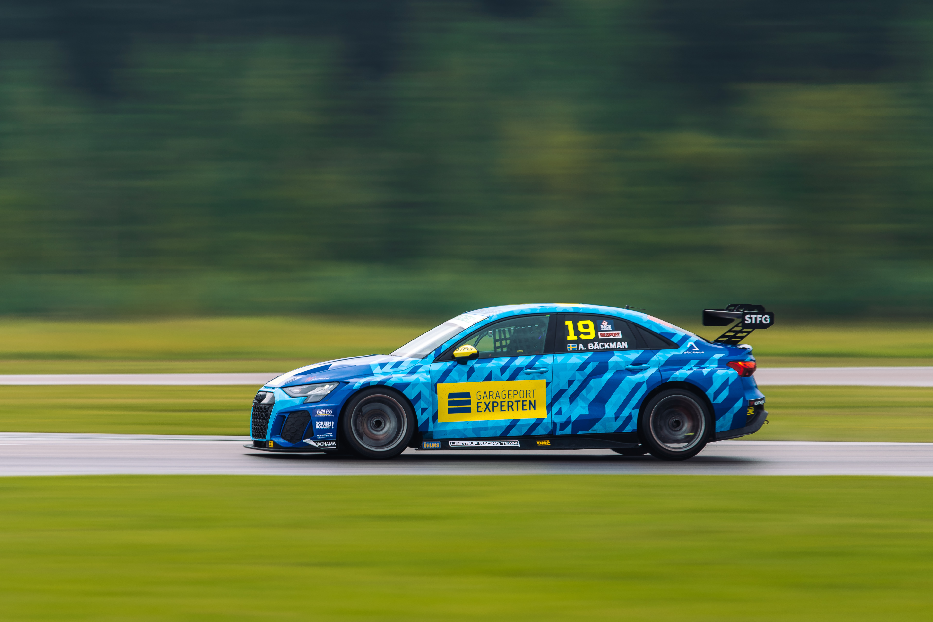
Andreas Bäckman is competing this weekend with his Audi RS 3 LMS TCR car for Lestrup Racing Team in this year’s fifth STCC event at Scandinavian Raceway in Anderstorp, Sweden.
Photo: Martin Öberg (Free rights to use the image)
This weekend, September 9th-11th, Andreas Bäckman competes in the penultimate STCC event of the season at the classic track Scandinavian Raceway in Anderstorp, which hosted Formula 1 races in the 70s.
– Looking forward to driving at Anderstorp again, I have good memories from the last time I drove here, Andreas Bäckman says.
STCC (Scandinavian Touring Car Championship) is Sweden's most prestigious motorsport championship and is today the leading class for Touring Car Racing in Sweden. The cars are built according to the global TCR regulations, which means that the cars used in STCC are the same as those in the other TCR series around the world. The series consists of six races that are run on different Swedish tracks and this weekend, September 9th-11th, the fifth and penultimate round of the championship are being held at Scandinavian Raceway in Anderstorp. The historic track is located in Anderstorp, which is close to Gislaved, Sweden, and was inaugurated in 1968. It is the only track in the Nordics with Formula 1 history, where famous names such as Ronnie Peterson and Niki Lauda have previously competed.
Andreas competes together with Lestrup Racing Team in an Audi RS 3 LMS TCR car in this year's STCC season and is in fifth place in the driver's championship after the first four races of the season.
- Nice to come back to the classic F1 track Anderstorp, it's a track I enjoyed and have good memories of driving there during the 2018 season. Hopefully we have a strong weekend and can continue to build on the positives from recent races and continue to improve even more, Andreas Bäckman says.

The structure of the race weekend
Already on Friday, the practice begins with two official test sessions, which are one hour long each. Then on Saturday morning, the race weekend continues with two more practice sessions, which are followed by two timed qualifying sessions in the afternoon. The timed qualifying consists of two qualifying segments, Q1 (20 minutes) and Q2 (10 minutes), where it is important to drive as fast as possible and the lap times are counted. The eight fastest drivers in Q1 will continue to drive in Q2. The result from Q1 determines the starting position for Race 1 and the Q2 starting position for Race 2 for the top eight drivers.
Sunday is the race-day and consists of three races; Race 1, Race 2 and Race 3. The starting position for Race 3 is based on the result from Race 2 but with the reverse starting order for the eight top drivers from that race.
Points are awarded to the top five in the Qualifying and the top 15 in each race.
The event are broadcasted LIVE at STCC+
The STCC weekend at Scandinavian Raceway are broadcasted LIVE at: plus.stcc.se
Live-timing:
raceresults.se
livetiming.getraceresults.com
More information about STCC can be found here: stcc.se
Information about the event:
stcc.se/race/anderstorp/

Timetable for this weekend (STCC round 5 - Anderstorp):
(all times are in CEST/Swedish time)
Friday September 9th:
12:00 Official test 1
16:32 Official test 2
Saturday September 10th:
09:00 Free Practice 1
13:35 Free Practice 2
17:05 Qualifying (Q1 and Q2)
Sunday September 11th:
11:15 Race 1 (Broadcasted LIVE on plus.stcc.se)
13:35 Race 2 (Broadcasted LIVE on plus.stcc.se)
15:15 Race 3 (Broadcasted LIVE on plus.stcc.se)

About the track (Scandinavian Raceway):
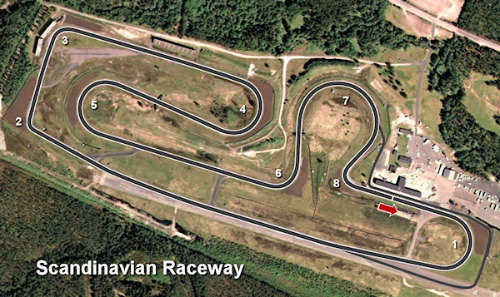
Located in: Anderstorp, Sweden
Length: 4,025 km
Corners: 8
Race duration: 9 laps (18 minutes + 1 lap)
Lap record (TCR): 1min 37.126s

STCC Championship Standings before round 5 of 6:
STCC – TCR Scandinavia – Drivers’ Championship Standings – Overall (Top 3)
STCC 2022 (After 4 of 6 race weekends)
1: Robert Dahlgren (SWE), 168 p.
2: Mattias Andersson (SWE), 141 p.
3: Oliver Söderström (SWE), 141 p.
–
5: Andreas Bäckman (SWE), 140 p.
See the full standings here
STCC – TCR Scandinavia – Teams’ Championship Standings – Overall (Top 3)
STCC 2022 (After 4 of 6 race weekends)
1: CUPRA Dealer Team - PWR Racing, 281 p.
2: Lestrup Racing Team, 281 p.
3: Brink Motorsport, 249 p.
See the full standings here

Did you miss the previous STCC race at Gelleråsen Arena?
Click here to see the replay at STCC+
Follow the STCC season:
Live-stream: plus.stcc.se
Other information: stcc.se
Facebook: facebook.com/STCCOfficial/
Twitter: twitter.com/stcc_official
Instagram: instagram.com/stcc_official/
YouTube: youtube.com/c/STCCTV

Free rights to use the images.

Download press-photos here:
http://bit.ly/jabaeckman-photos
https://www.mynewsdesk.com/se/ja-backman/images

