2021

ICA INTERNATIONAL CONFERENCE

Why CPTED? Creating liveable environments

Credit: Photo by Hanseric Orre on Unsplash. https://unsplash.com/@hansericorre

A B S T R A C T S U B M I S S I O N F O R M

Abstract requirements

All information must be provided in English.

The submitter must ensure that the use of the English language is grammatically and scientifically correct.

The abstract should not exceed 300 words.

Consider the following when preparing your abstract:

Clearly and concisely outline the topic and content of your presentation.

Indicate how the topic of your presentation relates to the theme of the conference.

Links to one or more of the topics identified in the Call for Abstracts would be an advantage.

If possible, demonstrate the practical relevance or potential impact of the aspects addressed in your presentation.

We encourage presentations that introduce innovative interpretations or applications of CPTED and advance knowledge in the field.

 | 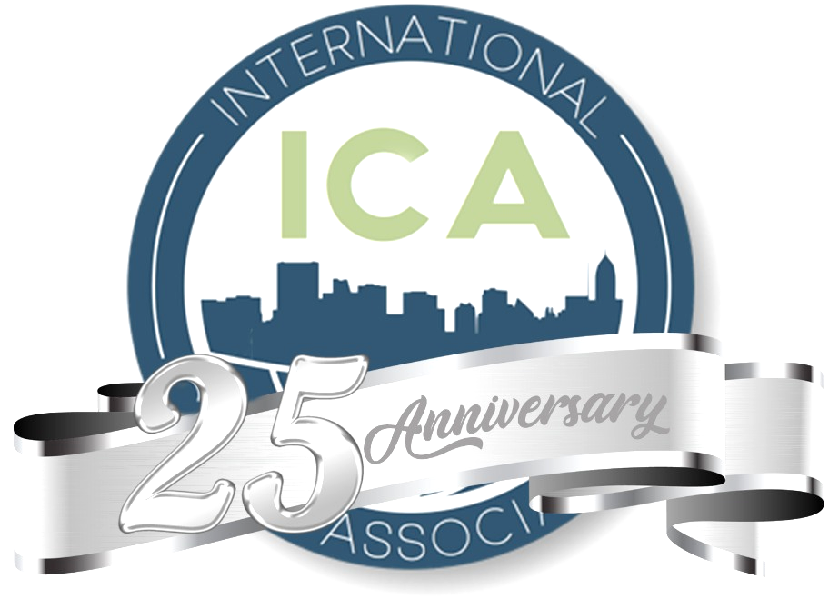
https://visithelsingborg.com/?lang=en | https://cpted.net | https://tryggaresverige.org

ABSTRACT SUBMISSION 2021

Title:

PRESENTATION TITLE (12 words maximum)

Abstract:

ABSTRACT (300 words maximum)

PRESENTER INFORMATION

Provide the details of the presenter below. If there are more than one presenter, provide the details of the primary presenter here and add the details of the co-presenters separately (see following pages). Unfortunately, only the primary presenter will be eligible for the reduced registration fee.

Title, name, surname
Affiliation (institution, organisation)
Country
State/Province
Contact email

Bio:

PROFESSIONAL BIO OF PRESENTER (100 words maximum)

CO-PRESENTER INFORMATION

Provide the details of the co-presenter below.

Title, name, surname
Affiliation (institution, organisation)
Country
State/Province
Contact email

Bio:

PROFESSIONAL BIO OF CO-PRESENTER (100 words maximum)

CO-PRESENTER INFORMATION

Provide the details of the co-presenter below.

Title, name, surname
Affiliation (institution, organisation)
Country
State/Province
Contact email

Bio:

PROFESSIONAL BIO OF CO-PRESENTER (100 words maximum)

