**Jessica Bäckman joins STCC at Anderstorp for Brink Motorsport**

**This weekend Jessica Bäckman will compete in STCC (Scandinavian Touring Car Championship) at Scandinavian Raceway, Anderstorp together with Brink Motorsport. It will be both a new team and a completely new car for Jessica, as she will drive an Audi RS 3 LMS TCR car for the first time.  
- It will be very fun to compete in Sweden again, it is two years since I competed in STCC and it ended well with a podium position, Jessica Bäckman says.**

STCC is Sweden's most prestigious motorsport championship and is today the leading class for Touring Car Racing. The cars are built according to the global TCR regulations, which means that the cars used in STCC are the same as those int the other TCR series around the world. The series consists of six race weekends held on different Swedish tracks, and this weekend, September 4-5th, the championship's fourth race is run at the traditional Scandinavian Raceway in Anderstorp, Jönköping; The only track in the Nordic region with Formula 1 history, where names like Ronnie Peterson and Niki Lauda have competed in the past. It is now official that the young, Swedish rising star Jessica Bäckman will participate this weekend, while there is a gap in the World Cup calendar and this time she will drive an Audi RS 3 LMS TCR car for the first time in her career for Brink Motorsport.

**New car and new team**Jessica Bäckman made her debut in karting 2006 and has competed around the world since. In 2018, Jessica made her debut in car racing and has over the years taken podium positions in 4 different TCR championships and has also represented Sweden in the Motorsport Olympics - FIA Motorsport Games when she finished in 6th place. 2021, Jessica competes as the first female driver ever in the World Cup series - WTCR - FIA World Touring Car Championship for Target Competition in a Hyundai Elantra N TCR car, where Jessica is currently in third place in the Junior Championship. This weekend the Swedish female racer enters STCC at Anderstorp and this time for Brink Motorsport in an Audi RS 3 LMS car.

- I am very happy to be back in Sweden again and this time I will get to try an Audi RS 3 LMS car for the first time together with Brink Motorsport which I look forward to working with. It will be a big challenge considering the limited preparations, but a challenge that I look forward to, **Jessica Bäckman says.**

- It is very fun to be able to welcome an FIA WTCR driver to the team and we have followed Jessica's progress in Europe the recent years where she has shown good potential. It will be fun to see what we can create together, even if we have respect for the task as it will be a straight path into the hot air with extremely limited test opportunities, **Ted Brink, team manager for Brink Motorsport says.**

**Timetable for the weekend (STCC round 4):**  
(all times are in CET/Swedish times)

**Saturday September 4th:**  
09:00 Free practice 1   
13:15 Free practice 2   
16:20 Q1 – Qualifying 1  
16:45 Q2 – Qualifying 2

**Sunday September 5th:**   
11:00 Race 1   
14:10 Race 2   
16:35 Race 3

**Live-stream on STCC Plus**STCC race at Scandinavian Raceway, Anderstorp runs on September 4-5th and is broadcast LIVE on: plus.stcc.se

**About the track (Anderstorp):**

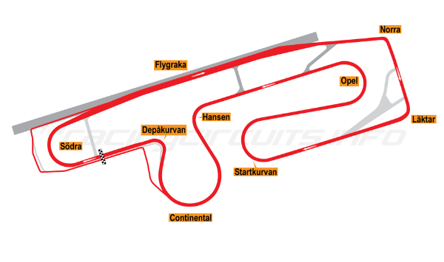

**Place:** Anderstorp  
**Track length:** 4,025 km  
**Corners:** 8

***Free rights to use image***s