Double podiums for Jessica Bäckman at Sachsenring
﻿Last weekend, September 23-25th, Jessica Bäckman claimed two podiums in the sixth round of the ADAC TCR Germany at the legendary Sachsenring track in Germany. This despite minimal preparations as Jessica just before the weekend changed both team and car, when she drove for Comtoyou Racing with an Audi RS3 TCR Gen 2. Jessica is still 2nd in the championship standings with one race weekend remaining.
- It has been a challenging weekend, both learning the tough hilly Sachsenring track and the new Audi car. Considering the limited preparations, I'm very happy about the performance, we took big steps forward every time I sat in the car, it bodes well for the final at Hockenheim October 20-23rd, Jessica Bäckman says.
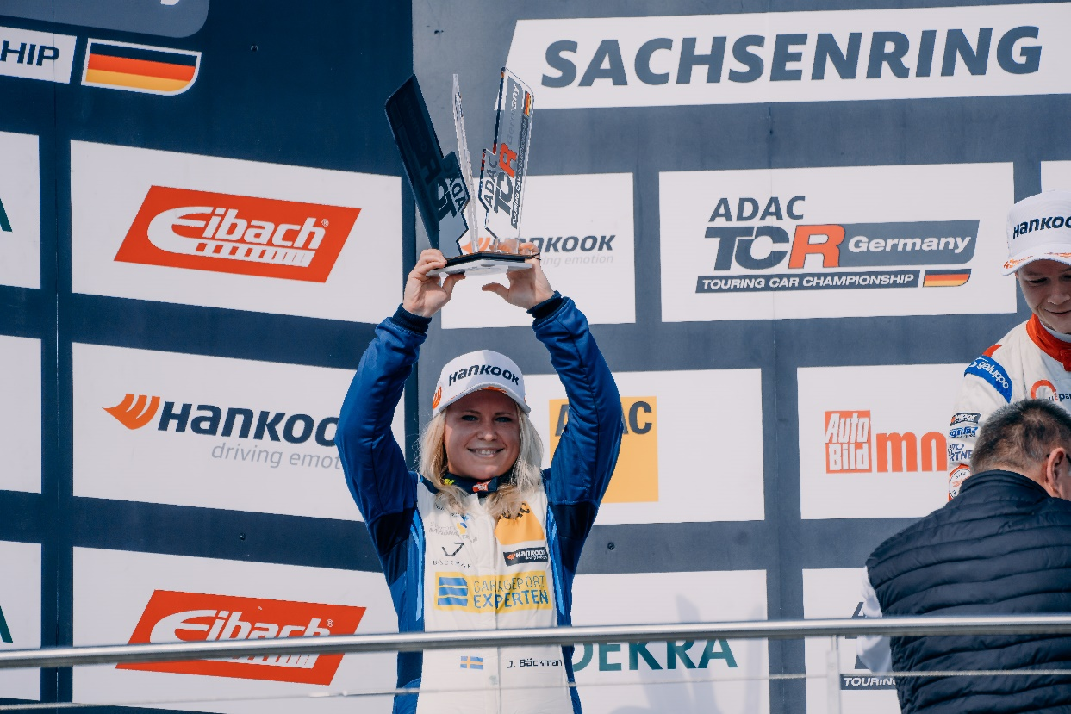
﻿
TCR Germany is one of the toughest TCR series in the world and has a high status of the drivers who come from several different countries around Europe. Each race weekend consists of two free practice sessions on Friday, one qualifying session on Saturday which determines the starting position in Race 1 on Saturday, and one qualifying session on Sunday which determines the starting position in Race 2 on Sunday. Points are awarded to the top 8 in the time qualifying and the top 15 in each race. The driver with the most points after the final race at the Hockenheimring at the end of October will take home the "ADAC TCR Germany Drivers Title" in the ADAC TCR Germany series. Last weekend, September 23-25th, the sixth round was held at the Sachsenring track in Germany, where Jessica finished on a third place in Saturday's Race 1 and then finished on a second place in Race 2 on Sunday.
- It has been a challenging weekend, both learning the tough hilly Sachsenring track and the new Audi car. Considering the limited preparations, I'm very happy about the performance, we took big steps forward every time I sat in the car, it bodes well for the final at Hockenheim October 20-23rd, Jessica Bäckman says.
Changing team & car in the middle of the season did not stop Jessica's success
The Sweden National Team driver took a big step from the two free practice sessions on Friday morning to the qualifying’s in the afternoon. Jessica qualified in 2nd place in the first qualifying and then finished 3rd in the second qualifying. In Race 1 on Saturday, Jessica started from second position and got off to an impressive start and was up and close to the first place already in the first corner. But then had problems with the grip during the first laps, when a small drift caused her to drop down to fifth place. In the end, the Sweden National Team driver managed to drive up to third place, which was the first podium place but the new team Comtoyou Racing and car Audi RS3 LMS
-Saturday's race was tough, I was happy with the start but after that I didn't feel quite comfortable in the car, the grip was missing the first few laps. In the end, I am satisfied that I managed to race myself up and take a podium place, a nice revenge after the difficult weekend at the Lausitzring, Jessica Bäckman says.
﻿﻿﻿﻿
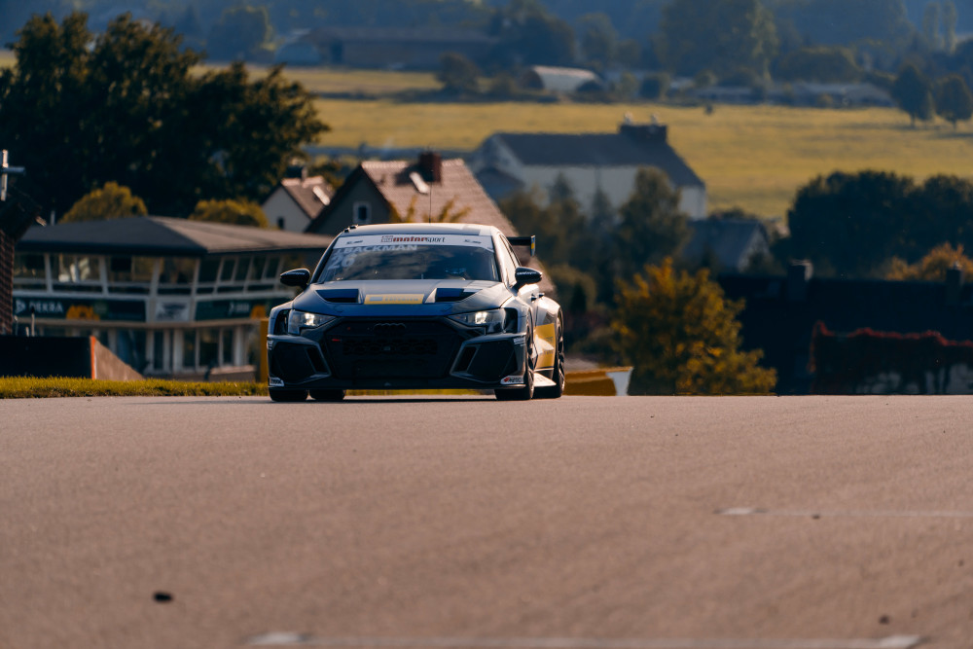
2 out of 2 podiums at Sachsenring
On Sunday, the team had made some changes to the car for Race 2 and Jessica had analyzed Race 1 to find the fastest way around the Sachsenring circuit. The Sweden National Team driver felt much more comfortable with the car and could now challenge for first place throughout the race. Jessica got off to an even better start from her third position on the grid and was up to second place going into Turn 1. After that she chased the leader Martin Andersen from start to finish, gaining time lap after lap. In the end, it wasn't enough, as Jessica was beaten by just over a second by Martin Andersen, who also secured the championship at the Sachsenring. Jessica finished the race in a strong 2nd place and collected important points for the championship. This means that Jessica has now taken a total of 8 podiums this season including 4 wins and is still 2nd in the championship with one race weekend remaining.
-On Sunday, the car felt a lot better from start to finish. I got an even better start, which I was very happy with as I was a little worried about how the starts would work with the Audi. We also showed good speed throughout the race and had a chance at first place, but it wasn't enough all the way. Now I'm really looking forward to the final at Hockenheim in a few weeks. Then we go to a track I like and with more time in the car, I aim to finish the season with a win. Many thanks to Comtoyou Racing for this weekend, Jessica Bäckman says.
﻿
Jessica’s results:
Free Practice 1: 4th place
Free Practice 2: 4th place
Qualifying 1: 2nd place
Race 1: 3rd place
Qualifying 2: 3rd place
Race 2: 2nd place
Championship standings:
ADAC TCR Germany – Total (Top three)
ADAC TCR Germany 2022 (after 6 of 7 raceweekends)
1: Martin Andersen (DKK), 372 p.
2: Jessica Bäckman (SWE), 281 p.
3: Szymon Ladniak (POL), 243 p.
Click to see the full championship standings
﻿TV links in case you missed last weekend’s races:
Race 1: Click to watch Race 1
Race 2: Click to watch Race 2
﻿Free rights to use images

