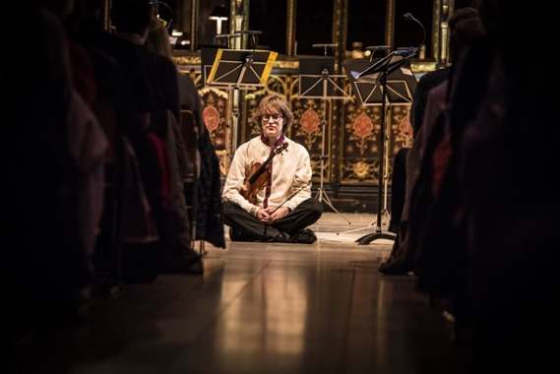
“Past, present and future bound together in an act of creative freedom:
a continuous elaboration of the absolutely new.”
Hugo Ticciati

Striving to live in the present moment through the medium of sound is the quest that guides the artistic life of violinist and artistic director, Hugo Ticciati.

• Hugo curates a series of innovative collaborations in the UK across 2018
• Wigmore Hall Purcell weekend on 7-8 April will also be the launch of debut O/Modernt album, White Light
• Kings Place artist-in-residence for Time Unwrapped annual series
• Artist-in-residence with RPS Ensemble of the Year Manchester Camerata
• linked education events for all ages including symposiums, masterclasses and outreach

The past is an inexhaustible source of inspiration for artists working in every creative field. O/Modernt (Swedish for ‘Un/Modern’) is the concept devised by Hugo Ticciati that celebrates the imaginative act of looking back by using inventive programming to explore vital connections between old and new. As performer and curator, Hugo’s musical year in London starts in January with the first of his six contributions to the Time Unwrapped series at Kings Place, conceived as a tribute to the magic power of music to stretch, condense, reverse, loop and suspend time. In April Hugo will be curating a Purcell-themed Festival O/Modernt weekend at Wigmore Hall.

As Kings Place Artist-in-Residence for 2018, Hugo will be presenting six unique and eclectic concerts for Time Unwrapped, a cycle of concerts marking the ten-year anniversary of the award-winning Kings Place Unwrapped series. In the course of 2018 Hugo will be performing at Kings Place with a host of world-class artists, including Evelyn Glennie, Víkingur Ólafsson, VOCES8, and the Sanddorn Balance artist, Miyoko Shida Rigolo. The first concert on 21 January is a French-inflected portrait recital featuring Messiaen, Rameau, Lutosławski, Ravel, and improvisations on themes deriving from Bach. Concerts later in the year include UK premieres of Erkki-Sven Tüür’s violin concerto (September) and Schnelzer’s Apollonian Dances (March).

On 7 and 8 April Henry Purcell and his inimitable ground basses provide the creative spark for a weekend Festival O/Modernt at Wigmore Hall. Four O/Modernt concerts and a symposium take their inspiration from Purcell’s Dido and Aeneas: Laments and Consolations based on the iconic descending fourth; Shakespeare-Inspired Rap, accompanied by funked-up Purcellian ground basses; Sexy Spanish Chaconnes; and Fairest Isle, devoted to Purcell and his English musical compeers.

Hugo summarises the aspirations of Festival O/Modernt and his yearlong London residency as follows: ‘O/Modernt’s aim is to open up new cultural spaces in which dialogues can take place between diverse genres and styles of art, based on a shared sense of reflection and surprise that takes audiences from familiar to exotic musical places in order to reawaken active innovative listening. The special interaction of listeners and performers makes each of this year’s collaborations a unique journey into the present moment.’

Among other events in 2018, Hugo will be enjoying a residency with RPS Ensemble of the Year, Manchester Camerata. April sees the launch of the debut O/Modernt Chamber Orchestra album, White Light: The Space Between, in collaboration with cellist Matthew Barley, sarod player Soumik Datta, tabla player Sukhwinder Singh, and overtone singer Gareth Lubbe. White Light explores an interchange of contemplative traditions, combining East and West, classical and popular, and includes a cover ensō created by Antony Gormley in response to the music. The 2-disc album will be launched at the weekend Festival O/Modernt at Wigmore Hall in April. Passionate about musical education, Hugo will be closely involved in a range of international masterclasses, workshops, and lectures. He is Vice-Artistic Director of Lilla Akademien, a specialist music school in Stockholm, and in April he will lead the O/Modernt Chamber Orchestra on a tour of India where they will be involved in outreach projects and concerts.

21 January 2018, 6.30 pm at Kings Place | Portrait: Hugo Ticciati & Friends
Hugo Ticciati Improvisations on Themes by Bach
Olivier Messiaen Theme and Variations
Witold Lutosławski Partita for Violin and Piano
Jean-Philippe Rameau Excerpts from Suite in A minor (1728)
Maurice Ravel Piano Trio
LINK http://bit.ly/ticciatiandfriends

Hugo Ticciati, London 2018
21 Jan | Portrait: Hugo Ticciati & Friends with Natacha Kudritskaja (piano), Julian Arp (cello) | Kings Place
2 Mar | Alternate Time Flows with Dame Evelyn Glennie & O/Modernt Quartet | Kings Place
7–8 April | Purcell from the Ground Up, a weekend Festival O/Modernt | Wigmore Hall
11 May | Time Stands Still with Víkingur Ólafsson (piano) & Miyoko Shida (Sanddorn Balance) | Kings Place
21 Sept | Looping Time Hugo Ticciati directing O/Modernt Chamber Orchestra | Kings Place
1 Dec | Mozart’s Requiem with O/Modernt Chamber Orchestra, Mary Bevan, VOCES8, et al. | Kings Place
5 Dec | Quartet for the End of Time with Mark Simpson, Alasdair Beatson & Andreas Brantelid | Kings Place

For press tickets to any of Hugo’s concerts, contact Louise Hughes: louise@omodernt.com or call +447886 196450
Media enquiries: Sofie Haag, sofie@fromswedenproductions.com, T. +46 (0)70 688 38 84
Hugo Ticciati
As violinist and artistic director, Hugo imbibes all possible forms of creativity. Performing premieres at Carnegie Hall, improvising with monks in India, or devising innovative programs for Festival O/Modernt, Hugo embraces life in its transient fragility and beauty, never forgetting to return to the greatest of all musics—silence. As Arvo Pärt wrote, ‘Hugo has a rare ability to convey a profound understanding of the music and shed light on its spiritual intent.’

‘Violinist Hugo Ticciati is so full of music and expressive power that he makes everything vibrate with excitement.’
—Dagens Nyheter, Sweden

