News Release November 13, 2013 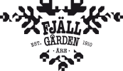
New ski lift puts Åre’s Hotell Fjällgården at the centre of the slopes – and village

With the winter season impending, a new chapter begins in the century-long history of Hotell Fjällgården and the Åre Funicular, as the six-chair ski lift Fjällgårdsexpressen opens right outside our doors.
The new Fjällgårdsexpressen lift, which opens just in time for Christmas, will pass just by the hotel, leading up to Sadeln with slopes to the Björnen and the Åre By ski areas. This six-chair lift will place Hotell Fjällgården at the very hub of the Åre ski system. The Funicular, with regular departures from Åre Torg, makes the Grill Fjällgården restaurant easily accessible for many more lunch and dinner guests, aside from the hotel guests.
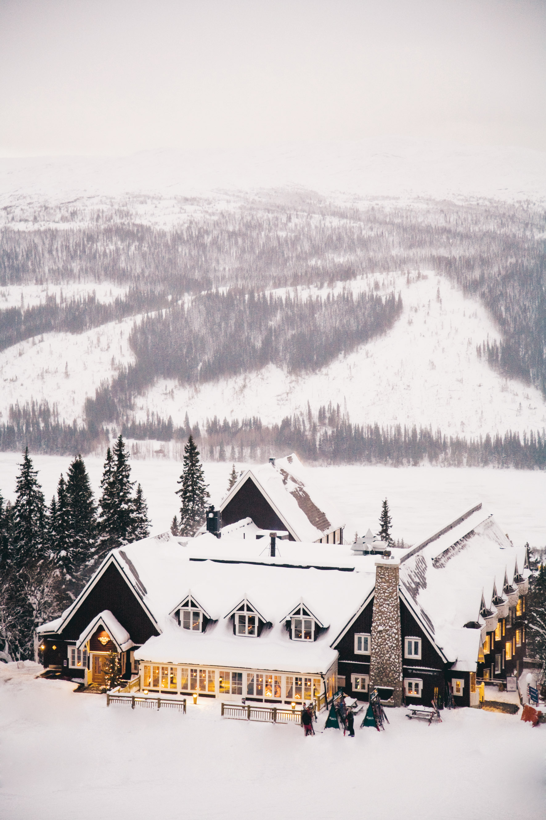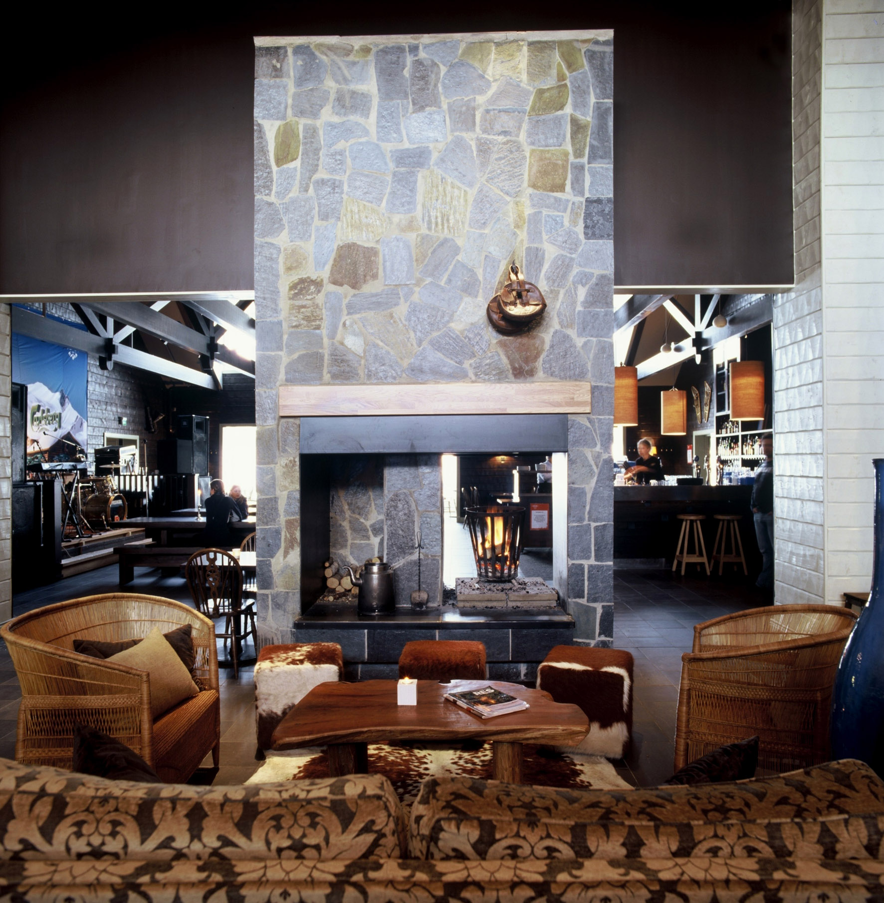
Grill Fjällgården opened last season with a new interior by architect Ulla Knutsson – also known as the designer of Fjäderholmarnas Krog, Den Gyldene Freden and Cultur Bar – combined with a new cooking concept. This is centered around the Josper grill, with a menu of charcoal grilled main courses and a selection of side dishes.
On two occasions this winter, January 30 through February 2 and March 13-16, Grill Fjällgården will feature a guest appearance by master chef Christer Lingström – when at Edsbacka Krog, he led the first establishment in Sweden to be awarded two stars by the Guide Michelin. In the Grill Fjällgården kitchen, Lingström will be grilling hamburgers to perfection.
“With Christer Lingström at the Josper grill, the Funicular and the Fjällgården express right outside our door, Hotell Fjällgården becomes a natural meeting place,” says Henrik Samuelsson, CEO of Hotell Fjällgården. “This winter, getting here will become even more convenient through Malmö Aviation’s new direct flight Stockholm Bromma-Östersund, and additional departures from Göteborg and Malmö to Östersund.”
For further information, contact Elin Ryer, elin@atv.se, +46 70-767 01 10 or visit www.fjallgarden.se

Åre’s Hotell Fjällgården is located on the slopes in the village centre, with the Åre Funicular and the Fjällgårdsexpressen lift right outside the door. The Hotel is open all year and offers 66 guest rooms, two restaurants, conference facilities, a spa and relax area with an outdoor pool during summer and outdoor wooden hot tubs during winter. Fjällgården Åre is operated by ATV Holding AB which also runs restaurants Ullådalsstugan and Rautjoxa Värdshus in Åre, as well as Den Gyldene Freden, Cultur Bar and Fjäderholmarnas Krog & Magasin in Stockholm.

