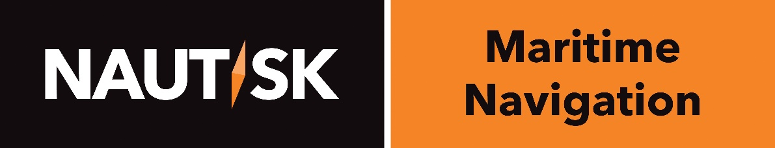

Press Release

FOR IMMEDIATE RELEASE, London, 05 March 2015

A new direction for Navigational Publications:
Nautisk launches NaviTab

World leading chart distributor Nautisk unveiled its latest navigational solution today to the maritime and shipping media in the prestigious surroundings of the HQ of the International Maritime Organization (IMO) in central London.

NaviTab from Nautisk is a unique new concept that replaces a vessel’s onboard Navigational Publication library. Hundreds of vital books have been uploaded onto a hi-spec hand-held device, suitable for use both onshore and on the bridge.

Speaking at the launch, Nautisk CEO Thomas Fjeld said:

“Currently, all vessels sailing global routes must carry a full portfolio of navigational publications (NPs) in order to sail compliantly and meet SOLAS Regulation. These NPs include a number of IMO Publications, Sailing Directions, Pilot Guides, Radio Signals and list of lights.”

“Having to carry this amount of hardback books on the bridge of a vessel where space is already at a premium can be challenging for most shipowners and navigating officers. In addition to storage issues, each and every publication needs to be manually updated for the latest corrections, an exercise which can be extremely time consuming and one which potentially offers a chance of human error.”

“NaviTab is a brand new solution developed by our team of experts that we expect to revolutionise the way vessels manage their onboard NPs. NaviTab stores hundreds of up to date NPs on one single tablet device, which is updated automatically and can be used by shore based and onboard teams.”

NaviTab’s optimised, super-fast search engine automatically locates the latest available publications in a vessels’ holdings and licenses latest editions as and when they are available, meaning that whatever route a vessel is sailing and wherever it is in the world, it will always be compliant and its publication holdings up to date.

more/

Users can search in seconds to find the relevant publication for a particular voyage, bookmark essential notes and add their own. Information and notes can be easily cross referenced and essential data highlighted using the hand written text recognition feature.
Peter Pran, Nautisk Head of Global Sales said:
“Every year, chart distributors such as Nautisk ship hundreds of tons of paper publications to Fleets all over the world. Due to their urgent nature, most of these shipments are airfreighted. Switching to NaviTab’s complete digital library allows a greener form of shipping, with less strain on the environment and a smaller carbon footprint.”
“NaviTab is an all-in-one solution that once purchased, does not require any complex user training, license costs or upgrade fees. In fact, all that is required is an internet connection. We are confident that the investment that customers make with NaviTab will offset their usual freight fees in just one year.”
NaviTab is presented on a hi-spec Lenovo Think Pad 10 with a user-friendly touch-screen interface. It is IP54 Certified and comes with a rugged case. It is insured against accidental damage and backed up by Nautisk’s 24/7 technical support and customer service from its global hubs located across the world in five regions.
To discover more about what NaviTab can do, visit the website: www.navitab.com

Ends

Follow Nautisk on twitter: @nautiskonline
Nautisk.com

Issued by Emma Jones PR on behalf of Nautisk
Cell: +44 7590 750489

