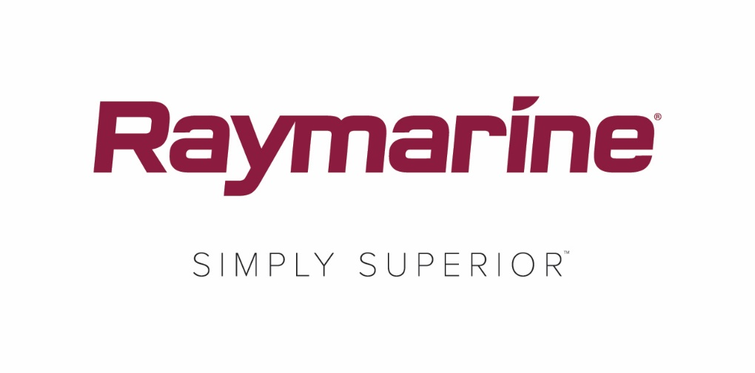
Raymarine Axiom now Supports Yamaha Command Link Integration
FLIR is pleased to announce the addition of Yamaha Command Link and Command Link Plus integration into Raymarine’s family of Axiom® multifunction displays. This new capability is one of many new features introduced with the recent release of the ​LightHouse Annapolis 3.9​ operating system for Axiom.
Certified by Yamaha, Raymarine’s Axiom series of multifunction can now display the instrumentation for up to 4 Yamaha outboard engines on a single display. The Axiom engine data display echoes the look and feel of Yamaha’s digital instrument displays and is compatible with a wide array of Yamaha outboards installed on existing boats as well as on new boats.
Raymarine’s integration with Yamaha outboards gives boaters a big-screen view of engine parameters, tank levels, battery status, and more. Raymarine and Yamaha integration is ideal for boats with towers and secondary control stations, allowing captains to see exactly what’s happening with their engines from any networked Raymarine Axiom display.
Just about any boat with Yamaha Command Link or Command Link Plus can be integrated with Raymarine’s Axiom multifunction displays using Yamaha’s optional NMEA 2000 gateway and pigtail. Boats equipped with Yamaha Helm Master or Set Point systems can also integrate with Raymarine using Yamaha’s optional NMEA 2000 gateway (6YG) and Yamaha’s CL7 display.
In addition to Yamaha Command Link integration, LightHouse Annapolis 3.9 adds several other major features and enhancements for Raymarine Axiom. The free LightHouse Annapolis 3.9 OS update is available now for ​Axi​om, Axio​m Pro, Axio​​m XL, eS Series and gS Series multifunction displays at raymarine.eu/multifunction-displays/lighthouse3/.
Home to thousands of boaters, steeped in rich maritime tradition and a magnet for generations of sailors, powerboaters and fishermen, the coastal city of Annapolis is the inspiration behind the name of Raymarine’s latest LightHouse operating system update. Beginning with LightHouse 3.9, Raymarine is adopting alphabetical names for LightHouse OS updates that pay homage to the great boating destinations of the world.
Whether you sail, fish or cruise, LightHouse 3 Annapolis unlocks powerful new features and functionality in your Raymarine Multifunction display. As with every Raymarine LightHouse operating system update, downloads are free and easy at ​http://www.raymarine.eu/multifunction-displays/lighthouse3
####

Media contact:

Karen Bartlett
Saltwater Stone
+44 (0) 1202 669 244
k.bartlett@saltwater-stone.com

