**Alpine A110 Pikes Peak: Heading for the summits!**

17/05/2023

**In its irresistible quest to the top, Alpine is launching an assault on the American summits, starting with the most famous ascent across the Atlantic: Pikes Peak. This adventure, which has been underway since November 2022, has accelerated in recent weeks with the first runs of the Alpine A110 Pikes Peak, specifically designed for the event. After tests in the Drôme and in Val Thorens validating the technical solutions, this new car is now getting ready to take off on Monday for the United States, where new challenges await it throughout the month of June.**

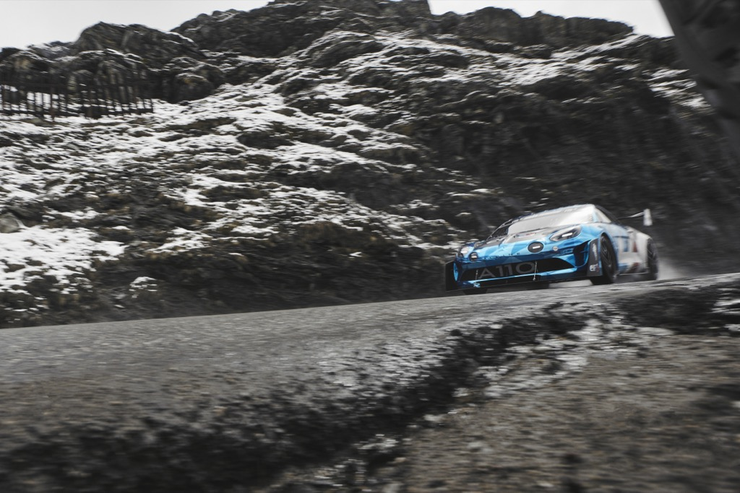

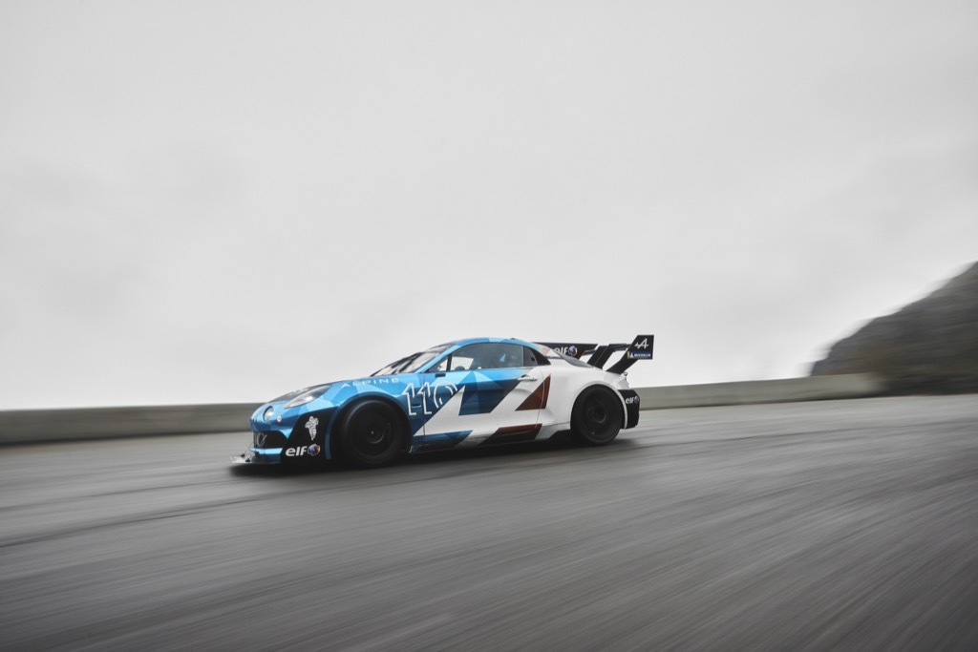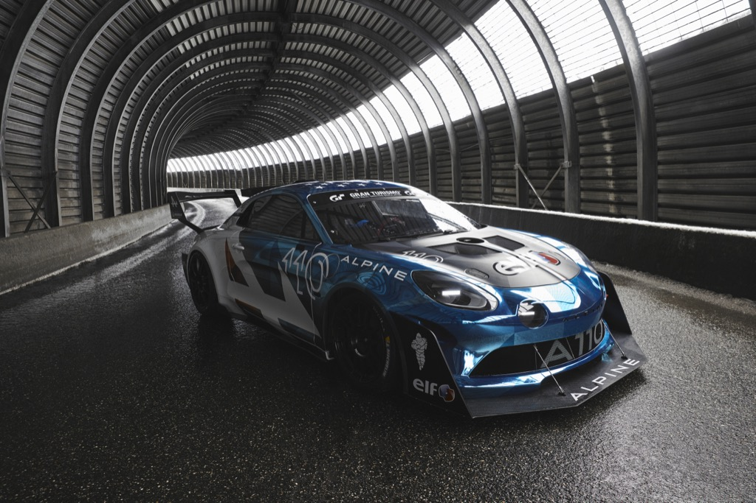

*"Alpine's history has been built on challenges. From Jean Rédélé's first ventures to our present-day challenges, the brand's DNA is as vibrant and present as ever. This quest for performance leads us to always aim higher, towards the summits. Hill climb racing has always been a passion of the A-arrow enthusiasts. Today, our unquenchable thirst for competition brings us to Pikes Peak, a motorsport event that has captured the imagination for decades. We look forward to being there with our partners from Signatech and Raphaël Astier, racers whose drive is matched only by their unwavering hunger for challenge. To race on a legendary course, we needed a car fit for the event. The Alpine A110 Pikes Peak is here. It is the culmination of Alpine's art. Aggressive, extreme and stylish, this project again embodies our roots, present and future, all in a country of strategic importance. We stay humble, but we are determined to give our best on the other side of the Atlantic to write a new and unforgettable chapter in the history of Alpine through this magnificent adventure to the clouds."* ***Laurent Rossi, Alpine CEO***

*"Pikes Peak is a must-do motorsport event. We have all been motivated by the iconic footage of this climb, and this dream has naturally found its way into our teams. We are competitors, and the challenge is appealing, to say the least. We know quite well that this is a different, particular and specific exercise on an atypical course, but that only makes the challenge all the more motivating. We want to stamp the Alpine name on this event, and this first-ever participation will allow us to set ourselves among the stiff competition in our category. Although we are not aiming for the overall win, we know we can rely on a versatile and high-performance car with this Alpine A110 Pikes Peak designed for the event. We are also fortunate to have the support of our loyal partners Elf and Michelin as well as one of our best ambassadors, Raphaël Astier, who brings his wealth of experience in this event after his international title with Alpine. This entry also allows us to consolidate Alpine's position as a brand present in all forms of motorsports."* ***Philippe Sinault, Signatech CEO***

**PIKES PEAK, THE MYTH**

Featuring among the most legendary races, the Pikes Peak International Hill Climb is one of the longest-running automobile competitions in the United States. Held in the Rocky Mountains since 1916, this motorsport landmark has undergone many changes over the past century, but remains among the most challenging sporting events.

Affectionately known as "the race to the clouds", this hill climb features a 19.93 km long course with 156 turns, starting at an altitude of 2,865 metres and finishing about 1,440 metres higher. The cars, bodies and nerves are put to the test. The difference in air pressure significantly influences engine power output throughout the course, whilst the drivers often have to deal with a particularly dusty road, changing weather conditions, different exposures to the sun, blind curves and the ever-present threat of the ravine!

Always ready to take on the toughest challenges, the Alpine and Signatech teams will tackle Pikes Peak on Sunday 25 June with the Alpine A110 Pikes Peak, which has been the object of a masterpiece of engineering to grasp the subtleties of this iconic climb.

***Did you know?***

The Alpine A110 won the well-known French Le Mont-Dore hill climb in the Under 1300cc class in 1965 with the late Jean-Pierre Jabouille. Five years later, Jean Ortelli won the national Groups 3 & 4 titles with the Alpine A110 1300. And in 2020, Anthony Dubois echoed this resounding success by taking the GT Sport crown in the French Mountain Championship with an Alpine A110 GT4.

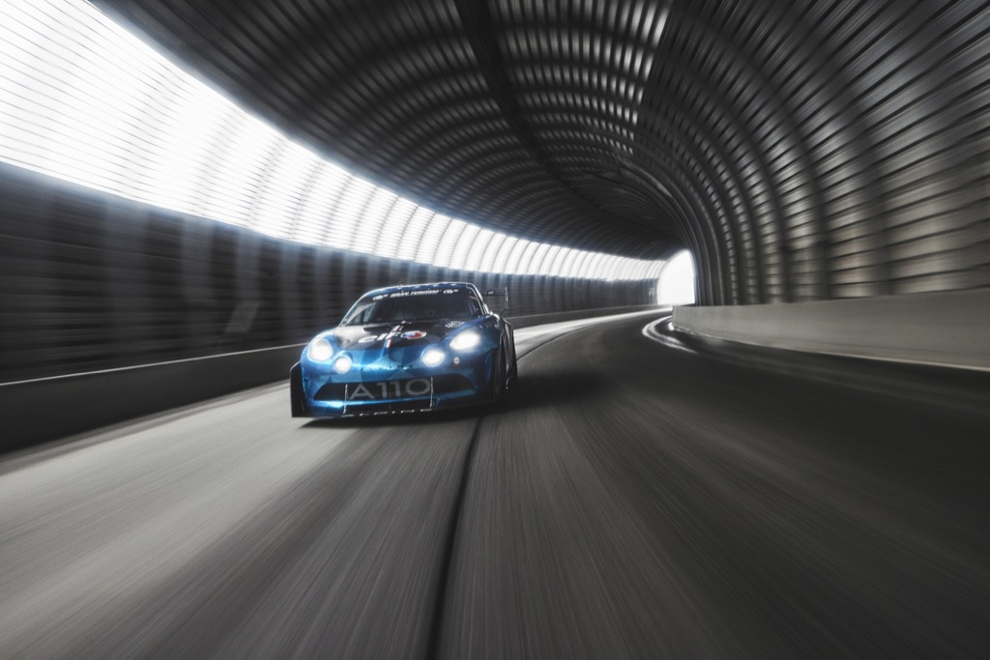**FRANÇOIS LETORT: "THE A110 PIKES PEAK PUSHES THE BOUNDARIES OF OUR IMAGINATION"**

Technical manager for all customer racing activities around the Alpine A110 Cup, A110 GT4 Evo and A110 Rally, François Letort took on the challenge of adapting the new berlinette to a unique challenge. Today, he unveils the first secrets of the Alpine A110 Pikes Peak...

**What was the genesis of the Pikes Peak project?**

"Pikes Peak is one of motorsport's landmarks. It's a race I've always been familiar with, and early in my career, I was lucky enough to work for a supplier involved in Jean-Philippe Dayraut and Sébastien Loeb's projects. Within Signatech, the idea emerged in 2022, but we had other priorities back then. Everything finally came together in November with the enthusiastic support of Alpine. We quickly started with sketches and meetings with our most important suppliers to be as responsive as possible."

**How does someone approach such a challenge for the first time?**

"We formed a commando operation led by our technical director Lionel Chevalier. I was appointed project manager while working on the electronics side, while Etienne Mulon was put in relation with the design. Additional support came on board as needed, but the roles were naturally divided with the Alpine design office, our engine partner Oreca - as for all our programmes with the Alpine A110 - and our suppliers. Chronologically, we first carried out preliminary studies combining turn-by-turn analysis and a rally stage approach. We tried to collect data from the climb, but we were unsuccessful, so we studied a lot of videos, then collected impressions to refine our initial observations of the demands of Pikes Peak."

**How did the collaboration with the design office go?**

"It was a pleasure to collaborate with the Alpine design office, with whom we quickly moved in the same direction thanks to our in-house expertise and ability to be extremely reactive. Our core business lies in this strength, and we were also able to rely on a network of local suppliers and subcontractors who were attentive to our needs. For example, the designers quickly proposed a dynamic air intake. This snorkel gives the car an aggressive look, and we immediately adopted it by adjusting the air intake. We quickly responded to their ideas, and this responsiveness is one of the many reasons for the success of this fruitful and productive collaboration."

**Was it an obvious choice to use the Alpine A110 GT4 Evo as a base?**

"We are proud of all the cars produced for Alpine in customer racing, and the idea was to come with our GT4 as the Time Attack category offers great diversity with many brands in the field. So, naturally, we went down this route to maintain the spirit of our original target."

**What can you tell us about the technical specifications?**

"We focused on the lightweight of the car to keep the Alpine DNA. We worked on the weight by removing everything unnecessary for this event. We went from an Alpine A110 GT4 Evo of 1,080 kg to the Alpine A110 Pikes Peak of 950 kg. We have revised the cinematics and the damping while retaining many standard parts. At the same time, we worked extensively with Oreca to specifically adapt the engine-gearbox assembly to the challenge of the gradient. With a start at an altitude of 2,800 metres and a finish at 4,400 metres, the demands on the power supply are huge, as we lose 100 millibars of pressure as soon as we climb 1,000 metres. The aim was to keep the same amount of power input throughout the climb without going overboard. We have been working hard to ensure that the performance is always the same, which has required a lot of work on this significant power increase compared to the capacity of our engine. The large turbocharger received special attention to eliminate any lag phenomenon and throttle response time. Lastly, our partner Elf was deeply involved in providing us with specific fuel and lubricants to enable us to maintain an optimal level of performance at any altitude.”

**What about the tyres?**

"We already work closely with Michelin in all the Alpine customer racing programmes organised by Signatech. Pikes Peak offers an open regulation for tyres, and Michelin already has a specific range for hill climbs. We chose the Michelin Pilot Sport H S5C+ with a differentiated tyre size of 17 inches at the front and 18 at the rear. We decided with Michelin to go with a narrower front tyre size after reducing the car's weight to extract the full potential of this truly unique Alpine A110 Pikes Peak."

**How helpful was Raphaël Astier in this project?**

"His experience has been invaluable in many areas. His previous participation has helped us immensely and freed us from the requirements associated with the newcomer status. As it is our first entry, we needed people who already knew about the event. We aim to get the best out of the car and driver we have. We need to put everything together to perform well, and Raphaël's contribution is crucial as there is so much to gain in driving. What's more, he knows the fundamentals of the car and has an outstanding record in a category at Pikes Peak!"

**Are you satisfied with the final result?**

"The Alpine A110 Pikes Peak has pushed the boundaries of our imagination, far beyond anything we could have imagined in the early days. The first tests went very smoothly. The Alpine A110 Pikes Peak achieved all its initial targets, a tour de force in such a short-time frame. It was an exhilarating project, and we all look forward to the legendary challenge ahead with this spectacular car, visually and performance wise!"

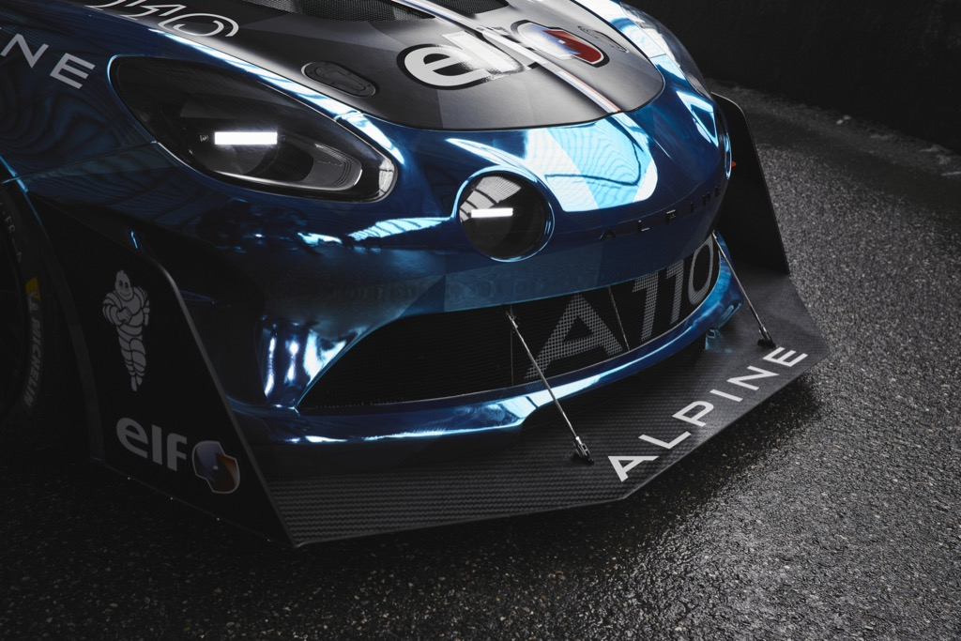**RAPHAËL LINARI: "THE WILDEST SIDE OF AN ICONIC ALPINE"**

Raphaël Linari is Alpine's chief designer and has worked at Renault Group for over ten years. Raphaël has been at the heart of some of the most ambitious projects of the A-arrow brand, including the future Alpine Hypercar, and had the opportunity to display his most expressive side with the Alpine A110 Pikes Peak.

**How was the design office involved for the Alpine A110 Pikes Peak?**

"Last year, Laurent Rossi, Philippe Sinault, David Gendry and Anthony Villain met to discuss several projects during the Abu Dhabi Grand Prix. Pikes Peak was studied and validated, and we started working on it in December. It was an extremely exciting and stimulating adventure. It is a legendary competition, and the desire to create the wildest Alpine A110 was highly motivating. I already had some ideas and a fairly clear vision in this direction, and we were able to outline the project with the Signatech teams on 23 December. They blew us away by accepting all our ideas, even the craziest ones, to make this car atypical and iconic."

**How did you overcome the tight agenda for this project?**

"We were aware of the performance requirements as well as the viability and creation of the specific parts. We aimed for efficiency with Signatech. Our goal was to have the most impactful and distinctive car possible within the shortest timeframe and given constraints. We worked hand in hand and clearly understood each other, and nothing was impossible. It has allowed us to materialise many ideas."

**How did you join the Alpine's line with the brutality of Pikes Peak?**

"More than a harmony, we wanted to make the most visually striking object possible. A race like Pikes Peak requires a demonstrative, almost wild car, amongst the American monsters. It had to stand out, and this was a unique opportunity to make a truly extreme car."

**How does this visual impact manifest itself?**

"Pikes Peak is a race where you need a lot of aerodynamic downforce, but the Time Attack regulations limit us in widening the body and tracks. Therefore, on this Alpine A110 GT4 Evo base, we have added very pronounced splitters at the front and deflectors on the edges of the front bumper. On the sides, we have borrowed the side skirts and diffuser from the Alpine A110 R. There is also an air intake on the roof to provide air to the engine, which is now nearly 500 horsepower. Lastly, there is this huge wing at the rear."

**Has this project allowed you to fulfil some ideas?**

"Indeed! It was extremely inspiring as we all have a vision of the A110. For a long time, I wanted to make a central shark fin on the rear window and, to make it even more extreme, I imagined it cutting the rear wing in two. The result is quite spectacular and punchy. With the repositioning of the light functions, we have a laser cutting and broadening the rear wing. It is one of the strongest details of this car. At the same time, we also worked on the front light signature, with two other very thin lasers giving a truly aggressive look. Pikes Peak was the perfect medium to showcase the Alpine A110, whose reinvention is more exciting than ever... And several easter eggs remain to be discovered!"

**How would you sum up this project?**

"The A110 Pikes Peak brings out the wildest side of this iconic car. It is already agile and light by design, but with its specific aero and extreme proportions, it becomes a genuine racing beast. This legendary event was an endless source of inspiration to push our creativity and transcend the A110 while integrating performance constraints. Thanks to the close collaboration with Signatech's technical teams, this project was completed in a very tight timeframe. We look forward to seeing our creation challenge the American powerhouses on their home turf. I want to thank Jun Okazaki and Victor Sfiazof, the two designers who worked with me on the design of this car. Not to mention the fantastic collaboration with the expert and enthusiastic Signatech team."

**Q&A WITH RAPHAËL ASTIER**

French Rally Cup winner in 2016, Raphaël Astier also scored FIA R-GT Cup titles in 2018 and 2022. In the wake of his international title with the Alpine A110 Rally, the 32-year-old French driver is about to make his fifth start at Pikes Peak, where he holds the Time Attack 1 class record of 9:23.721s…

**Raphaël, what does this project mean to you?**

"Pikes Peak is a legendary race that I always dreamed of, and I am thrilled to return for the fifth time in my career. It is an honour to be part of this adventure initiated by Alpine and Signatech after two years of competition with the Alpine A110 Rally. I am so proud to be the driver chosen for this programme, and I can't wait to provide all my on-site experience and knowledge to the brand in its first runs at Pikes Peak. While winning overall is not the target, I am convinced that the Alpine A110 Pikes Peak will perform well in its Time Attack category. It's an extremely motivating project, and I think we will have a lot of fun while giving our best for Alpine in this first appearance!"

**What are your first impressions after driving the Alpine A110 Pikes Peak?**

"The first runs went very well. We tested for three days in France, and the results were extremely positive. The car is very agile and easy to drive. The chassis sticks to the ground, the engine looks promising, and the weight loss makes the Alpine even more dynamic than it already is naturally. It feels very light and responsive, with very direct steering and no delays in shifting. We now need to confirm this good feeling on other roads and heights, but our debut has been more than positive, and I am confident."

**What are the biggest challenges for any driver at Pikes Peak?**

"There are four practice mornings during the week of the competition. The competitors are divided into several groups from Tuesday to Friday, and each day, we work on a given sector. We get to discover the course throughout the week, but we never run the complete climb before the event, when we only have one attempt. That's what makes it so unique. On Sunday, you have to give it all you’ve got from the start. You have to immediately get into the rhythm and not let up, even if it's the first and only time you know the evolution of the tyres and their pressures over the entire course. Fortunately, I am lucky enough to have a bit of experience with four starts already under my belt. The other catch is that a lot of the sections look the same. Many incidents are due to confusion between two corners. When you're in the thick of it, some things can throw you off, so you have to remain focused, and that's quite a challenge in itself."

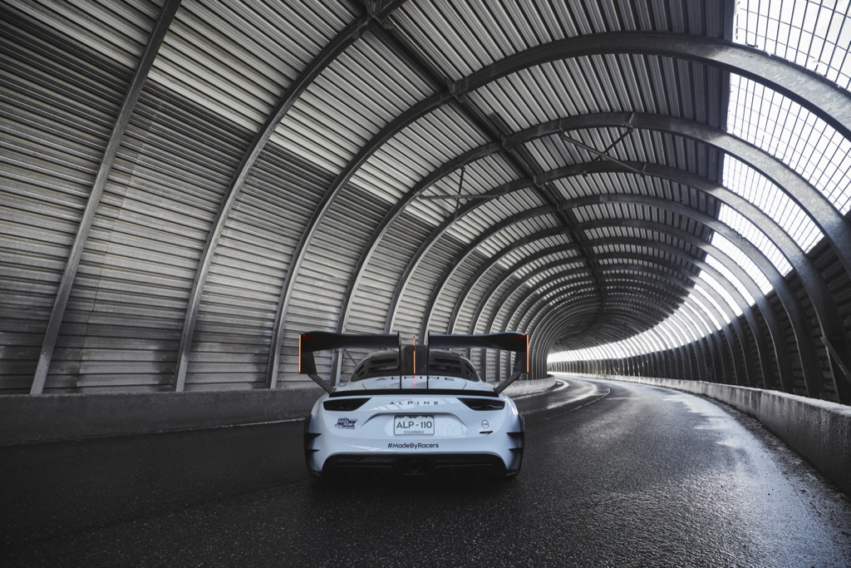

**Q&A WITH LIONEL CHEVALIER**

Signatech Technical Director Lionel Chevalier oversees all the projects linked to the Alpine A110 for customer racing. Initiator of this new adventure along with Philippe Sinault, the Frenchman explains the main challenges taken up by his teams before looking ahead to Colorado...

**What do you think of this new Alpine A110 racing version?**

"At the beginning of our collaboration with Alpine, we never imagined that we would offer so many different versions, but the success is well and truly beyond our expectations. We had previously thought of adapting an A110 GT4 for hill climbing, but we had never gone this far with a car specifically designed for Pikes Peak. Alongside the A110 Cup, A110 Rally and A110 GT4, it is thus a fourth model intended for racing, with new and dedicated parts as well as different cinematics. It has been meticulously thought out whilst respecting the DNA and nature of the Alpine A110, and we are very proud of this new close collaboration with Alpine and its design office to offer the best of our worlds."

**What were the targets of the test sessions?**

"With such a tight timeframe, we had less than a month between the completion of the car and its departure for the US. This schedule was a challenge as we had no room for mistake. Carrying over many well-known parts helped us make the right technical calls to avoid fundamental issues. The tests went very well. We first conducted engine-specific tests on track to validate things before focusing on the chassis driving on twisty rally stages to prepare for Pikes Peak and its varied road profile. We then went to Val Thorens to do the same at altitude, although the snow and the closure of the passes meant we couldn't run above 2,400 metres. We knew it would be difficult to find roads at Pikes Peak elevations in Europe, but we were productive in gathering valuable data for what’s next!"

**What adjustments have been necessary, and what are the next steps?**

"We tested two types of gearboxes to try out different ratios and make our choice for our first runs at Pikes Peak. We also worked hard on the suspension and damping in close collaboration with our long-time rally supplier, ALP Racing Suspension. On Monday, the Alpine A110 Pikes Peak returned to Bourges. We cleaned it up after it ran in the snow, and then we are servicing and preparing it for its departure to the USA this coming Monday. We will do a shakedown on Thursday 8th June at a track near Denver to ensure the car is operational as all fluids need to be drained for its journey. Then we will immediately switch to the first three days of testing at Pikes Peak from 9 to 11 June. These will run from 5:30 am to 8:30 am before the road reopens for tourists, another unique feature of the event!"

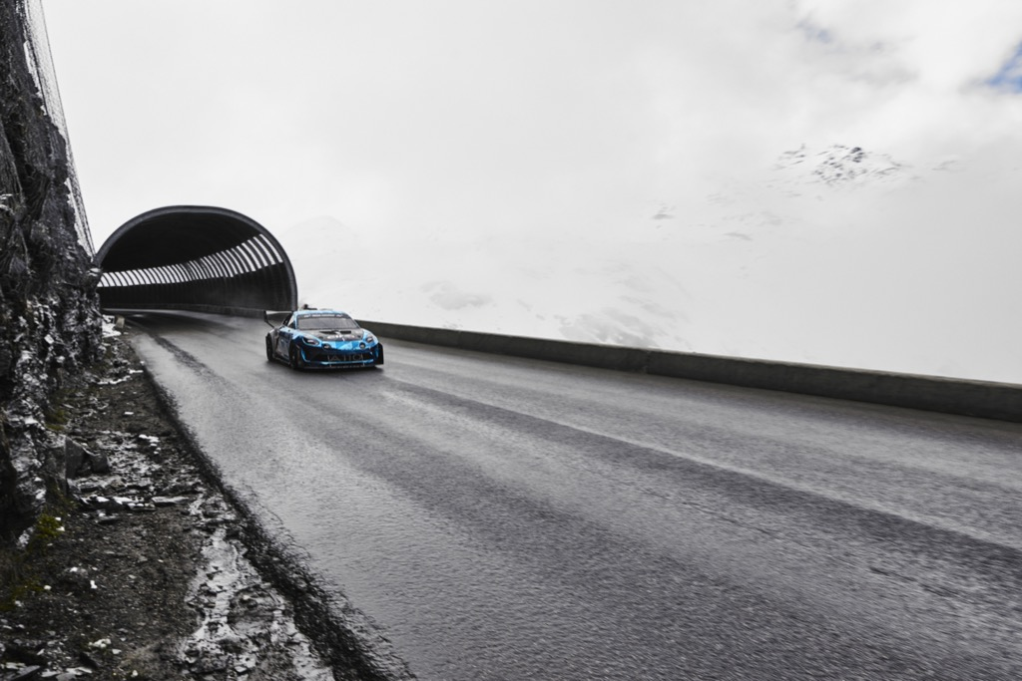

**TECHNICAL SPECIFICATIONS**

**CHASSIS**

Type Aluminium monocoque

Safety Multi-point roll cage

Bodywork Aluminium

Aerodynamics Front splitter with fins, flat bottom, A110 R side skirts, rear fins, A110 R diffuser, rear wing, rear window with integrated shark fin

**ENGINE**

Type Four-cylinder 1.8-litre 16v

Layout Rear mid-mounted

Power 500hp at 7,500rpm

ECU Magneti-Marelli SRG 140

**TRANSMISSION**

Type Rear-wheel drive

Gearbox 3MO six-speed sequential

Controls Steering-wheel mounted

Differential Self-locking, limited slip

Clutch Sintered steel twin-disk

**AXLES AND SUSPENSION**

Suspension Double Wishbone, Coil Springs & Anti-Roll Bars

Shock absorbers ALP Racing Suspension, 3-way adjustable

FR brakes Ø 355x32mm, six-piston Brembo callipers

RR brakes Ø 300x28mm, four-piston Brembo callipers

Steering Electric power-assisted

**WHEELS**

Rims Aluminium, 8x17’’ (FR) et 10x18’’ (RR)

Tyres Michelin 20-61x17 (FR) and 27-65x18 (RR)

**DIMENSIONS, WEIGHT AND CAPACITIES**

Length/width/height 4,230 / 1,850 /1,240 mm

Wheel base 2,415 mm

FR/RR tracks 1,580 / 1,555 mm

Fuel tank FIA FT3 homologated, 25 litres

Weight Approximately 950 kg

**How to follow Pikes Peak :** [**https://ppihc.org/how-to-follow/**](https://ppihc.org/how-to-follow/)

**ABOUT ALPINE**

Founded in 1955 by Jean Rédélé, the brand has set itself apart with its French-style sports cars. In 2018, the brand presented the new A110, a sports car faithful to Alpine's timeless principles of compactness, lightness, agility and driving pleasure. The Alpine Business Unit was created in 2021 and thus became the brand dedicated to innovative, authentic, exclusive sportscars of the Renault Group, benefiting from the heritage and craftsmanship of its historic plant in Dieppe and the Alpine Racing and Alpine Cars teams engineering mastery.

**PRESS CONTACTS**

**Orianne TAMBURINI**

Head of product communication Alpine

[orianne.tamburini@alpinecars.com](mailto:orianne.tamburini@alpinecars.com)

+33 (6) 26 63 28 14

**India de la Fressange**

Press Officer Motorsport

[india.deseignarddelafressange@fr.alpineracing.com](mailto:india.deseignarddelafressange@fr.alpineracing.com)

+33 (6) 34 48 51 31

**FOLLOW OUR BAND OF RACERS!**

**FACEBOOK**

@alpinesportscars

**TWITTER**

@AlpineCars

@SignatechAlpine

@AlpineRacing

**INSTAGRAM**

@alpinecars

@alpine_endurance_team

@alpine_racing

**TIKTOK**

@alpinecars

**YOUTUBE**

@AlpineCars

**SITES INTERNET**

www.alpinecars.com

media.alpinecars.com