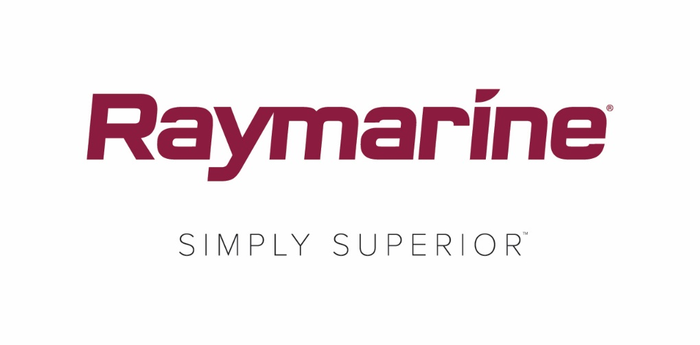
Marine Industry First: Raymarine Delivers Axiom UAV App
New LightHouse 3.6 update for Axiom MFD offers integration with DJI Mavic Pro Drones

Delivering a marine electronics industry first, Raymarine Axiom users can now take to the skies with the latest LightHouse 3.6 OS update. The new Axiom UAV app brings together the power and simplicity of Raymarine navigation with advanced unmanned aerial imaging.

Compatible with the popular and highly capable DJI Mavic Pro drone, the Axiom UAV app automates many common tasks including launch, airborne imaging, in-flight navigation, and return-to boat. Fishing and cruising boats alike can greatly benefit from having this added aerial imaging platform integrated onboard.

Advantages include:

Virtual Tuna Tower
Launch the Mavic Pro and use its camera system to scout for fish in the water ahead of the boat. When fitted with an optional polarized lens, the Mavic Pro’s 4K UHD camera system can see gamefish, baitfish, weed lines, sandbars, reefs and more. This technology allows smaller boats many of the fish-scouting advantages once limited to boats of a very specific size and cost.

Capture the Action
Capture the action of landing trophy fish. Use Axiom UAV’s Fish-On feature to instantly launch the UAV, start video recording, and automatically fly the camera in an orbit around the boat. Convenient on-screen controls let you fine-tune the UAV’s altitude, orbit radius, orbit speed and camera angle right from the screen of your Raymarine Axiom or Axiom Pro.

Birds-Eye Viewing on the Big Screen Axiom MFD
Free your drone from your tiny Smartphone screen and view imagery on your sizeable Raymarine Axiom or Axiom Pro MFD screen. Shoot video, take still images, and capture other imagery you can see from the air, all easily saved to Mavic’s onboard memory card.

Scout Ahead with UAV Goto
Fly to points of interest, waypoints, or chart locations. Use the UAV GOTO command on your Axiom or Axiom Pro chartplotter screen to send the UAV out on a mission. Using GPS navigation, the Mavic Pro will fly to the precise location you selected and hover on station. While airborne you can see the UAV on your navigation chart along with its course, speed, altitude and camera orientation.

Automated or Manual Flight Controls
The Axiom UAV app offers multiple options to control the Mavic Pro in flight, including an automatic “Return to Boat” feature. In addition to the automatic flight modes, Axiom UAV also offers virtual on-screen joysticks for manual flight. You can also take control at any time with the DJI Mavic Pro joystick controller.

Axiom UAV is a free update for Axiom, Axiom Pro and Axiom XL multifunction displays. The LightHouse 3.6 update is now available for Axiom owners to download directly to their Wi-Fi-enabled MFDs or users can download the software from the Raymarine.com website.

For more information on the Raymarine Axiom UAV APP visit
http://www.raymarine.com/multifunction-displays/lighthouse3/v3-6/.

####

About FLIR Systems
Founded in 1978 and headquartered in Wilsonville, Oregon, FLIR Systems is a world-leading maker of sensor systems that enhance perception and heighten awareness, helping to save lives, improve productivity, and protect the environment. Through its nearly 3,500 employees, FLIR's vision is to be "The World's Sixth Sense" by leveraging thermal imaging and adjacent technologies to provide innovative, intelligent solutions for security and surveillance, environmental and condition monitoring, outdoor recreation, machine vision, navigation, and advanced threat detection. For more information, please visit www.flir.com and follow @flir.

About Raymarine:
Raymarine, a world leader in marine electronics, develops and manufactures the most comprehensive range of electronic equipment for the recreational boating and light commercial marine markets. Designed for high performance and ease of use, the award-winning products are available through a global network of dealers and distributors. The Raymarine-branded product lines include radar, autopilots, GPS, instruments, fishfinders, communications, and integrated systems. Raymarine is a brand of FLIR Systems, a world leader in thermal imaging. For more information about Raymarine please go to www.raymarine.com.

Media contact:

Karen Bartlett
Saltwater Stone
+44 (0) 1202 669 244
k.bartlett@saltwater-stone.com

