Picture gallery: The World’s 10 Largest Factories

**The Size of a Small Town**

**It's easy to get lost in these factories. With an area of up to 10 million square meters, the world's largest production facilities are as big as a town. ​**[**Machineseeker.com**](http://www.machineseeker.com)**, the marketplace for used machinery has published a ranking of the 10 largest factories.**

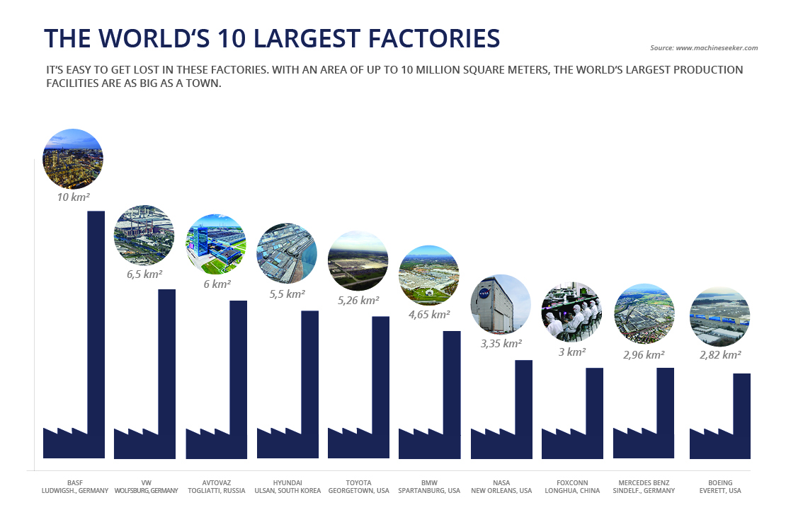

They are home to enormous production lines and at the same time the work and living space for up to 500,000 employees. The largest factories in the world have their own fire brigades, ports or hospitals. They function like real cities with their own road network and an inner city.

In the ranking of Machineseeker.com there are mainly technical companies, most of them from the automotive industry. Their highly automated production lines require a lot of space but are also extremely efficient. At the Hyundai plant in South Korea, on the fourth place in the ranking, 5,600 cars are produced every single day - one vehicle every 12 seconds.

The VW plant in Wolfsburg with its 6.5 million square meters ranks second. The factory's built-up hall area alone is as large as the entire Principality of Monaco. NASA's assembly centre, on the other hand, accommodates space rockets that transport space vehicles, astronauts and supplies into space. A rocket is 65 metres high - the height of a 16-storey high-rise!

**Hall areas as large as Monaco**

But you don't have to travel across the world to see large production sites. Because the world's largest factory is located in Germany. BASF in Ludwigshafen, the world's largest chemical site, employs about 39,000 people. Even manufacturers of huge missiles cannot compete with the traditional German plant, which was established in 1865 and is now 10 million square meters in size - the NASA and Boeing plants only rank seventh and tenth place respectively.

It is unlikely, however, that the industry will continue to outbid itself with ever larger factories. "The factory 4.0 must be able to react highly flexibly to current customer desires, prognosticates Thorsten Muschler, managing director of Machineseeker.com. "This requires smaller, more responsive production plants that are organized decentrally and, at best, localized directly at the point of consumption.

[*Machineseeker.com*](http://www.machineseeker.com)*, the leading online marketplace for used machines, has put together a picture gallery of the huge factories for you. Have fun clicking through.*

**About us**

[Machineseeker.com](http://www.machineseeker.com) is the world's leading online marketplace for used machinery. More than 5,000 dealers currently offer more than 140,000 machines on the platform. As a globally active marketplace, the company is available with Machineseeker.com in over 60 country versions. Used machines worth more than 700 million euros are inquired monthly.

**Press Contact**

**Patrick Ratzke**Head of PR, Marketing & Sales  
Machineseeker.com – The leading marketplace for used machinery

Tel.: +49 (0) 201 458 455 72  
Fax: +49 (0) 201 857 86 111  
Mobil: +49 (0) 176 439 912 53  
Email: [ratzke@machineseeker.com](mailto:ratzke@machineseeker.com)

**Link to download the picture gallery**

<https://press.machineseeker.com/latest_media/tag/the-worlds-10-largest-factories>

Press information: Re-publication is royalty-free. Source of the images must be indicated. We would be delighted to find our link [www.machineseeker.com](http://www.machineseeker.com) in your article.

**Ranking and Sources of Images**

**The World’s 10 Largest Factories:**

1. BASF// Ludwigshafen, Germany// 10 km² total area  
   Bildquelle: BASF SE
2. Volkswagen AG//Wolfsburg, Germany// 6,5 km² total area  
   Bildquelle: Volkswagen AG
3. AvtoVAZ// Togliatti, Russia// 6 km² total area  
   Bildquelle: Renault
4. Hyundai// Ulsan, South Korea// 5,5 km² total area  
   Bildquelle: Hyundai Motor Company
5. Toyota// Georgetown, USA// 5,3 km² total area  
   Bildquelle: Toyota Motor Company
6. BMW// Spartanburg, USA// 4,7 km² total area  
   Bildquelle: BMW Group
7. NASA// New Orleans, USA// 3,4 km² total area  
   Bildquelle: https://flic.kr/p/RvgvPS, Rawpixel Ltd, Lizenz: CC BY 2.0
8. Foxconn// Longhua, China// 3 km² total area  
   Bildquelle: https://bit.ly/2HenzTW, Steve Jurvetson, "glue works", Uploaded by Zolo, Lizenz: CC BY 2.0
9. Mercedes-Benz// Sindelfingen, Germany// 2,9 km² total area  
   Bildquelle: Daimler AG
10. Boeing// Everett, USA// 2,8 km² total area  
    Bildquelle: https://bit.ly/2XZED5g, David Axe - Flickr: KC-767 1, Lizenz: CC BY-SA 2.0

**Picture Captions**

**The World’s 10 Largest Factories**

**10th place**

With its factory in Everett, Washington and a total area of over 2.8 million square meters, the aircraft manufacturer Boeing ranks 10th in our ranking. The site is so large that it could accommodate 392 football pitches.

**9th place**

With its 2.96 square kilometres, the Mercedes-Benz plant in Sindelfingen is the automobile manufacturer's largest factory in terms of area and ranks 9th in our rankings. However, the Group's most effective production site is now outside Germany. The factory in Beijing produces more than 430,000 vehicles annually - 110,000 cars more than Sindelfingen.

**8th place**

Apple supplier Foxconn's plant in Shenzhen, China, ranks 8th among the world's largest factories. Around 500,000 employees live and work in "Foxconn City," which is roughly equivalent to the population of Lisbon. The production plant is repeatedly in the headlines because of its poor working conditions and increased suicide rates among workers.

**7th place**

The NASA assembly plant near New Orleans, Louisiana, is home to a 70-meter-high vertical assembly facility, the world's largest robotic missile assembly tool. With its 3.4 square kilometres site, it is almost as large as the famous Central Park in New York.

**6th place**

The BMW plant in Spartanburg, a town in the state of South Carolina in the USA, is ranked 6th on the list. The factory set a record right at the start - only 23 months lay between the initial ground-breaking ceremony and the first car that rolled off the assembly line.

**5th place**

Toyota Motor Manufacturing Kentucky, in short TMMK, was the automobile manufacturer's first US plant. The factory was designed to recycle or reuse any waste generated at the plant - none of it is sent to landfill. This works so well that other companies are already having their waste recycled at the Toyota plant.

**4th place**

The 4th place of the ranking is taken by a factory of unimaginable size - the Hyundai factory in Ulsan, South Korea. The factory covers an area of 5.5 million square metres, has its own harbour, fire brigade, hospital and is planted with around 500,000 trees.

**3rd place**

The Togliatti plant, number 3 on our list, is located in Russia and belongs to the largest Russian car manufacturer, AvtoVAZ, better known under the brand name "Lada". Renault-Nissan bought into the company in 2008, which is why the Russian plant also produces various Nissan and Renault models in addition to the Lada.

**2nd place**

The Volkswagen plant in Wolfsburg is in 2nd place with 6.5 million square metres of factory premises. Built in 1938, the factory produces around 800,000 vehicles a year (as of 2017) and employs more than 62,000 people.

**1st place**

The world's largest factory is in Germany. It is the BASF plant in Ludwigshafen with 10 million square meters of factory premises. The main plant houses a good third of the chemical company's employees worldwide.