Kongsberg Digital partners with MAN Energy Solutions on digitalization project with Höegh Autoliners
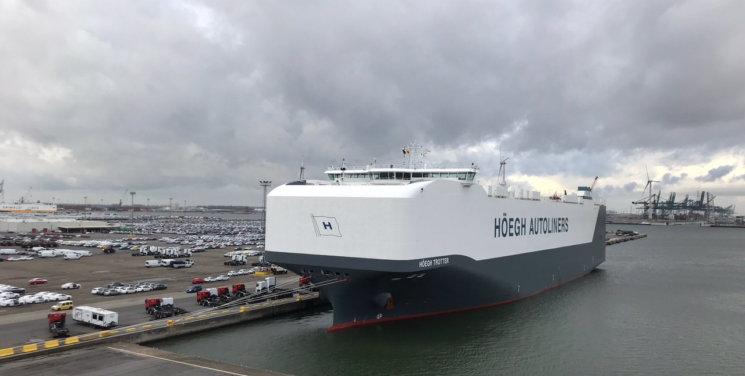
By combining the benefits of Kongsberg Digital’s Vessel Insight and MAN Energy Solutions’ PrimeServ Assist, Höegh Autoliners will gain a holistic data infrastructure solution to facilitate efficient operation

Kongsberg, Norway, September 28th, 2020 – Kongsberg Digital and leading engine manufacturer MAN Energy Solutions are entering into a strategic digitalization partnership, formalizing the Memorandum of Understanding (MoU) signed by the two companies in October 2019. The first project undertaken by the partnership will be to deliver joint digital infrastructure to Höegh Autoliners, marking the first step in their stated aim to work together in accelerating the rate of digitalization in the maritime industry and securing greater value for customers on both sides.
The agreement to collaborate in developing digitalization solutions for the maritime sector came about as the two companies realized that their separate efforts in this space were complementary. Kongsberg Digital’s recently launched Vessel Insight – a new, cost efficient data infrastructure solution for the maritime market – is a natural match with MAN Energy Solutions’ PrimeServ Assist digital solution for optimization of engine use and maintenance.
Vessel Insight captures contextualized data from vessels and fleets for use in value generating applications for ship owners and operators, so by integrating the data from PrimeServ Assist will be able to provide a more holistic picture for the majority of vessels with MAN Energy Solutions’ two-stroke engines on board. With two major maritime vendors collaborating on a common data infrastructure, customers will benefit from interfacing with one system instead of many, automated data integration, and a larger selection of digital solutions. This will make the digital transformation faster and more cost efficient for customers in the maritime sector.
“The engine is the most critical component onboard a vessel, and this strategic collaboration will ensure optimal operation and maintenance of the engine,” says Hege Skryseth, President, Kongsberg Digital. “This will generate significant value for our customers. We look forward to working together with MAN Energy Solutions and our customers to ensure that they get the digital solutions that fit their capabilities and needs.”
The maritime industry is in a transformational phase and is still learning new ways to extract additional value from digitalization, and with two major vendors now working together to further develop a powerful, safe and open infrastructure, this transformation will accelerate. For vendors of digital solutions and services, developing value adding applications and software for customers will be easier and more cost efficient, which in turn leads to a broader selection of available solutions. This will speed up the ability to digitalize and gives ship owners and operators a quicker return on their digital investment.
Per Hansson, Head of Digital and Strategy, MAN Energy Solutions, says: “We are constantly searching for opportunities to bring the benefits from digital development to our customers faster and more easily. Our advanced analytics and support services are areas where we can provide unique benefits to our customers’ businesses – further optimizing the operation, maintenance and availability of their vessels. Working together with renowned industry partners like Kongsberg Digital gives us one more way to provide our services to our customers, and to jointly further digitalization within the maritime sector.”
The inaugural project with Höegh Autoliners is currently in a testing and validation phase, with a goal to enable real time engine monitoring and digital assistance for optimization, while reducing digital equipment onboard. Kongsberg Digital will provide its data infrastructure solution, Vessel Insight, for real time data transfer while MAN Energy Solutions will deploy PrimeServ Assist for engine data analysis.
Geir Frode Abelsen, Head of Technical Operations in Höegh Autoliners said: “For us at Höegh Autoliners, this collaboration is an important step towards the utilization of digital solutions in optimizing the running and maintenance of our engines in a safe and effective way.”
Ends

For further information, please contact:

Mathilde Vik Magnussen
VP Communications & Marketing
Kongsberg Digital
Tel: +47 4567 8255
mathilde.magnussen@kdi.kongsberg.com

Safia Reddy
Head of Communications
Höegh Autoliners
Tel: +47 400 39 857
safia.reddy@hoegh.com
Nils Søholt
Group Communications
MAN Energy Solutions
Tel: +45 33 85 26 69
Nils.Soeholt@man-es.com

David Pugh
Saltwater Stone
Tel: +44 (0)1202 669244
d.pugh@saltwater-stone.com

About Kongsberg Digital
Kongsberg Digital is a provider of next-generation software and digital solutions to customers within maritime, oil and gas, and renewables and utilities. The company consists of more than 500 software experts with leading competence within the internet of things, smart data, artificial intelligence, maritime simulation, automation and autonomous operations.
Kongsberg Digital is subsidiary of KONGSBERG (OSE-ticker: KOG), an international, knowledge-based group delivering high-technology systems and solutions to clients within the oil and gas industry, subsea, merchant marine, defense and aerospace. KONGSBERG has 11,000 employees located in more than 40 countries.
Web: Kongsberg Gruppen | Kongsberg Digital
Social media: LinkedIn | Twitter | Facebook

About MAN Energy Solutions
MAN Energy Solutions enables its customers to achieve sustainable value creation in the transition towards a carbon neutral future. Addressing tomorrow’s challenges within the marine, energy and industrial sectors, we improve efficiency and performance at a systemic level. Leading the way in advanced engineering for more than 250 years, we provide a unique portfolio of technologies. Headquartered in Germany, MAN Energy Solutions employs some 14,000 people at over 120 sites globally. Our after-sales brand, MAN PrimeServ, offers a vast network of service centers to our customers all over the world.
Web: MAN Energy Solutions | MAN PrimeServ

About Höegh Autoliners
Höegh Autoliners is a leading global provider of RoRo transportation services. The company operates around 45 PCTC (Pure Car and Truck Carriers) vessels in global trade systems, making around 3 000 port calls yearly. With a fleet designed for maximum flexibility, we are able to cater for a wide variety of cargo. Our customers range from global vehicle manufacturers to producers of high and heavy construction equipment and other rolling and non-rolling stock. Höegh Autoliners is also a leading carrier of second-hand vehicles. The company is managed from a global network of 20 offices, owners’ representatives and agents. The Company has approximately 400 employees ashore and 1300 seafarers.
Web: Höegh Autoliners

