Power Woman presents WILD Collection
In our view, a wild woman embraces life and lives it to the fullest. She's wild in mind and bold in appearance. She's wild enough to believe she can do anything – and seizes any opportunity to achieve what she sets her mind to.
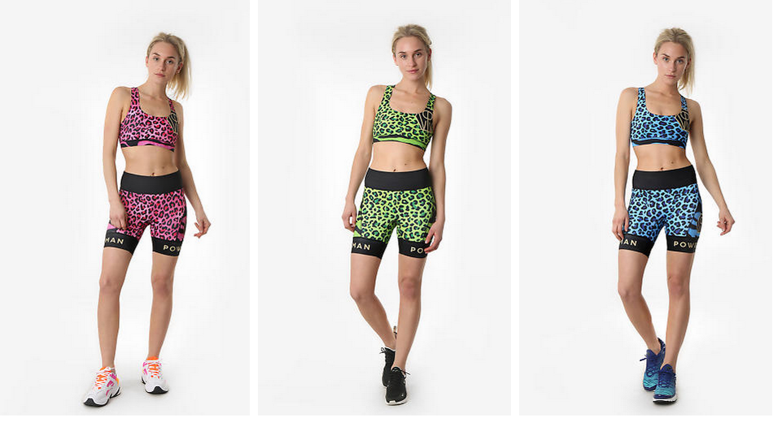
Power Woman's brand-new Wild collection is created for the woman who wants to stand out from the crowd and be bright and bold. To this end, we have chosen colours to match an equally strong and colourful personality. The colours and prints hint of exotic vibes and playfulness. We want you to have fun while engaged in your favourite activities – that and to look great while you train hard to achieve your goals.
The high-quality garments in the Wild collection are perfectly suited for performance sports, as they are both created and tested by marathon runners. Shorts come in an anti-chafing fit, with silicone at the leg endings and a wide elastic band in the waist to keep them in place. The top uses firm, quick-dry materials that provide support while running. All prints are made by hand and developed to endure tough, extreme training as well as sweat, sun and salt.
We created the Wild collection for running, but it will serve you just as well at the gym, when swimming or as summer wear. The technical Italian performance materials and the garments' excellent fit will help you perform at your best.
Our new collection, which includes a wide variety of sportswear, will be released in limited sets during the second quarter of 2019. The first two sets have been incredibly successful, with some prints selling out in the first weeks.

About Power Woman
Power Woman is a Swedish premium sportswear brand. Power Woman designs sports apparel that is perfectly tailored for the female body and extensively tested by the world's top female athletes. Our apparel combines fashion, fit and sports in one. The brand's founder is entrepreneur and triathlete Anna Wretling, who's passion is to empower women through the brand and through the sports community.

Team PowerWoman Athletic club.
Contact: info@powerwoman.com
Instagram: @powerwoman_official
Site: www.powerwoman.com

