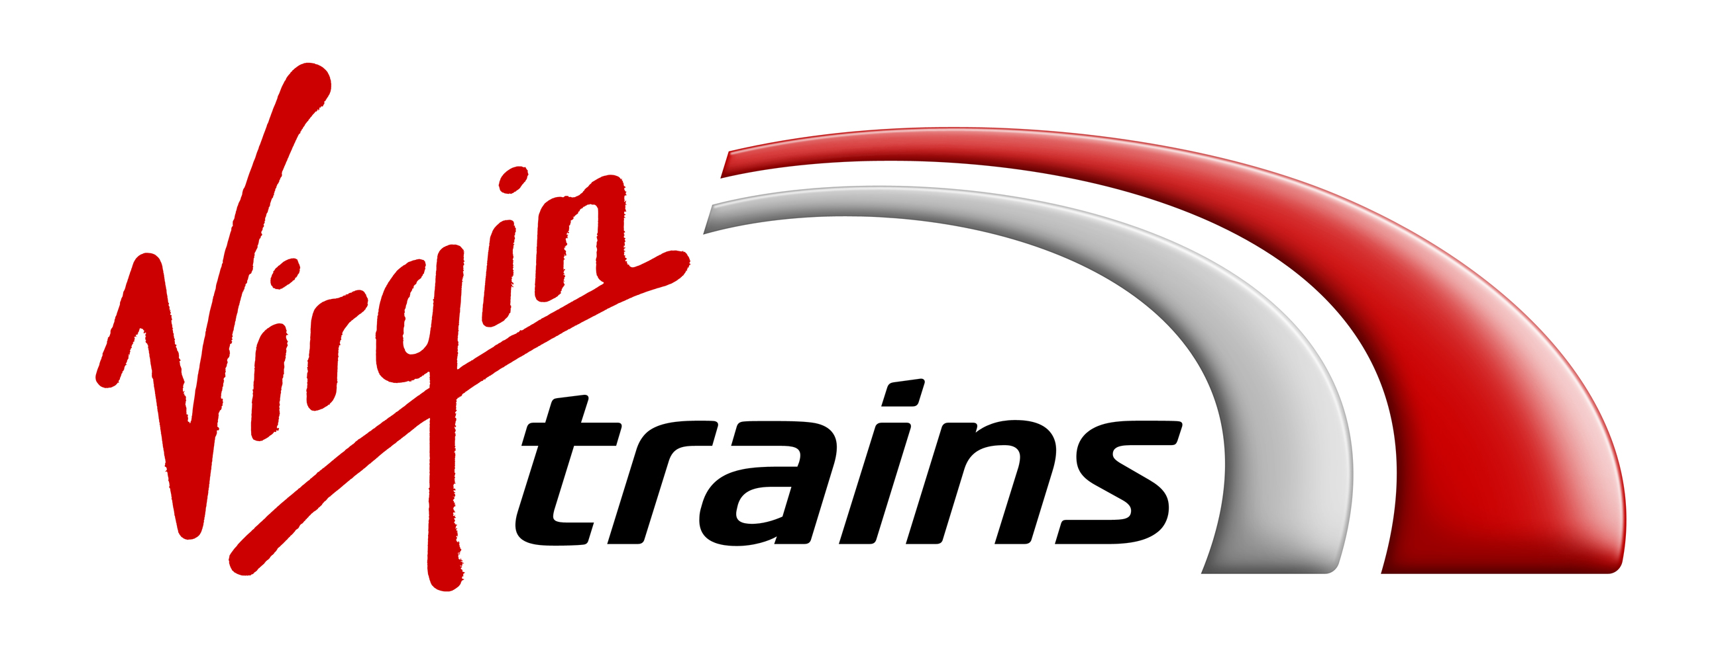

Press Release
EMBARGOED UNTIL 00.01 THURSDAY 28TH SEPTEMBER

PICTURE PAW-FECT! ALL CHANGE AS JAKE THE TRAINSPOTTING DOG MODELS NEW VIRGIN TRAINS UNIFORM
- Virgin Trains launches a new body-neutral uniform range for both East and West Coast
- Wayne Hemingway MBE and Gerardine Hemingway MBE created modern new look uniform
- Platform Pawtroller Jake receives his own special-edition uniform
- Zero waste to landfill initiative launched for old Virgin Trains uniforms

London, 28th September, 2017: Virgin Trains has today gifted a special-edition, tailored uniform for loyal Virgin Trains fan and trainspotter, Jake the Dog, to launch its new body-neutral uniform range for every gender, size and shape across both the East and West Coast.

To create the new uniform range, Virgin Trains involved its frontline staff as part of the re-design to get their expert opinion, from an extensive employee-wide survey on their favourite designs, to trialling initial versions on the job over two years.

The Virgin Trains body-neutral uniform offers up to six combinations (six for women and four for men) on the West Coast route, and up to ten combinations (ten for women and five for men) on the East Coast route.

When Virgin Trains decided to introduce a new body-neutral uniform for their staff, it wasn’t just the humans they were thinking of. Proving it fits all sizes, the new uniform has been created by British designers Wayne Hemingway MBE and Gerardine Hemingway MBE and Virgin Trains has even gone the extra mile for dedicated train fan, Jake the Dog.

Over nine years, Jake has been a regular sight at Virgin Trains stations and has become part of the Virgin Trains family; joining the station staff and delighting customers to welcome trains into the platform with lots of lively wags and barks.

As a reward for his devoted service, aside from his favourite doggy snacks, the design team set out to make Jake his own bespoke dog-friendly uniform, carefully measuring him from furry head to trainspotting tail to create a fetching look that would suit his unique personality and shape.

On receiving his new uniform, Neil McNamara, Jake’s owner, said;

“Jake’s always had a love and fascination for Virgin’s trains, he doesn’t bark for any other! His daily trip to the station is a real highlight for him. Over nine years he’s become a mascot for the regular passengers and we’re excited for him to show off his special uniform.”

Natasha Grice, Route General Manager, of Virgin Trains West Coast said;

“We involved our Virgin Trains staff from the very beginning of the design-process. There’s been a real passion behind creating the new stylish uniform. We wanted to combine everyone’s favourite parts to create up to six practical mix and match combinations*. We want our staff at Virgin Trains to feel their best, to be empowered to confidently express their own style and be their incredible selves, while still looking totally Virgin Trains.”

Jessica Kelly-Mckay, Uniform Delivery Manager, of Virgin Trains East Coast said;

“We want our people to be able to express their own unique style and personality, and that’s why we’ve worked with them to create a new tailored wardrobe to fit every shape, size and gender. The launch of our striking, new uniform combinations is another milestone on our journey towards totally transforming our East Coast service, and our customers can expect to see an extra spring in the steps of our staff as we roll it out.”

Wayne Hemingway MBE of HemingwayDesign said;

“The uniform took two years to make as we were determined to end up with designs that included significant input from the Virgin Trains team and were fully tested so as to be practical for their roles. We have also ensured that this is a collection with up to ten combinations in the knowledge that the Virgin Trains team are not “uniform” and quite rightly wanted to let their individual personalities shine through. The wide range lets Virgin Trains staff choose what they feel comfortable in and we hope they all wear their uniforms proudly, including trainspotting dog Jake, who is sure to turn some heads in his stylish piece.”

In an effort to achieve zero waste to landfill, the old Virgin Trains uniforms are being recycled into new items at HMP Northumberland. Ex-offenders will upcycle the old uniforms in the onsite textile factory, as part of a rehabilitation scheme that helps to prepare prisoners for life outside in an effort to reduce reoffending rates.

The HMP Northumberland textiles team will use the uniforms to create new items such as blankets and coats, which will be donated to local homeless charity, The Albert Kennedy Trust which supports young LGBT homeless people in crisis, and working with Virgin Trains charity partner, Rethink Mental Illness.

This initiative was developed by Virgin Trains, HMP Northumberland, and the Hubbub Foundation.

The new uniform was created by Wayne Hemingway MBE and Gerardine Hemingway MBE and manufactured and distributed by Hunter Apparel Solutions and Dimensions.

– ENDS –

For further information on Virgin Trains on the West Coast, please contact Lily Marriott at Kaper,
020 3301 2261/ lily@kaper.uk.com

For further information on Virgin Trains on the East Coast, please contact Dana Leigh at Kaper,
020 3301 2210 / dana@kaper.uk.com

*Virgin Trains West Coast uniform offers up to six combinations (six for women and four for men) and Virgin Trains East Coast uniform offers up to ten combinations (ten for women and five for men).

Notes to Editors:
Virgin Trains would like to thank the Hubbub Foundation for their introduction to HMP Northumberland and their continued support.

About Virgin Trains:
Stagecoach and Virgin are working in partnership to operate the East Coast and West Coast inter-city routes under the Virgin Trains brand. Together, they are on track to revolutionise rail travel across the UK.

The combined network connects some of the nation’s most iconic destinations including Glasgow, Liverpool, Birmingham, Manchester, Edinburgh, Newcastle, Leeds, York and London.

Virgin Trains is committed to delivering a high speed, high frequency service, offering shorter journey times, more comfortable travel and excellent customer service. Customers consistently rate Virgin Trains as one of the top long-distance rail franchise operators in the National Rail Passenger Survey (NRPS) commissioned by industry watchdog, Transport Focus.

On the East Coast route, £140m is being invested to create a more personalised travel experience. We have already invested over £40m in our existing fleet, including £21m refurbishing the interiors and £16m towards improving the engines of our trains. Customers can now benefit from 42 additional services between Edinburgh and London every week, and an extra 22 Saturday services between Leeds and London – a total of 1.74 million additional seats since May 2016. 2018 will see the introduction of completely new Azuma trains being built in the UK by Hitachi.

The West Coast route has a proud record of challenging the status quo - from introducing tilting Pendolino trains, to a pioneering automated delay repay scheme and becoming the first franchised rail operator to offer m-Tickets for all ticket types.

Visit the Virgin Trains Media Room - virgintrains.co.uk/about/media-room - for the latest news, images and videos. Subscribe here for regular news from Virgin Trains.
Press Office: 0845 000 3333.

About Hemingway Design:
HemingwayDesign is a multi-disciplinary design agency led by two generations of the Hemingway family and a wider team of talented designers. At HemingwayDesign, we have a firm philosophy – “Design is about improving things that matter in life.” It is this mantra that continually ensures our brave creative thinking and method for delivering positive, socially-responsible design. Our greatest strength lies in the multifaceted way we look at all projects, which comes from years of multi-disciplinary design. Our work takes us across culture-led regeneration, affordable housing, urban design, interiors, placemaking and events, exhibition design, brand, visual design and uniform – and we do it all with a community-focused and ethically minded approach.

Hunter Apparel Solutions:
Hunter Apparel Solutions Limited (Hunter) is a uniform and PPE specialist. Hunter is a third generation family company, which has evolved from being a traditional garment manufacturing company into a technology company which specialises in providing fully managed professional apparel solutions.

About Dimensions:
Dimensions is one of the world’s largest providers of corporate clothing solutions and is one of the most respected brands in the industry. Steeped in knowledge and expertise on delivering successful clothing solutions for people at work, the team at Dimensions is able to solve corporate clothing challenges through leveraging vast experience.

About Hubbub:
Hubbub is a charity that creates environmental and playfully designed campaigns with a difference that inspire people to make healthier, greener lifestyle choices, which more often than not help save money and bring people together. Hubbub concentrates on things people are passionate about and keeps things simple, offering practical and realistic solutions that help people to cut waste, make clothes last longer, save money and create cleaner spaces to live and work in.

About Rethink Mental Illness:
Rethink Mental Illness help millions of people affected by mental illness by challenging attitudes and changing lives. A better life is possible for millions of people affected by mental illness and today Rethink Mental Illness, along with its partners Hafal in Wales and Support In Mind Scotland helps tens of thousands of people every year to get through crises, to live independently and to realise they are not alone.

About Albert Kennedy Trust:
The Albert Kennedy Trust supports lesbian, gay, bisexual and trans homeless young people in crisis every day, dealing with the effects homelessness can have on young people's lives. The Albert Kennedy Trust has offices based in London, Manchester and Newcastle.

