LG OG GOOGLE PRÆSENTERER NEXUS 4
Ny smartphone kombinerer brancheførende hardware fra LG med den seneste og bedste Google-oplevelse

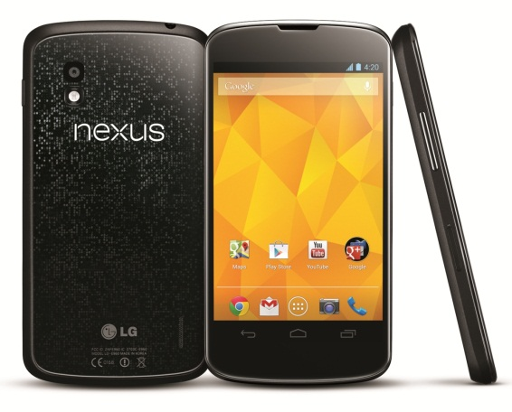
København, 29. oktober, 2012 – I dag præsenteres Nexus 4 – den nyeste model fra Googles Nexus-serie. Nexus 4 er udviklet i samarbejde mellem LG og Google og kombinerer sofistikeret hardwaredesign fra LG med den seneste version af Android™ for den bedste Google-oplevelse. For mere information og specifikationer, se venligst den engelske pressemeddelelse nedenfor.

Billeder i høj opløsning
For billeder i høj opløsning, gå til LGs billedarkiv og skriv ”Nexus” i søgefeltet til højre.

Pris og tilgængelighed
Nexus 4 vil være tilgængelig i udvalgte lande fra og med den 13. november. Pris og nøjagtig lanceringsdato for Norden offentliggøres snart.

For mere information, kontakt venligst

Susanne Persson
PR Manager
LG Electronics Nordic AB
Box 83, 164 94 Kista
Mobil: +46 (0)70 969 46 06
E-mail: susanne.persson@lge.com
Kristoffer Ejebro
Product Specialist MC
LG Electronics Nordic AB
Box 83, 164 94 Kista
Mobil: +46 (0)70 239 30 09
E-mail: kristoffer.ejebro@lge.com

____________________________________________________________________________
Se venligst den originale pressemeddelelse nedenfor:

LG AND GOOGLE ANNOUNCE NEXUS 4
Sleek, New Smartphone Combines LG’s Best-in-Class Hardware with the Best of Google

SEOUL, Oct. 30, 2012 – Designed collaboratively by LG and Google, Nexus 4, the newest smartphone in the Nexus line-up from Google, was announced today for availability starting next month in select markets. With a sophisticated hardware design from LG, your favorite Google Apps, and the latest version of Android™, Nexus 4 puts the best of Google in the palm of your hand.

“LG is proud and excited to play this role in helping build the latest Nexus smartphone,” said Dr. Jong-seok Park, President and CEO of LG Electronics Mobile Communications Company. “Users will be delighted by the perfectly balanced combination of form and function with the latest generation of Android.”

“This is the first time we collaborated with LG to build a Nexus device,” said Andy Rubin, Senior Vice President of Mobile and Digital Content at Google. “They brought an extraordinary amount of talent to the project, and the result is a feature-packed device that feels great in your hand, and blazingly fast under the hood.”

Capture and share your world
Nexus 4 comes with a high-performance 8MP camera and takes stunning Photo Sphere images, letting you capture every detail of the world around you. Up, down and all around you, it’s like no camera you’ve ever seen; with Nexus 4, you can snap pictures in every direction that come together into incredible, immersive Photo Spheres that put you right inside the scene. Plus, photos upload themselves with Instant Upload so you’ll never lose a shot.

All of this comes to life with stunning clarity and crisp, natural color on the vibrant 1280-by-768 4.7-inch True HD IPS Plus display supported by Zerogap Touch technology. Gently curved glass edges allow your finger to slide smoothly on and off the 320ppi screen, while cutting edge display technology means you feel like you’re touching every pixel, protected by scratch resistant Corning® Gorilla® Glass 2.

Built for speed
Nexus 4 comes with a cutting-edge Qualcomm Snapdragon™ S4 Pro processor, so you’ve got speed and power to spare. Zip around the web, experience rich 3D graphics and gameplay, and effortlessly switch between multiple apps without ever missing a beat. With 2GB of RAM and the fastest version of Android ever, Nexus 4 is the snappiest Nexus smartphone yet.

Information at your fingertips
Nexus 4 comes with the latest Google apps, putting the best of Google in the palm of your hand. The latest version of Google Now is built-in, which keeps you even more organized – get reminders about upcoming flights, restaurant reservations, hotel confirmations and even nearby photo opportunities – when and where you need them.

Get to the places you care about quickly and easily with Google Maps™ for Android. With turn-by-turn GPS navigation, live traffic info, and integrated driving, walking and public transit directions, getting from A to B has never been easier. 3D Maps and rich satellite imagery give you a more realistic sense of what’s around you while features like Street View and Indoor Maps make sure you always know what’s in front of you.

Nexus 4 is sold unlocked and is GSM/HSPA+ compatible so it will operate on more than 200 network providers worldwide. Just pop in a supported SIM card and be up and running in no time. It will be available to purchase in both an 8GB version and a 16GB version on Google Play™ starting November 13 in the US, UK, Canada, Germany, France, Spain and Australia. Offline availability in Europe, Central/South Americas, Asia, CIS and the Middle East will begin from the end of November.

Key specifications
• Chipset: Qualcomm Snapdragon™ S4 Pro processor with 1.5GHz Quad-Core Krait CPUs
• Operating System: Android 4.2, Jelly Bean
• Network: 3G (WCDMA), HSPA+
• Display: 4.7-inch WXGA True HD IPS Plus (1280 x 768 pixels)
• Memory: 8GB / 16GB
• RAM: 2GB
• Camera: 8.0MP rear / 1.3MP HD front
• Battery: 2,100mAh Li-Polymer (embedded) / Talk time: 15.3 hours / Standby: 390 hours
• Size: 133.9 x 68.7 x 9.1mm
• Weight: 139g
• Other: Wireless charging, NFC

Android, Google Maps and Google Play are trademarks of Google, Inc.

Om LG Electronics
LG Electronics, Inc. (KSE: 066570.KS) er en af verdens største og mest innovative leverandører af forbrugerelektronik, hårde hvidevarer og mobil kommunikation. I kraft af virksomhedens 117 selskaber over hele verden, opnåede LG en global omsætning på 49 mia. USD i 2011. LG Electronics består af fire forretningsenheder – Home Entertainment, Mobile Communications, Home Appliance og Air Conditioning & Energy Solutions – og er en af verdens største producenter af fladskærme, mobiltelefoner, luftvarmepumper, vaskemaskiner og køleskabe.
LG Electronics har eksisteret i Norden siden oktober 1999. Den nordiske omsætning i 2011 beløb sig til 2,7 mia. SEK. For mere information, besøg www.lg.com.

Om LG Electronics Mobile Communications
LG Electronics Mobile Communications Company er en af verdens førende virksomheder inden for mobil kommunikation. Avanceret teknologi og innovativt design skaber produkter, som fremmer en bedre livsstil for forbrugere verden over via optimale smartphone-oplevelser. Som en ledende virksomhed inden for 4G Long Term Evolution (LTE) fortsætter LG sit engagement for at skabe banebrydende LTE-teknologier, der imødegår forbrugernes behov gennem differentierede LTE-produkter af den højeste kvalitet, som baseres på virksomhedens besiddelse af en række LTE-patenter og tekniske kunnen.

