Stockholm, 7 June 2010

PRESS RELEASE

Norwegian Cleantech Award was a close race – and the winner is…

It was a very close race for all five finalists after the audience voting results have been counted at the Cleantech Capital Day in Oslo on June 2nd. All contestants’ business cases have been given high appraisal by the audience, though one winner had to be chosen.
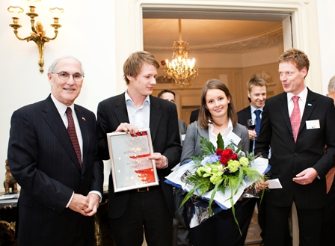
The Award went to WindFlip AS, a Trondheim-based provider of innovative offshore wind turbines transportation solution. A team of young entrepreneurs, Eirik Hogner and Ane Christophersen, gave a professional and well-prepared presentation that convinced the most experts and investors. See www.windflip.com for more information about the company.
A jury had evaluated 27 relevant applications to select five finalists. The quality of applicants was deemed to be very high and the selection of five finalists was not easy. This year’s jury consisted of representatives from Cleantech Scandinavia, Statkraft Development, Investinor, BASF Venture Capital and Innovation Norway.
The winner among the five finalists was selected during a session at the Cleantech Capital
Day in Oslo 2010, were the audience voted for the best company based on how the entrepreneurs presented their business cases to an audience of Norwegian and international investors and cleantech experts.
The award, consisting of EUR 10,000 and a selection of free advisory services from Statkraft and Investinor, was handed over by the Ambassador of the United States to Norway Mr Barry B. White at an award ceremony at his Residence.

About the Norwegian Cleantech Award
The Award is presented by Cleantech Scandinavia, Statkraft, Investinor and Innovation Norway. The Norwegian Cleantech Award aims to highlight the future cleantech success stories and give investors an early view of these rising stars.
The Award is open to Norwegian cleantech companies that have received less than EUR 1,000,000 (1 million) in external private financing (grant funding, internal industrial and

money from friends and family excluded). The overall and main criterion of the award is growth potential, judged through information provided by the participants regarding innovation, ability to execute and market.

The Finalists
Kyoto Energy AS: develops solutions that allow affordable renewable energy production in the developing countries.
www.kyoto-energy.com
MemfoACT AS: developer of a new type of carbon membrane for various gas separation applications.
www.memfoact.no
Sorbwater Technology AS: a Bergen-based supplier of a novel process wastewater cleaning technology.
www.sorbwater.com
ECOsubsea AS: an Oslo-based developer of an environmentally conscious hull cleaning technology for seagoing vessels.
www.ecosubsea.com
WindFlip AS: a Trondheim-based provider of offshore wind turbines transportation solution.
www.windflip.com

- ENDS -

For more information please visit www.cleantechscandinavia.com or contact:
Magnus Agerström, Managing Director
magnus@cleantechscandinavia.com
+46 40 602 76 00

Svetlana Gross, Project Manager
svetlana@cleantechscandinavia.com
+46 73 940 20 81

About Cleantech Scandinavia:
Cleantech Scandinavia is a membership network of investors and affiliated cleantech professionals designed to provide cleantech knowledge, contacts and investment opportunities; be a coordinating voice to promote the Nordic cleantech sector, and drive cleantech innovation and growth in the Nordic countries. Cleantech Scandinavia offers its members a series of networking and pitching events, business intelligence research and reports including Nordic cleantech deal flow statistics, and holds a database of investment opportunities in the region.

