Nova 2011 Prizewinners –
Nordic Designer of the Year

Hanna Hedman and Simon Klenell

The Jury’s explanatory statement:

”We should perhaps point out that we decided to award the prizes to two young designers who, completely in keeping with the spirit of the times, combine skilful handicraft with a personal design language ….

To Hanna Hedman – for her exciting, personal and headstrong design language with strong emotional expressions.

To Simon Klenell – for the breadth he demonstrates in his design, with, on the one hand, user-friendly objects and, on the other, different and personal works of art.”

The Jury for 2011 consists of Kerstin Wickman, Professor of the History of Design and Crafts at Konstfack, Lotta Lewenhaupt, a journalist, Gunilla Allard, a designer, Pascale Cottard-Olsson of Gallery Pascale, Hanna Nova Beatrice, Chief Editor of Plaza Interiör and Chicie Lindgren, a project manager at Formex.

The prize consists of two parallel exhibitions in January, one at Vår Formex and one at Gallery Pascale, where the public will also be given the opportunity to view and purchase the winner’s products. The winner will also receive the prize from our partners of being featured in Plaza Interiör and also an activity sponsored by the Stockholm Chamber of Commerce and Formex. This could, for example, be a trip, including subsistence, or a course. This year, this is to the value of SEK 60,000.

Another part of the prize is a unique diploma designed by a new illustrator and graphic designer each year. First up is Cornelia Waldersten Årfors.

- I have produced a portrait of the two prizewinners. Since it is a new designer who produces the diploma every year, I thought I would take the opportunity to live it up a bit. I allowed myself to be inspired by their works, which are bold, have a dark side and yet, at the same time, are playful, says Cornelia Waldersten Årfors.

Hanna Hedman
Hanna Hedman, born in 1980, is a costume jeweller operating in Stockholm. She has educational qualifications from places like New Zealand and the USA. Hanna completed her Master’s Degree at Konstfack, University College of Arts, Craft and Design, Stockholm in 2008. Her work for her finals, “Enough tears to cry for two”, in 2008 attracted a lot of attention and resulted in the first of her own exhibitions in New York. Since then, she has had several separate exhibitions and taken part in group exhibitions in both Sweden and abroad. She has won several awards and is represented in collections all over the world.
Hanna Hedman's jewellery is inspired by ornamental art and entices you into a mysterious world, full of details. In her jewellery, Hanna combines daydreams, reality and tales of bygone times with everyday life and magical nature. Her jewellery is somewhere between fantasy, reality, art and function.
- It is a great honour to receive such a fine prize as this. I spend a lot of hours in my studio doing monotonous and time-consuming work and so it is greatly motivating to be appreciated, which makes my work much easier.
- I will be using the prize money to develop my partnership with the photographer, Sanna Lindberg. Sanna and I met in 2008 and then began a partnership that has endured and been developed. Together, we combine photography with the art of costume jewellery. The photographs emphasise my jewellery's connection to the body and reinforce supporting concepts.
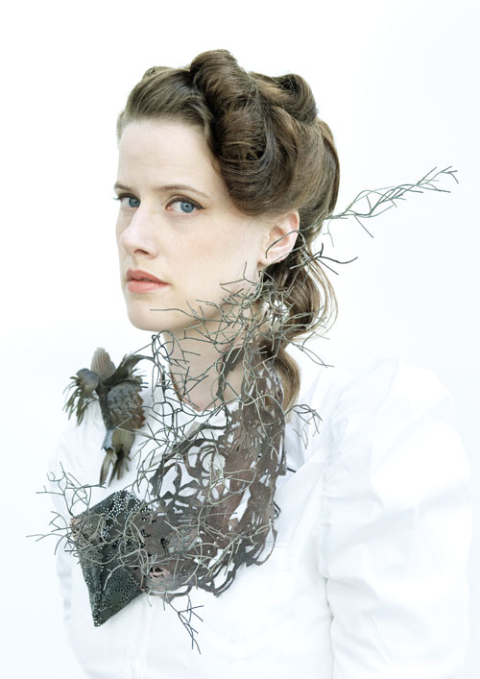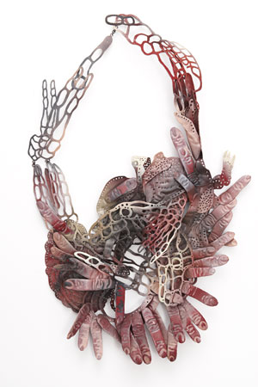

Simon Klenell
Simon Klenell is a craftsman and designer. He was born in Sunne in Värmland in 1985. Having recently passed his Master’s Degree at Konstfack, he is now working and based in Stockholm producing unique objects and product design. He has, among other things, exhibited at Galleri Inger Molin in Stockholm, Milan Design Week, Eskilstuna Art Museum and Designhuis in Eindhoven.
In his work, Simon Klenell tries to describe material conditions and situations. He usually uses familiar forms and patterns, which he transforms, extends and distorts. He often derives his inspiration from the material itself. This may be a physical condition that attracts him but could equally well be a pattern or a form. As Simon is essentially a craftsman, he sees being able to rework and understand things with his hands just as much as with his senses as his greatest advantage. He primarily works with glass, which is a material that carries charges and values. Being able to bend and redirect these is something he bases a great deal of his practical work on.

- The award obviously means a great deal to me as a designer who has recently graduated. Receiving this recognition is of major importance in several ways. It is not only flattering but also confirmation that what I am doing is good. The money element of the prize will be invested in future projects in order to develop my activity and my artistry. Something that is obviously of absolutely huge importance for me, says Simon Klenell.

