**Cutting-edge oil spill solutions and technology on show at Interspill London 2018**

* Participants from more than 50 countries prepare their stands for key oil spill conference and exhibition at ExCeL, London

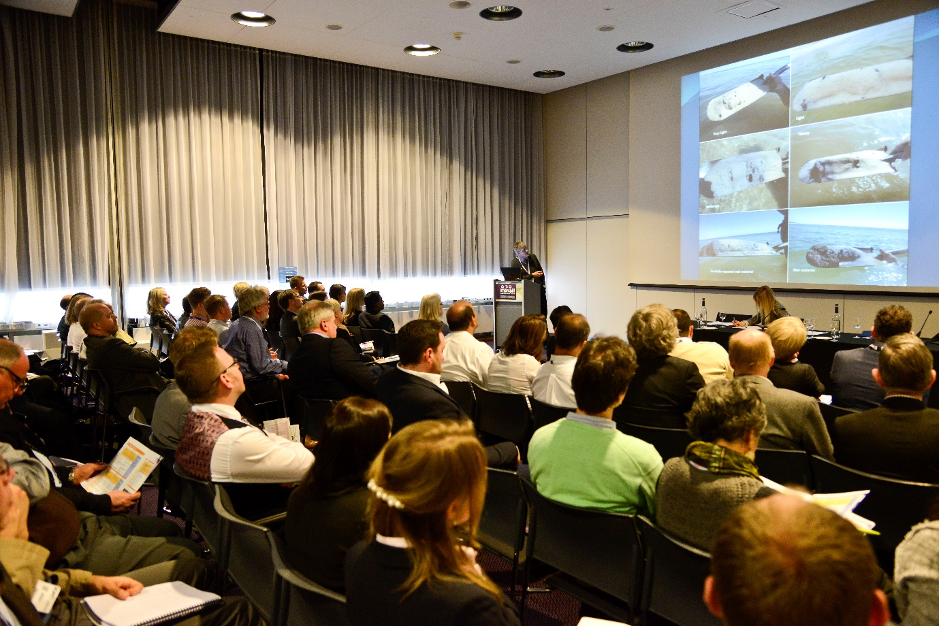

*Interspill 2018 takes place at ExCeL in London this March – image from Interspill 2015 in Amsterdam*

**London, 9 March 2018** – Running from March 13-15 at the ExCel in London, the Interspill London 2018 conference and exhibition represents an important networking opportunity for oil spill industry professionals, academics and government officials. This topical event provides a lively and inspiring forum wherein experts from differing but complementary professional backgrounds can exchange views, catch up with the latest scientific and technological developments and brainstorm potential solutions for future oil spills, focusing upon Spill Prevention, Preparedness, Response and Restoration.

Co-located for 2018 with the ExCeL-based Oceanology International marine science conference and exhibition, Interspill is now in its 8th edition. More than 80 exhibitors have booked stands for the London 2018 event, representing over 50 countries, in categories ranging from Prevention, Ecological Health & Pollution, Marine Bio Remediation and Environmental Consultancy to Emergency Response, Restoration, Field Equipment/Instrumentation and Shoreline Clean-up.

Reflecting the depth of expertise involved in Interspill London 2018, exhibitors include **Kongsberg Satellite Services** (stand S200), providing oil spill detection based on information received from satellite-based sensors; **Sajas Group** (stand W260), a 73-year-old brush manufacturing company from Finland; International Bird Rescue (stand W555), a professional group that manages emergency wildlife responses throughout the world; and **ITOPF** (stand S201), a non-profit organisation established to promote effective response to oil and chemical marine spills.

“ITOPF has been working in the spill preparedness and response field for the last 50 years and values Interspill as an excellent opportunity to share experiences and exchange views on current and future issues, and a useful vehicle for raising awareness of our on-going activities,” says ITOPF Technical Director, Richard Johnson.

In conjunction with Interspill committee members Cedre (stand S500), international experts in water pollution, ITOPF will also be hosting a series of free-to-attend, one-hour Science Workshops. These will cover topics including Response in Cold Environments and Marine Pollution Impacts, and will augment the Spill Industry Seminars, a sequence of exhibitor presentations intended to highlight the latest developments in oil spill prevention and response.

Hosting Interspill for the third time, and exhibiting on stand S100, **The UKSpill Association** is a national trade body which represents companies, organisations and individuals working in the oil and chemical spill response industry in the UK. “The changing causes, components and environmental effects of hazardous spills continue to present the industry with fresh challenges,” comments Executive Director Roger Mabbott, “which is precisely why Interspill is such an invaluable point of contact for the workers who operate in this sphere. Since Interspill was founded in 1998, the tireless intervention of oil spill professionals has drastically reduced the impact of major oil spills at sea; and for the industry as a whole, there can be no more convenient and compelling means of trading expertise, conducting business and outlining strategies for the future.”

The UKSpill Association will also be promoting Interspill+, a special space devoted to the subject of land-based oil and chemical spills, with seminars, demonstrations and presentations.

Other key exhibitors confirmed for Interspill London 2018 include **NOSCA** (stand S200), the Norwegian Oil Spill Control Association; **AllMaritim AS** (stand T251), a leading international supplier of high-quality oil spill response equipment; **International Air Response** (stand U95), an industry leader in global aerial dispersant services; and **NRC** (stand U302), an international service contractor providing environmental, industrial and emergency solutions to the oil and energy sectors.

The exhibition will be complemented across all three days of the event by a poster display on the show floor, covering aspects of oil spill preparedness and response. In addition, the Interspill conference programme will present an opportunity for delegates to derive insights from a set of detailed Technical Tracks, taking in topics such as Effective Preparedness, Government/Industry Partnerships and Shipping and Salvage Risks.

As Interspill 2018 Chairman Richard Proctor sees it, “Interspill has grown in stature and significance over the last two decades, to the point where even those outside the industry are acknowledging its influence, as a nexus of progressive thought, on the safeguarding of our environment.”

For more information and to register, see [www.interspillevent.com](http://www.interspillevent.com)

Ends

**For further information, please contact:**

Ainara Alonso Silva Saul Trewern

Marketing Manager, Interspill **Saltwater Stone**

**Reed Exhibitions** Tel: +44 (0)1202 669244

Tel: +44 (0)20 8910 7063 [s.trewern@saltwater-stone.com](mailto:s.trewern@saltwater-stone.com)

[ainara.silva@reedexpo.co.uk](mailto:ainara.silva@reedexpo.co.uk)

**About Interspill**

Interspill is the leading European oil spill conference and exhibition focusing on potential issues to be raised from any future oil spills, including Spill Prevention, Preparedness, Response and Restoration. Interspill 2018 will provide a unique platform for oil spill industry professionals, academia and government to meet, discuss and network. Co-located with Oceanology International at ExCeL for the 2018 edition, the Interspill conference and exhibition will return to London after a successful 2015 event in Amsterdam.

**About Reed Exhibitions**

Reed Exhibitions is the world’s leading events organizer, with over 500 events in 30 countries. In 2015, Reed brought together over seven million event participants from around the world generating billions of dollars in business. Today, Reed events are held throughout the Americas, Europe, the Middle East, Asia Pacific and Africa and organized by 40 fully staffed offices. Reed Exhibitions serves 43 industry sectors with trade and consumer events. It is part of the RELX Group plc, a world-leading provider of information solutions for professional customers across industries. [www.reedexpo.com](http://www.reedexpo.com/)

[calendar](http://www.reedexpo.com/en/Calendar_of_Events) [facebook](http://www.facebook.com/pages/Reed-Exhibitions/192420930839146) [twitter](http://twitter.com/#!/ReedExhibitions) [linkedin](http://www.linkedin.com/company/6651?trk=tyah) [RE logo](http://www.reedexpo.com/)