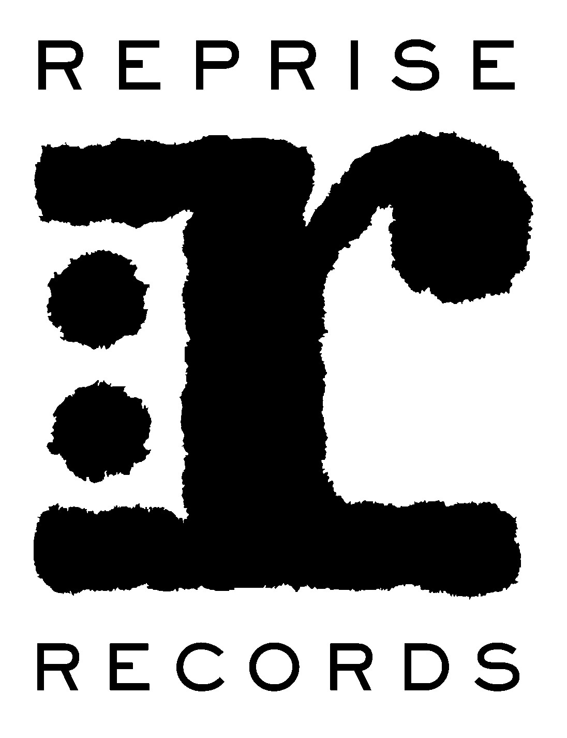

MASTODON ANNOUNCE NEW ALBUM — EMPEROR OF SAND —TO BE RELEASED MARCH 31ST VIA REPRISE RECORDS

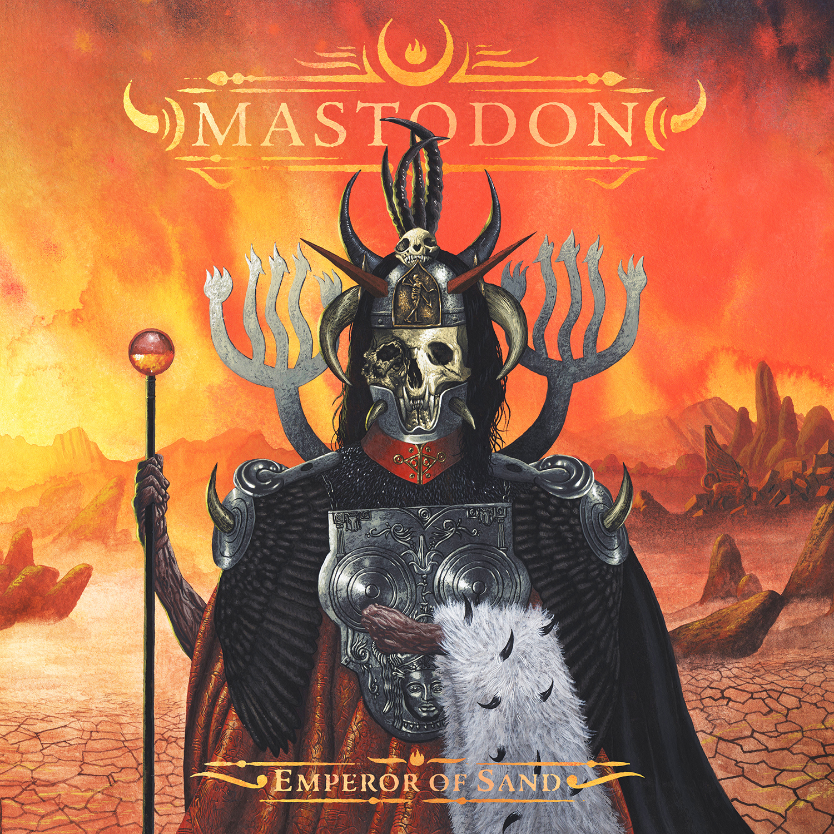

January 27th, 2017 (Burbank, CA) — Internationally celebrated heavy rock icons MASTODON are proud to announce the title, track-listing, and release date of their eighth studio album, Emperor Of Sand — the follow-up to their universally praised 2014 album Once More ‘Round The Sun. The album will be released on March 31st via Reprise Records. Emperor Of Sand will be available for pre-order beginning today at www.mastodonrocks.com. The deluxe pre-order package will contain the album on double 180-gram vinyl housed in a gatefold jacket along with a bonus Color-In-Your-Own vinyl jacket, plus an exclusive box of Mastodon colored pencils. In addition fans will also receive a digital copy of the entire album on March 31st, along with an instant download of the album track “Sultan’s Curse.” Emperor Of Sand will also be available digitally and on CD. Click here to view the typically stunning album artwork by Alan Brown in a glorious, full 360-degree view. Alan Brown, aka Medusawolf, created the cover and inside gatefold images. Click here to learn more about the artist.

Emperor Of Sand finds Mastodon returning to a deeply imaginative and complex conceptual storyline that ponders the nature of time. Threading together the myth of a man sentenced to death in a majestically malevolent desert, the band conjures the grains of a musical and lyrical odyssey slipping quickly through a cosmic hourglass. “Emperor of Sand is like the grim reaper,” says drummer/vocalist Brann Dailor. “Sand represents time. If you or anyone you know has ever received a terminal diagnosis, the first thought is about time. Invariably, you ask, ‘How much time is left?’”

“We’re reflecting on mortality,” adds bassist/vocalist Troy Sanders. “To that end, the album ties into our entire discography. It’s 17 years in the making, but it’s also a direct reaction to the last two years. We tend to draw inspiration from very real things in our lives.”

Emperor Of Sand was recorded at The Quarry Recording Studio in Kennesaw, just outside Mastodon’s hometown of Atlanta, with producer Brendan O’Brien (Pearl Jam, Neil Young, AC/DC, Rage Against The Machine), who first worked with Mastodon on their seminal 2009 album Crack The Skye.

Over the course of Mastodon’s career, the band members have fearlessly continued to push themselves towards greater creative heights on their recorded output. Each studio album has united an ever-expanding worldwide legion of fans who have come to expect the unexpected twists and turns that have elevated Mastodon to become one of the most respected and influential creative forces in rock music.

“Mastodon are the greatest metal band of their generation – no one else comes close.” Rolling Stone

“The coolest band in rock!” Drum! Magazine

“Chances are you could use heavier rock in your life, and Mastodon’s riff-heavy epics are as friendly to non-metalheads as they are to heshers.” New York magazine

***

Mastodon kick off a Spring U.S. headline tour in support of Emperor Of Sand beginning April 14th in Missoula, MT, with support from Eagles of Death Metal and Russian Circles. The tour also includes stops at several festivals, including the Carolina Rebellion Festival on May 5th.

Tour Dates:
# indicates festival date. All other dates are headline shows.

04/14 Missoula, MT Wilma Theater
04/15 Seattle, WA Paramount Theater
04/16 Portland, OR Roseland Theater
04/18 San Francisco, CA The Warfield
04/20 Los Angeles, CA The Palladium
04/21 Phoenix, AZ Comerica Theatre
04/23 Salt Lake City, UT Complex
04/24 Denver, CO Fillmore
04/26 Kansas City, KS Uptown Theater
04/27 St. Louis, MO Pageant
04/28 Birmingham, AL Iron City
# 04/29 Jacksonville, FL Welcome to Rockville Festival
# 04/30 Ft. Myers, FL Fort Rock Festival
05/02 Washington, DC Fillmore
05/03 Toronto, ON Rebel
05/04 Cleveland, OH Agora Theater
#05/05 Concord, NC Caroline Rebellion Festival
05/06 Philadelphia, PA Electric Factory
05/08 Boston, MA House of Blues
05/09 Portland, ME State Theater
05/11 New York, NY Hammerstein Ballroom
05/12 Pittsburgh, PA Stage AE
05/13 Chicago, IL Aragon Ballroom
05/14 Cincinnati, OH Taft Theatre
05/16 Detroit, MI Royal Oak Theater
05/17 Nashville, TN Ryman Auditorium
05/18 Memphis, TN Minglewood Hall
05/19 Dallas, TX Gas Monkey Live
05/20 Austin, TX ACL Live

For further tour and ticket info visit: www.mastodonrocks.com/tour

The track-listing for Emperor of Sand is as follows:

Sultan’s Curse
Show Yourself
Precious Stones
Steambreather
Roots Remain
Word To The Wise
Ancient Kingdom
Clandestiny
Andromeda
Scorpion Breath
Jaguar God

# # #

Mastodon:
Troy Sanders
Brent Hinds
Brann Dailor
Bill Kelliher

Follow Mastodon:
www.mastodonrocks.com
https://www.facebook.com/Mastodon
https://www.youtube.com/mastodonmusic
https://twitter.com/mastodonmusic
https://www.instagram.com/mastodonrocks

Mastodon Press Materials:
http://press.wbr.com/mastodon

