**Andreas Bäckman drives the 12 hours of Hockenheim**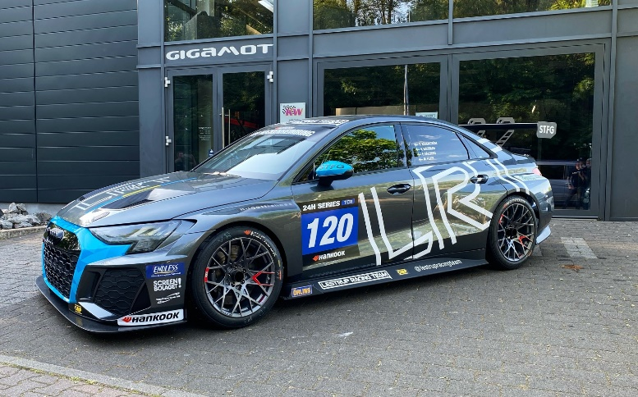Lestrup Racing Team's new Audi RS 3 LMS TCR car that Andreas Bäckman will drive this weekend at the Hockenheimring in Germany.  
Photo: Private (Free rights to use the image)

**This weekend, May 13th-15th, Andreas Bäckman will drive the 12-hour race Hankook 12h Hockenheimring together with Lestrup Racing Team in their brand-new Audi RS 3 LMS TCR car as a preparation for this year's STCC season. It will be both a new team and a new car for Andreas.  
- Exciting to get started and drive again, will be many valuable kilometres in the new car, Andreas Bäckman says.**

This weekend, May 13th-15th, the Hankook 12h Hockenheimring race of the 24H Series will be held. The 24H Series is a series of seven endurance races around the world, where the Hankook 12h Hockenheimring is the fourth race on this year's calendar to take place on the classic Formula 1 track Hockenheimring in Germany. Andreas Bäckman will, together with three other drivers, drive car #120 for Lestrup Racing Team in the TCR class.

**A new car, a new team and a new form of racing for Andreas**  
Andreas Bäckman made his competition debut in go-karting in 2006 as a 10-year-old and has since competed around the world with many national and international successes in go-karting. In 2018, Andreas made his debut in car racing after many years in go-karting and one year in rallycross.

Since his debut in car racing in 2018, he has over the years taken wins, pole positions and podiums in several TCR championships. In 2018, he got a win, a pole position and several podium places towards a 3rd place overall in the TCR UK Championship, which is the British counterpart of STCC.

In 2019, he took the step up to the European Series TCR Europe and finished in 4th place overall with one victory, two pole positions and two podium places during the season. In 2020, he also competed in TCR Europe and took home a win in Barcelona.

In 2021, Andreas competed in the World Cup series WTCR - FIA World Touring Car Cup for Target Competition.

In 2022, he will make a comeback in STCC (Scandinavian Touring Car Championship), after three years of international racing, in the brand-new Audi RS 3 LMS TCR car for Lestrup Racing Team.

This weekend, the team Lestrup Racing Team runs the 12-hour race Hankook 12h Hockenheimring as a preparation before the STCC season. The 12-hour race gives both the team and the drivers the opportunity to get to know the new car before the STCC season starts at Ljungbyhed, Sweden at June 3rd-4th.

- This is a critical switch for us in order to remain competitive and reach our goals of fighting for the STCC titles with the latest machinery. The new Audi is a considerably more competent race car with more setup possibilities, enabling us as a team to tailor the cars much better to the preferences of our drivers, **Fredrik Lestrup** **says**, co-founder of Lestrup Racing Team.

Andreas will together with Oliver Söderström, Emil Sällberg and Marcus Fluch drive Lestrup Racing Team's Audi RS 3 LMS TCR car with start number 120 in the TCR class.

Hankook 12h Hockenheimring will be both the team's first competition in the new car and also Andreas' first-ever endurance race in a TCR car.

- Exciting to get started and drive again, it will be many valuable kilometres for both me as a driver and also for the team to learn the new car as much as possible. It will also be good to get-to-know the team before the start of the STCC season, **Andreas Bäckman says**.

On Friday the weekend starts with free practice and then later in the evening the timed qualifying is held, where the starting positions for the race are decided. Then on Saturday and Sunday the 12-hour race is held, which is divided into two parts. The first part of the race is run on Saturday night and the second part is then held on Sunday night. There are several classes with different car types in the competition, and in the TCR class where Andreas will compete, there will be eight cars starting the race.

- I know the track from before but a lot of things will be very new for me, as I have not been driving endurance races before and that I will also be learning the new car. It will also be a lot to adapt to this competition format where the races are much longer than I am used to, but it will be a good experience and fun to try something new, **Andreas Bäckman says**.

**Timetable for this weekend (Hankook 12h Hockenheimring):**(all times are in CEST/Swedish time)

**Friday May 13th:**16:20 Free Practice (Broadcasted LIVE on 24H Series on [YouTube](https://www.youtube.com/user/24HSeries))  
19:05 Qualifying (Broadcasted LIVE on 24H Series on [YouTube](https://www.youtube.com/user/24HSeries))

**Saturday May 14th:**13:55 Race – Part 1 (Broadcasted LIVE on 24H Series on [YouTube](https://www.youtube.com/user/24HSeries))

**Sunday May 15th:**14:05 Race – Part 2 (Broadcasted LIVE on 24H Series on [YouTube](https://www.youtube.com/user/24HSeries))

**The event are broadcasted LIVE at 24H Series YouTube channel**The Hankook 12h Hockenheimring are broadcasted LIVE at: [youtube.com/24HSeries](https://www.youtube.com/user/24HSeries)  
Live-timing: [livetiming.getraceresults.com/24hseries](https://livetiming.getraceresults.com/24hseries)  
More information about STCC can be found here: [24hseries.com](https://www.24hseries.com/races/hankook-12h-hockenheimring-2022)

**About the track (Hockenheimring):**



**Located in:** Hockenheim, Baden-Württemberg, Germany

**Length:** 4.574 km

**Corners:** 16

**Race duration:** 12 hours (Race Part 1 – 6 hours on Saturday and Race Part 2 – 6 hours on Sunday)

**Lap record (TCR):** 1min 47.095s

***Free rights to use the images.***

***Download press-photos here:***[***http://bit.ly/jabaeckman-photos***](http://bit.ly/jabaeckman-photos)[***https://www.mynewsdesk.com/se/ja-backman/images***](https://www.mynewsdesk.com/se/ja-backman/images)

