

FOR IMMEDIATE RELEASE

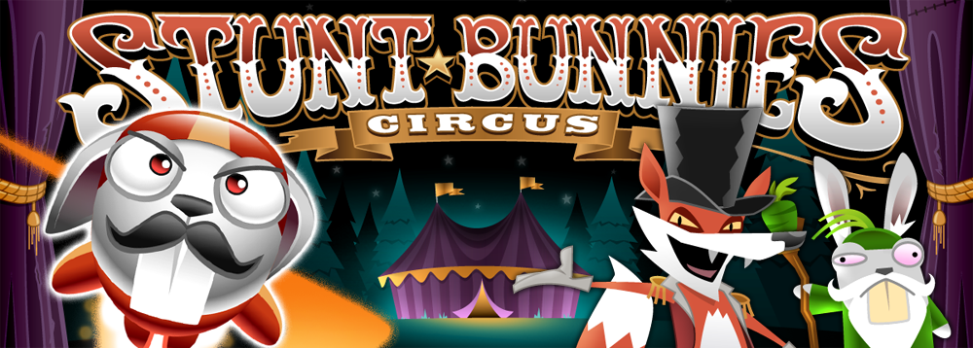

**Chilibite Games Brings Stunt Bunnies Circus to Google Play**

**Madrid, Spain - June 19, 2012** – Independent publisher Chilibite Games along with creative production studio Playerthree today announce that Stunt Bunnies Circus, an action-packed game recently launched for iPhone, iPad and iPod touch, is now also available on Google Play.

Stunt Bunnies Circus is a pick-up and play action game which, with a simple swipe of the screen, sees players send Jet Bunny flying through the air to save his falling long-eared friends from death after Ringmaster Fox, Claude Reynard, orders his Stunt Bunnies to perform increasingly dangerous routines, involving cannons, tight ropes, flaming torches and Lions, earning coins along the way. Players are able to make Jet Bunny's job easier by using a set of unlockable power-ups that include Crash mats, Fire jackets, Rocket fuel and the magical 'bullet-time' green carrot.

Stunt Bunnies Circus features two game modes; Story Mode and Arcade Mode, which include 40 levels, unlockable power-ups, an upgrade store and graphics with animated cut scenes.

This free to download version includes one chapter. Players can buy additional chapters one by one or the full game through an in-app purchase and they will get the arcade mode unlocked. Stunt Bunnies Circus is available on Google Play at <https://play.google.com/store/apps/details?id=me.chilibite.stuntbunnies&hl=en>.

YouTube video: <http://youtu.be/Rx-h_vyFl1g>

For more information on Stunt Circus Bunnies, please visit <http://chilibitegames.com/stunt-bunnies-circus/> or contact press@chilibitegames.com

**About Chilibite Games**

Founded in 2011, Chilibite Games is an independent game publisher offering top quality games for various platforms. For more information about Chilibite Games please visit [www.chilibitegames.com](http://www.chilibitegames.com)

**About Playerthree**

Founded in 2001, Playerthree is an award-winning independent game development studio with a reputation for high production values and original gameplay. Our goal is to entertain, educate or increase brand awareness to any brief across multiple platforms including web, mobile and handheld. For more information about Playerthree please visit www.playerthree.com.

###