 | PRESSRELEASE 2009-04-20

ESSVE launches:
New line of AMP-compressors yield more power

ESSVE launches an entirely new line of compressors on the Swedish market – the AMP Series. In spite of the small size, the new machines offer high performance at a low noise level.  At the same time as the TJEP selection is made available on the Swedish market, ESSVE introduces their new AMP-compressors. AMP (Air Mate Pro) is an entirely new range of compressors with an extremely high air-outlet volume in relation to its size.  Constructed to manage the toughest of challenges at the constructions sites, the compressors are also designed to function as smoothly as possible for the craftsman throughout the workday.  With the Low Noise System, unnecessary noise is reduced, which leads to a better working environment compared to previous generations of compressors.  – ESSVE’s new line of compressors yield a higher pressure than comparable compressors on the market. It gives you a margin between the pressure in the tank and the tools’ need for pressure. It provides you with a constant outflow without loss of pressure, which in turns lead to an even nailing result, says Bodil Almberg, Product Manager at ESSVE.  ESSVE’s AMP Compressors –  the craftsmen’s natural choice  - Newly developed and effective compressor unit  - Powerful single phase engine for top-notch performance  - Extremely high air outlet in a compact format  - Oil-free for easy handling  - Robust construction which suits the construction site  - Automatic safety shut off to prevent overheating  - Good mobility due to sturdy wheels and integrated handles  - Coiled hoses between vibrating and fixed parts | 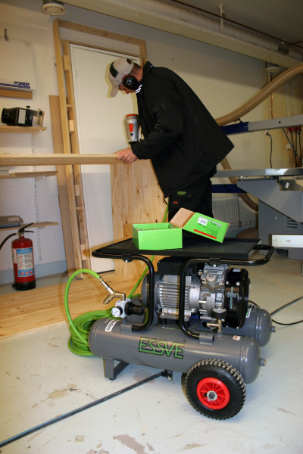  ESSVE AMP-compressor T22/260  About ESSVE  ESSVE’s goal is to serve its customers in the construction industry and the branch of industry with products of high quality to attractive prices. Strong brands ensure high quality and the products are distributed throughout the Nordic region which allows large requisitions leading to lower prices. ESSVE is a part of B & B TOOLS.  Website: www.essve.se  High resolution pictures can be downloaded in the online pressroom at essve.se  Brands in the ESSVE portfolio are:  ESSVE’s solutions for attachment: Products that are developed and adjusted to suit Nordic construction rules and conditions. Mounting, screw, industy- and attachment elements, mixed nails, fastening systems, glue, joint, drill and drill bits.  Milwaukee and Metabo: Electric tools with and without a cord for the professional craftsman.  FireSeal: Type approved and tested systems for fire sealing of lead-throughs.  TJEP: Air-driven machine nailers for the constructions industry.
For further information please contact Bodil Almberg, Product Manager, telephone +46-8-623 61 67 or
e-mail bodil.almberg@essve.se
Mattias Sebell, Marketing Manager, telephone: + 46 8-623 61 31, e-mail: mse@essve.se

