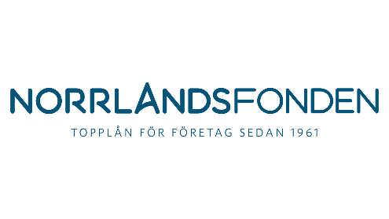
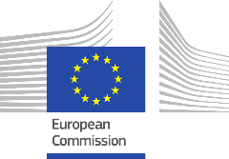
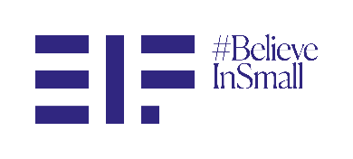
JOINT PRESS RELEASE Luxembourg/Luleå, 11 April 2023
Better access to finance for Northern Swedish businesses through EU guarantee
- Norrlandsfonden signs InvestEU guarantee agreement with European Investment Fund to facilitate over SEK 160 million in new financing
- The guarantee, backed by the InvestEU programme, is expected to benefit over 120 SMEs and small Mid-Caps in Northern Sweden, with a focus on innovation and sustainability.
- The collaboration, under which SMEs can get better lending terms, is expected to accelerate the green transition for Swedish SMEs.
The European Investment Fund (EIF) and the Swedish public investment agency Norrlandsfonden have signed a guarantee agreement to improve access to finance for SMEs and small Mid-Caps in Northern Sweden. The transaction is supported by the European Union’s InvestEU programme and is expected to benefit more than 120 companies throughout the Norrbotten, Västerbotten, Västernorrland, Jämtland and Gävleborg regions in Sweden. The European Investment Fund’s backing of Norrlandsfonden through the InvestEU programme will allow the intermediary to offer better lending conditions to its clients, in the form of reduced interest rates.
“In the coming years, northern Sweden is set to receive substantial investments, some of which are already in progress. The agreement between EIF and Norrlandsfonden will play a crucial role in supporting a green economy, fostering innovations and serving as an important financial tool for our region. This will enable Norrlandsfonden to become even stronger in the coming years and support small and medium-sized businesses in northern Sweden.” said Niklas Jonsson, CEO of Norrlandsfonden.

EIF Chief Executive Marjut Falkstedt commented: “The EIF needs regional partners like Norrlandsfonden to make sure that financial support can reach clients throughout Sweden. Norrlandsfonden’s expertise and knowledge of the local market provide optimal conditions to channel EU-backed funding to Swedish businesses, highlighting the direct link between the European project and local communities. We look forward to this renewed collaboration and the opportunity to back small businesses that are striving to innovate and drive the green transition in a region that is becoming a hotbed of innovation and sustainability.’’
The InvestEU guarantee agreement with Norrlandsfonden is split between the European Union’s “Innovation and Digitalisation” and “Sustainability” investment priorities. On one hand, the “innovation and digitalisation” part of the guarantee will allow Norrlandsfonden to further support innovation and digitalisation driven businesses, by enhancing access to finance to Research & Innovation-intensive companies, as well as supporting their digital transformation and uptake of digital technologies. Next to this, the “sustainability” guarantee part will see Norrlandsfonden boosting the green and sustainable transformation of the economy through the support for the environmentally friendly, green and inclusive investments of its clients throughout Northern Sweden, a region at the forefront of Europe's transition towards a sustainable economy.
Background information
The European Investment Fund (EIF): The EIF is part of the EIB Group. It supports Europe’s SMEs by improving their access to finance through a wide range of selected financial intermediaries. The EIF designs, promotes and implements equity and debt financing instruments targeting SMEs. In this role, EIF fosters EU objectives in support of entrepreneurship, growth, innovation, research and development, the green and digital transitions and employment.
The InvestEU programme provides the European Union with crucial long-term funding by leveraging substantial private and public funds in support of a sustainable economy. It helps generate additional investments in line with EU policy priorities, such as the European Green Deal, the digital transition and support for small and medium-sized enterprises. InvestEU brings all EU financial instruments together under one roof, making funding for investment projects in Europe simpler, more efficient and more flexible. The programme consists of three components: the InvestEU Fund, the InvestEU Advisory Hub, and the InvestEU Portal. The InvestEU Fund is implemented through financial partners who invest in projects using the EU budget guarantee of €26.2 billion. This guarantee increases their risk-bearing capacity, thus mobilising at least €372 billion in additional investment.
Established in 1961 as a foundation, Norrlandsfonden is a Swedish government-supported initiative set-up as a specialised institution for promotion of the economic activity and support of manufacturing companies in the North of Sweden (Norrland). Operating from two main offices in Luleå and Sundsvall, Norrlandsfonden provides high-risk financing in cooperation with banks and venture capital players. The fund works to promote the development of companies in the counties of Norrbotten, Västerbotten, Västernorrland, Jämtland and Gävleborg, investing across all business sectors with an interest in new technology and in business areas with an opportunity for growth. Norrlandsfonden offers loans for establishment, development and expansion with different loans, guarantees and guaranties dependent on the investment opportunity.

Press Contacts
EIB Group: Tim Smit, Tel: +352 691286423, t.smit@eib.org
Norrlandsfonden: Niklas Jonsson, +46 70 535 13 75, niklas.jonsson@norrlandsfonden.se
European Commission: Flora Matthaes, Tel: +32 229 83951, flora.matthaes@ec.europa.eu

