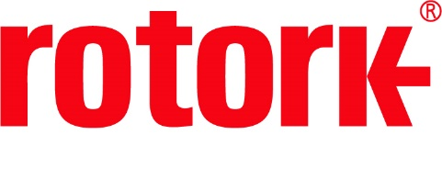
APPROVED PRESS RELEASE (3.1140) 6th November 2020
Rotork GP actuators selected for Asian LNG Terminal
GP range pneumatic actuators have been installed at a South Korean LNG Terminal. The terminal houses four Liquefied Natural Gas (LNG) storage tanks, each capable of storing up to 52.8 million gallons, a 45,000 tonne Liquefied Petroleum Gas (LPG) tank and a regasification plant.
Rotork has been providing actuators at the terminal since it was first constructed, with over 100 electric and pneumatic actuators installed during the initial front end engineering (FEED) phase of development. Additional GP actuators have now been installed as part of the site’s phase 2-2 expansion, with further electric and pneumatic actuators due for installation later this year.
The actuators have been installed on the terminal’s 32 inch main pipeline where they will perform an open/close function, which is used for the flow of both LNG and natural gas in its gaseous form. As these fluids are cryogenic, absolute control over the pipeline is critical. In the event of an emergency, the flow can be cut off immediately by the fail-safe functionality of the GP pneumatic actuators.
Fail-safe functionality can be provided in either direction due to the spring-return module inside the GP range. These are inherently safe due to the fact that they can only be removed from the centrebody (which incorporates a pressure relief valve) once all of the spring forces have been released.
The GP range of heavy-duty scotch yoke actuators provide a torque output of up to 600,000 Nm (442,537 lbf.ft). Available with double-acting or spring-return configurations, they are certified to IP 66M/67M, ATEX 2014/68/EU and are certified for use at SIL3 as a single device in accordance with IEC 61508.
END

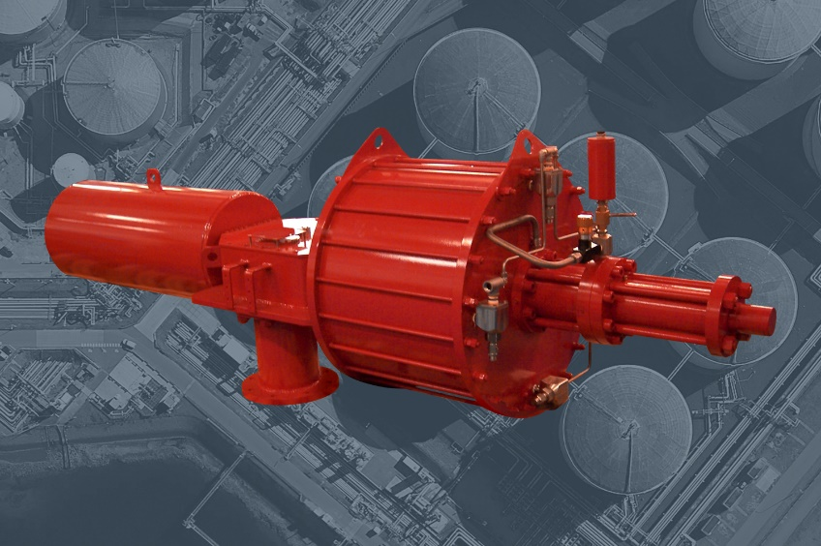
Photo caption
Rotork’s GP heavy-duty scotch yoke actuators have been installed at a South Korean LNG Terminal.

For further information please contact Rotork PLC
Sarah Kellett Brassmill Lane
Group Marketing Communications Manager Bath
Telephone: +44 (0) 1225 733492 BA1 3JQ
Email: Sarah.Kellett@rotork.com UK

About Rotork
Rotork is a market-leading global provider of mission-critical flow control and instrumentation solutions for oil and gas, water and wastewater, power, chemical process and industrial applications. We help customers around the world to improve efficiency, reduce emissions, minimise their environmental impact and assure safety.

